**Course Description**

In this course you'll take your skills with simple linear regression to the next level. By learning multiple and logistic regression techniques you will gain the skills to model and predict both numeric and categorical outcomes using multiple input variables. You'll also learn how to fit, visualize, and interpret these models. Then you'll apply your skills to learn about Italian restaurants in New York City!

**Parallel Slopes**In this chapter you'll learn about the class of linear models called "parallel slopes models." These include one numeric and one categorical explanatory variable.



In this course, we will learn how to extend simple linear regression to an arbitrary number of explanatory variables, which can be a mixture of numeric and categorical. We'll also learn about logistic regression, which allows to model a binary response variable.

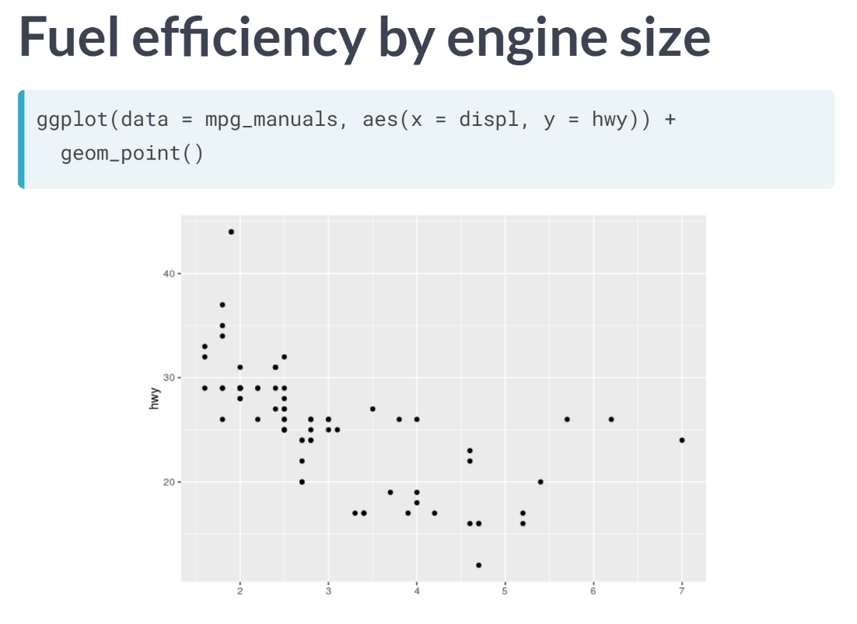  
Let's consider a situation in which simple linear regression might not be so sophisticated enough to suit our needs. This scatterplot shows the relationship between highway fuel economy and engine size for 77 configurations of manual transmission cars popular from 1998 to 2008. It appears as though there is a negative relationship between engine size and fuel economy - which should make sense: bigger engines tend to go in bigger cars, which tends to be heavier, and which tends to get worse mileage.

We could certainly fit a linear regression line through these points, but that would only tell us part of the story. The truth is that these cars were popular in each of the ten years between 1999 and 2008, the observations we have are only from 1999 to 2008.

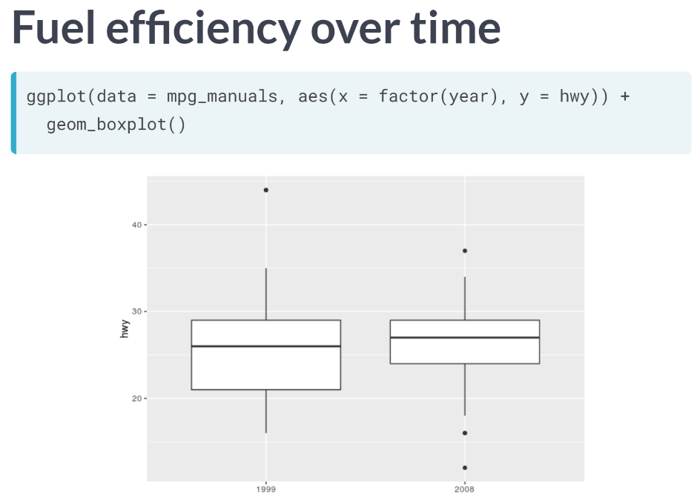  
Did fuel economy improve over time? These side-by-side boxplots suggest that it might have, but does that represent a feat of engineering? Or merely a change in a consumer taste?

How do we know that the increase in fuel economy was not due to the cars in 2008 generally having smaller engines - which we've already observed to be associated with greater fuel economy?

What we really want is a model that will assess the effects of engine size and year simultaneously. That is, we want to understand the effect of time on fuel economy, after controlling for engine size.

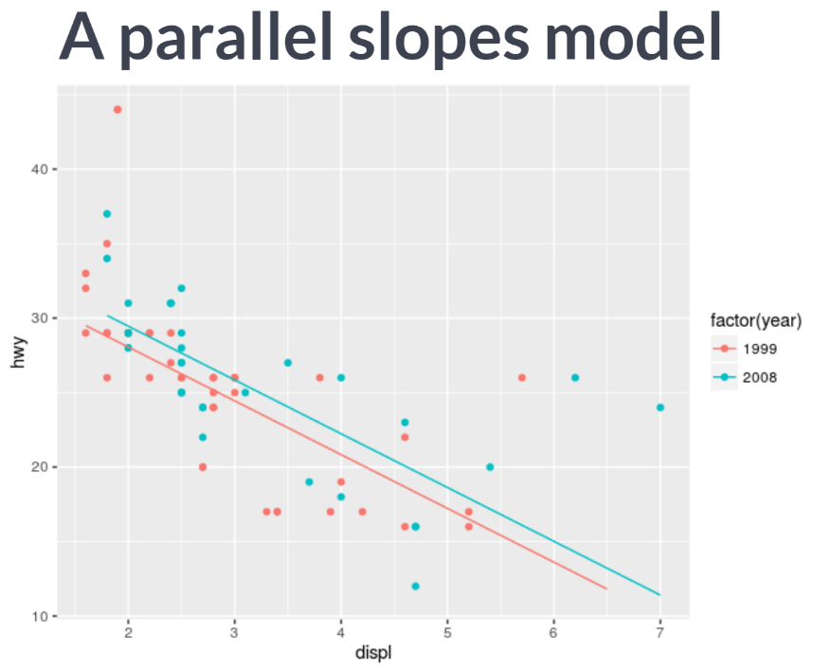  
Here we see a visual depiction of a parallel slopes model. These models occur when one of the explanatory variables is numeric, and the other is categorical. In this case, the year variables have two levels, and the model accordingly consist of two parallel lines.

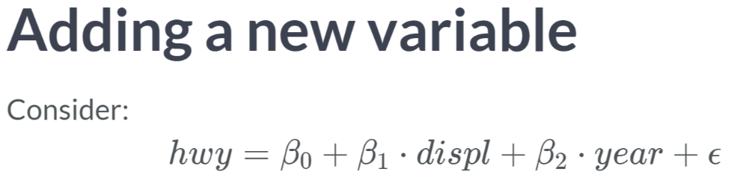  
Multiple regression allows us to build such models by simply adding another variable - and another coefficient - to our model.

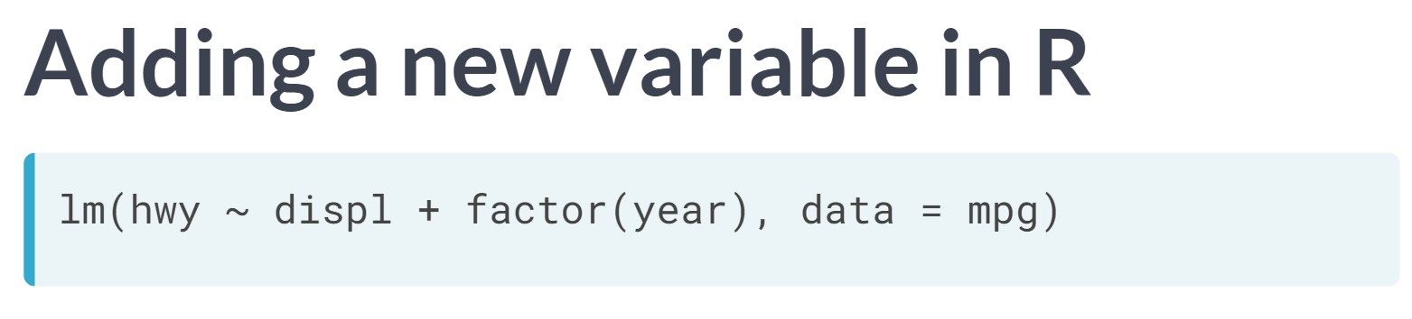  
As you might suspect, telling R about the second variable in our regression model is just as easy. We simply add another term to the right-hand-side of the formula that we pass to the ***lm()*** function.

Here, we have to be a bit careful to make sure that R interprets our year as a categorical variable, since it is encoded as a number. For our purpose, the year should be thought of as a label, not a quantity.

# Fitting a parallel slopes model

We use the lm() function to fit linear models to data. In this case, we want to understand how the price of MarioKart games sold at auction varies as a function of not only the number of wheels included in the package, but also whether the item is new or used.

Obviously, it is expected that you might have to pay a premium to buy these new. But how much is that premium? Can we estimate its value after controlling for the number of wheels?

We will fit a parallel slopes model using lm(). In addition to the data argument, lm() needs to know which variables you want to include in your regression model, and how you want to include them.

It accomplishes this using a formula argument. A simple linear regression formula looks like y ~ x, where y is the name of the response variable, and x is the name of the explanatory variable.

Here, we will simply extend this formula to include multiple explanatory variables. A parallel slopes model has the form y ~ x + z, where z is a categorical explanatory variable, and x is a numerical explanatory variable.

The output from lm() is a model object, which when printed, will show the fitted coefficients.

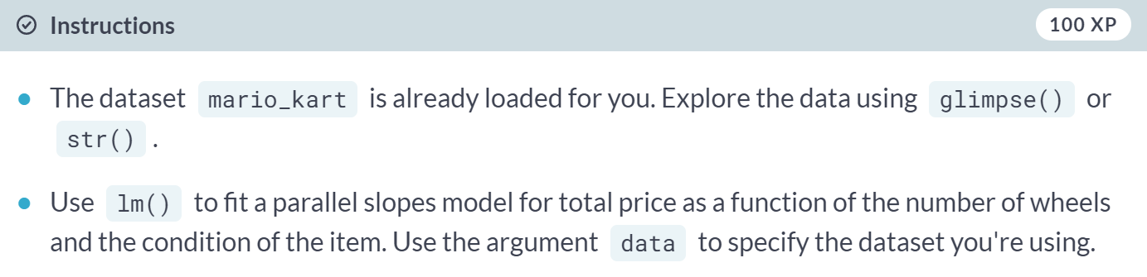

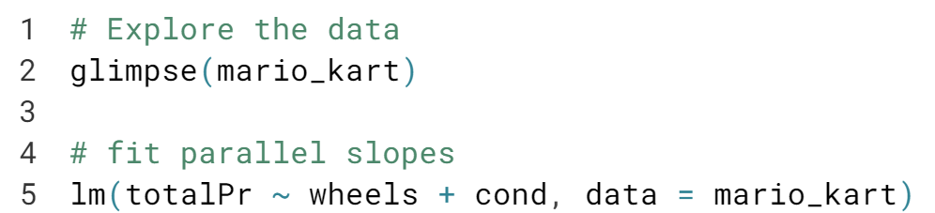

(Result on the next page)

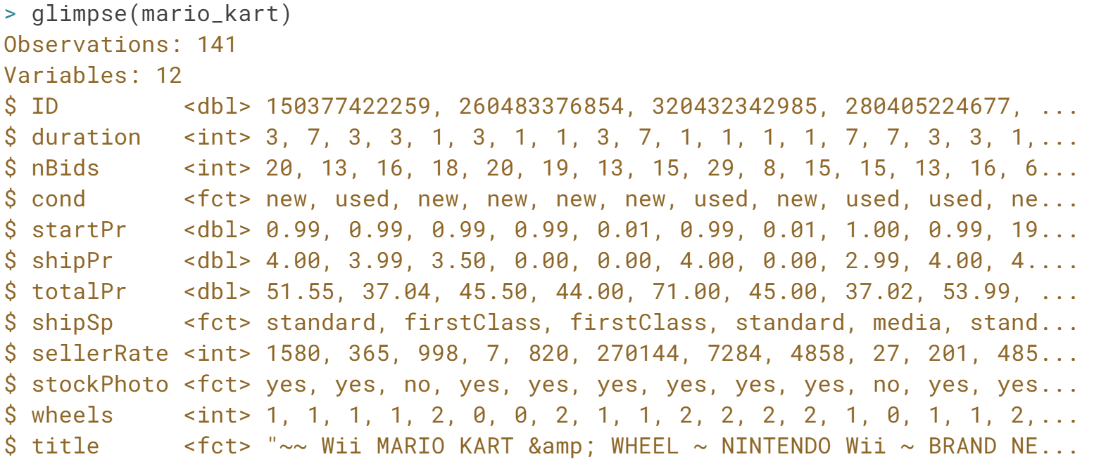

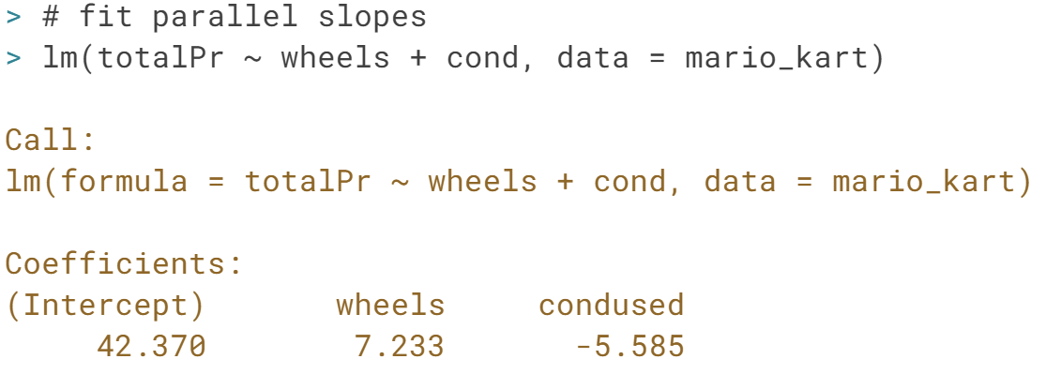

Awesome! On average, how much more does a new game cost compared to a used game?

# Reasoning about two intercepts

The mario_kart data contains several other variables. The totalPr, startPr, and shipPr variables are numeric, while the cond and stockPhoto variables are categorical.

Which formula will result in a parallel slopes model?

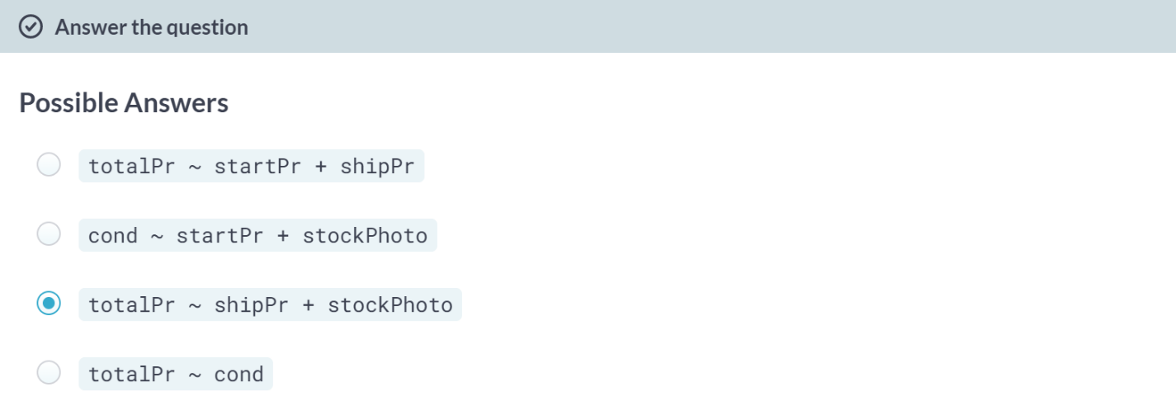



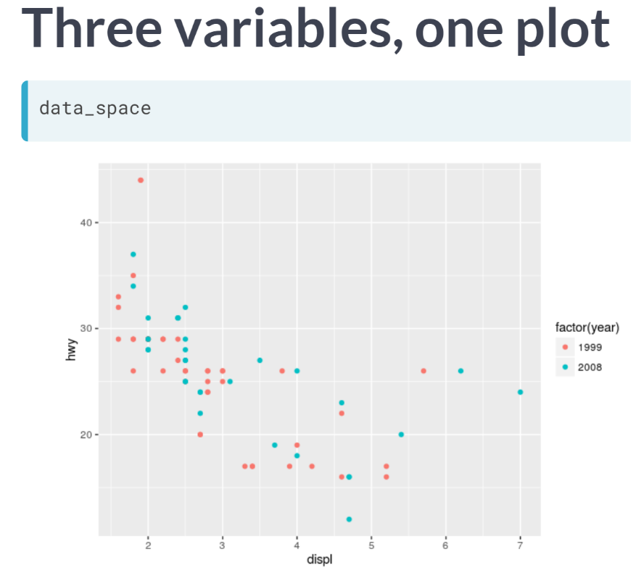  
In this scatterplot, we use color to differentiate the cars from 2008 from those in 1999. Do you notice anything about the green points relative to the red points?

In this manner, we have depicted three variables - two numeric and one categorical - on the same scatterplot. Thus, this plot will enable us to visualize our parallel slopes model in the data space.

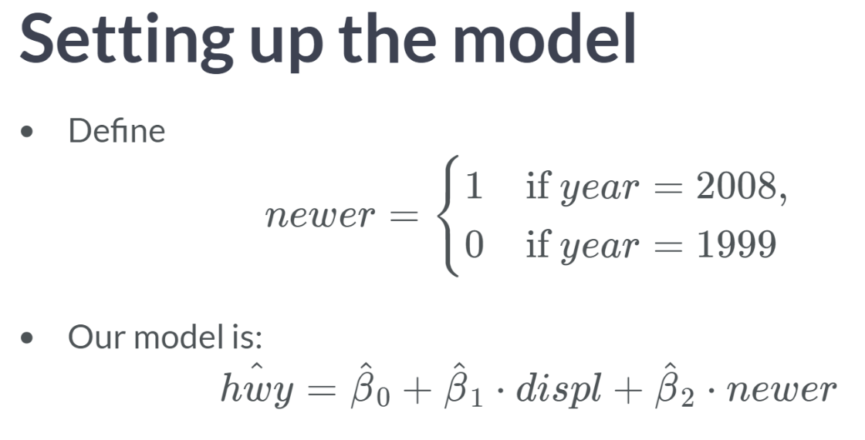  
We are going to make use of a little high school algebra to inform our understanding of geometry of our model. First, since our categorical explanatory variable year has only two levels, we are going to define a binary variable called newer that takes one the value 1 for cars from 2008 and is 0 otherwise. Then, we can express our model mathematically using this equation.

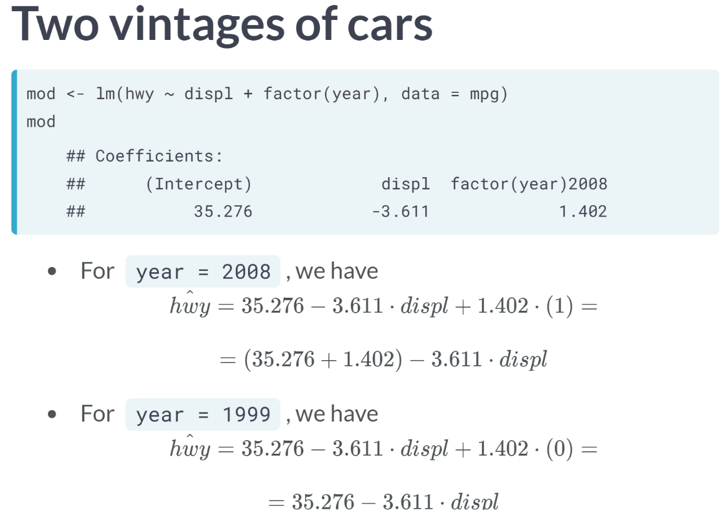  
We compute the fitted coefficient using ***lm()***. So, what happens when the cars are newer? Plugging in and simplifying reveals the equation for a line. Note that since displacement is our numeric explanatory variable, the slope of this line is -3.611 mpg per liter, and the intercept is 36.678 mpg - the sum of the other two coefficients.

What about the older cars from 1999? In that case, the value of newer is 0, and plugging that into our equation also results in the equation for a line. This line also has a slope of -3.611 mpg per liter, but now the intercept is just 35.276 mpg.

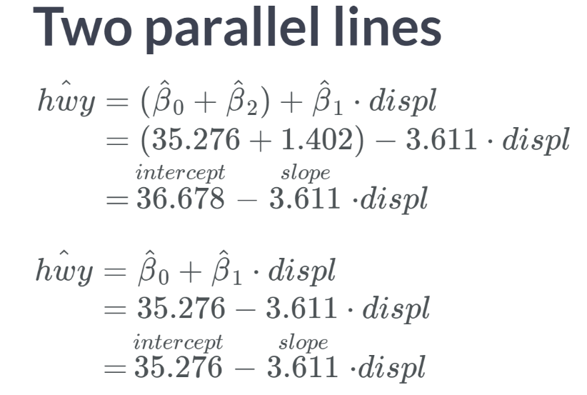  
Thus, our model consists of two parallel lines: one for newer cars from 2008, and one for older cars from 1999. The two lines are parallel because they have the same slope, but they aren't the same line, because they have different intercepts. This is why models with one numeric explanatory variable and one categorical explanatory variable are called **parallel slopes models**. Notice how the geometry was informed by the mathematics.

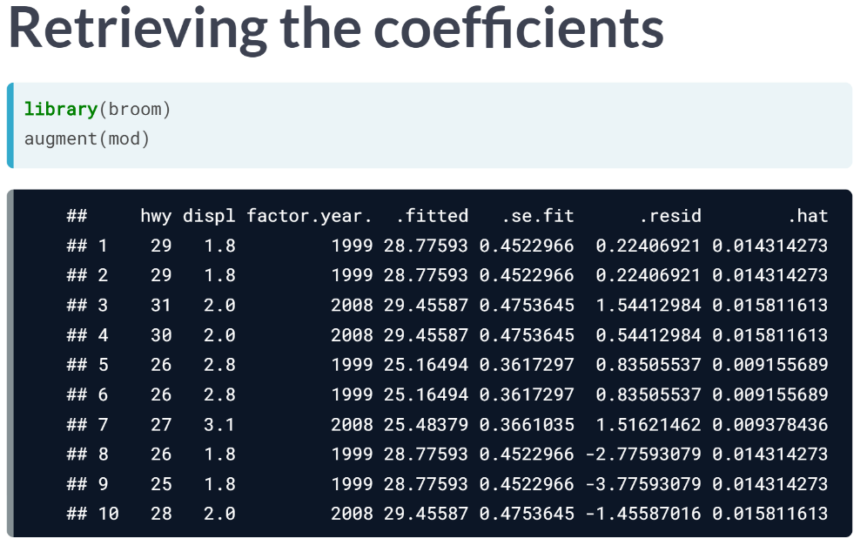  
In order to visualize our model, we need to extract the necessary information about our model that was created by ***lm()***. Conceptually, the three fitted coefficients will give us that information. However, it is easier in ggplot to simply plot the fitted values and connect them with a line. This process is streamlined by the augment() function from the broom package. Applying ***augment()*** to our model will return a data frame with the fitted values attached, like the one you see here. Note that the name of the variable that contains the fitted value is *.fitted*, and the name of the categorical variable is *factor.year.*

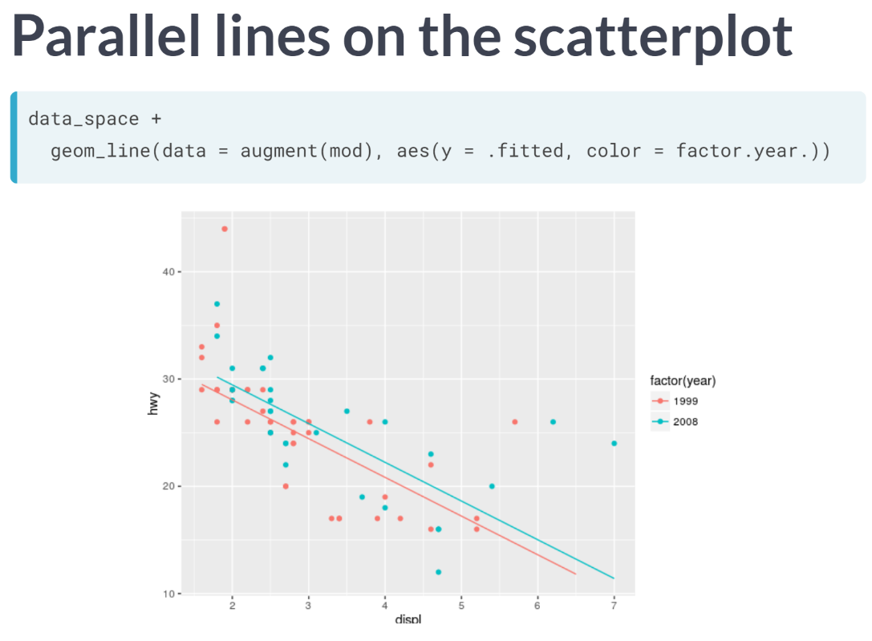  
Finally, we can use the ***geom_line()*** function to put the two lines on the scatterplot that we created previously. We need to tell ***geom_line()*** to plot the fitted values, rather than the observed values, and those values only exist in the augmented model object that we created previously.

# Using geom_line() and augment()

Parallel slopes models are so named because we can visualize these models in the data space as not one line, but two parallel lines. To do this, we'll draw two things:

* a scatterplot showing the data, with color separating the points into groups
* a line for each value of the categorical variable

Our plotting strategy is to compute the fitted values, plot these, and connect the points to form a line. The augment() function from the broom package provides an easy way to add the fitted values to our data frame, and the geom_line() function can then use that data frame to plot the points and connect them.

Note that this approach has the added benefit of automatically coloring the lines appropriately to match the data.

You already know how to use ggplot() and geom_point() to make the scatterplot. The only twist is that now you'll pass your augment()-ed model as the data argument in your ggplot() call. When you add your geom_line(), instead of letting the y aesthetic inherit its values from the ggplot() call, you can set it to the .fitted column of the augment()-ed model. This has the advantage of automatically coloring the lines for you.

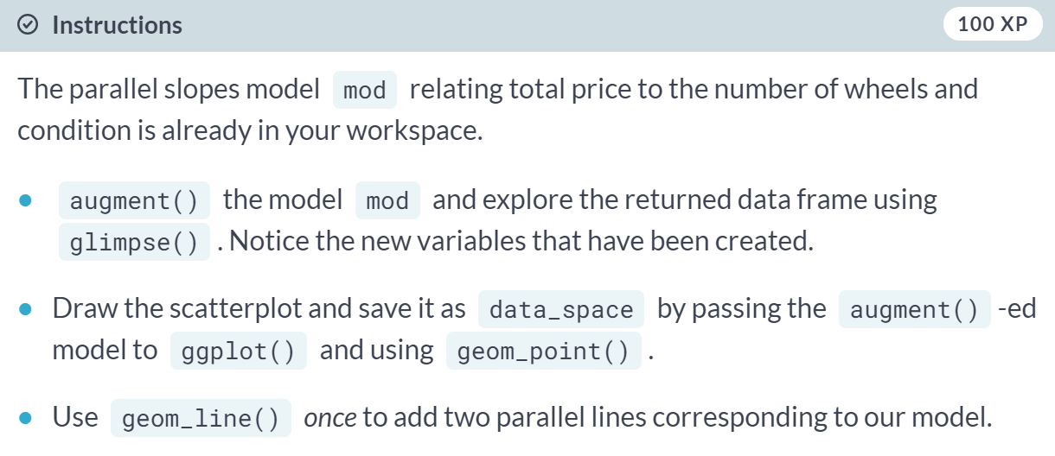  
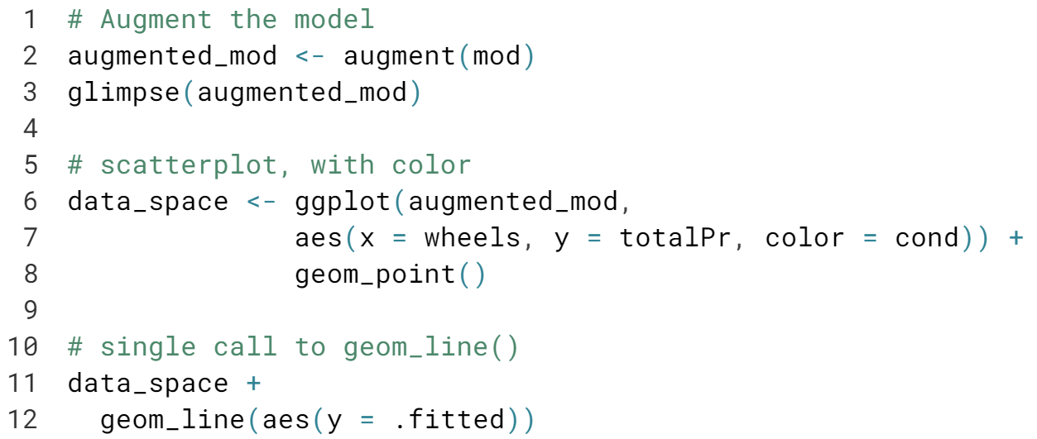

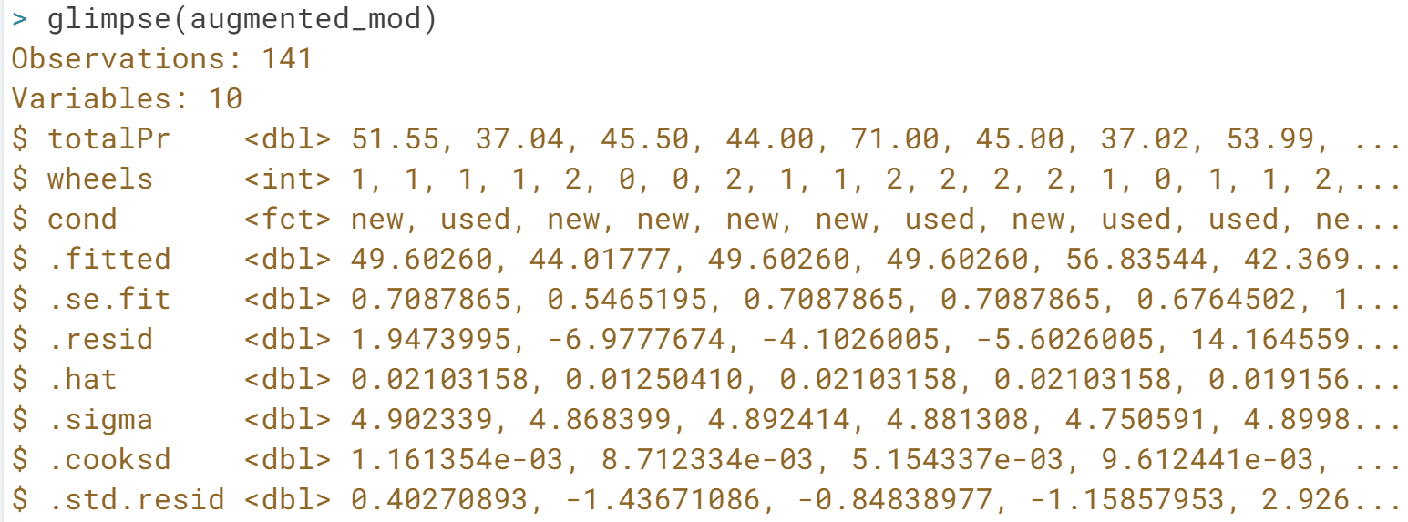

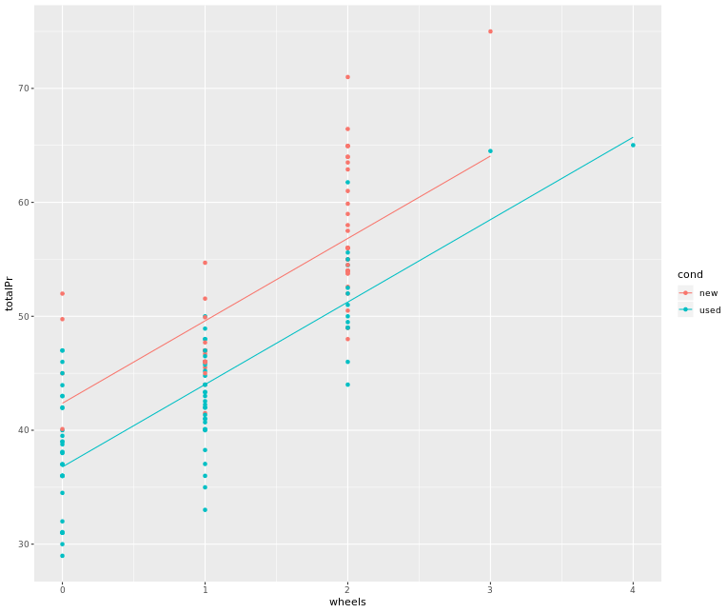  
Great work! Thinking geometrically is great way to get your head around how linear models work.



Most often, our primary interest in model like this one is interpreting the value of the coefficients. What does the model tell us about the relationship between fuel economy and engine size in the context of the year when the cars were manufactured?

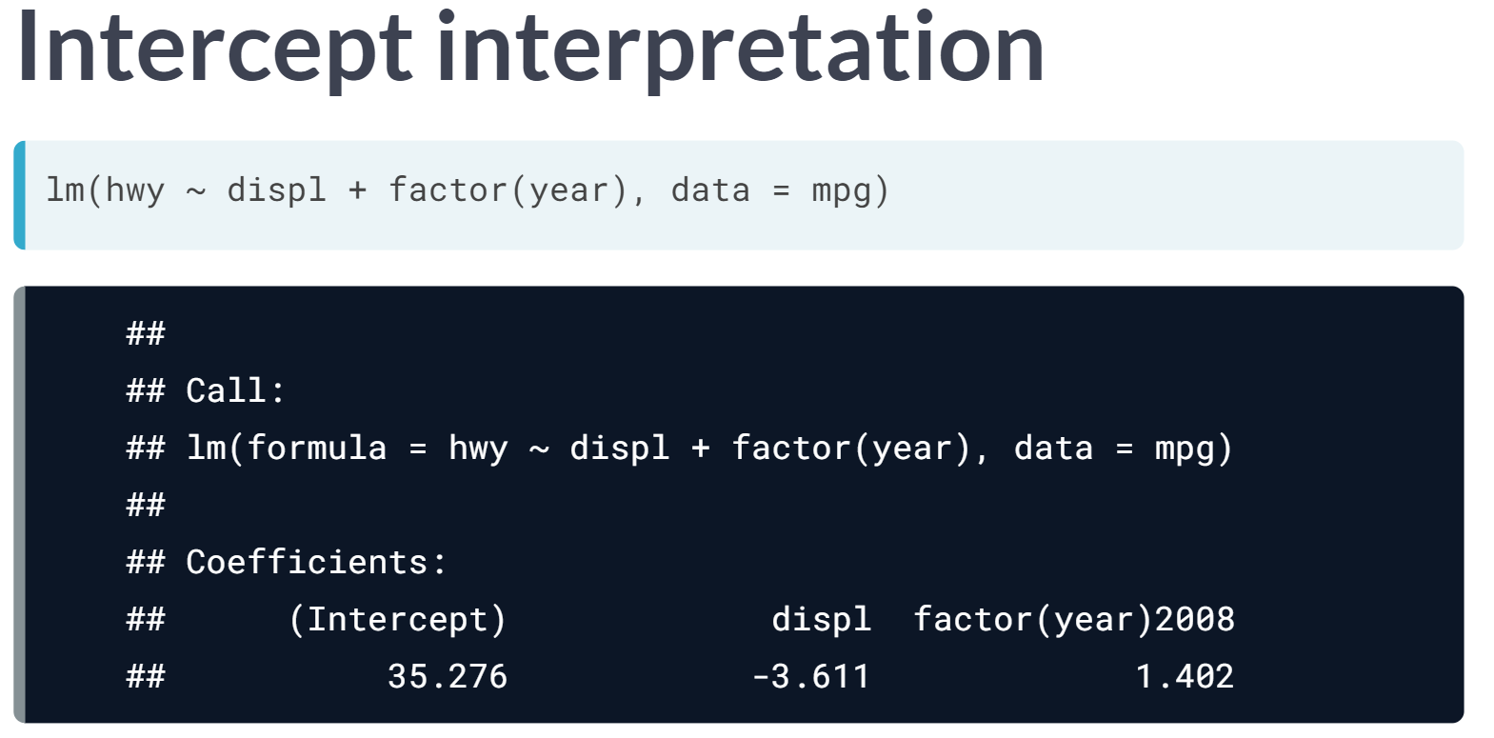

Let's start with the main intercept. The value is 35.276 and the units are the same as those of the response variable - miles per gallon. Recall that this is the expected fuel economy for a car from 1999 that had an engine size of 0 liters.

Of course, in this case, this value has little meaning, since there is no such thing as a car with an engine size of 0 liters, but that is the literal interpretation of the role that 35.276 plays in our model.

As we saw above, the coefficient on year can also be thought of as an intercept. Note here that R has chosen to report the name of the coefficient as factor(year)2008. This reflects the fact that factor(year) was the name of the variable we gave R, and 2008 is the value of that variable that R is reporting about.

This variable is identical to the newer variable that defined in the previous note. Here, R is telling us that cars manufactured in 2008 get about 1.4 mpg better gas mileage than those manufactured in 1999, after controlling for engine size. This is our key finding, and let's return to this in just a minute.

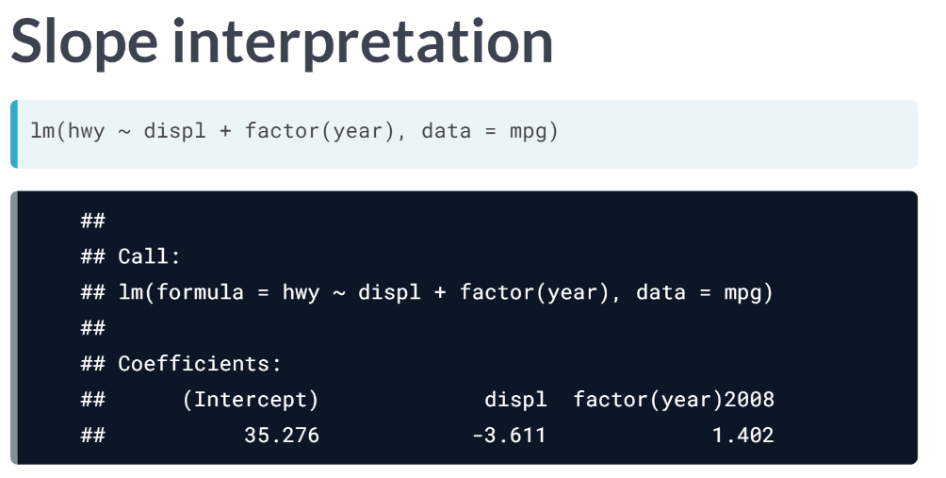

How did we "control for engine size"?

By including the *displ* variable in our model, we also obtain a coefficient for engine size. This is our slope coefficient, and it tells us that each extra liter of engine size is associated with a decrease in expected fuel economy of 3.61 mpg, after controlling for year of manufacture. This is the negative relationship we saw earlier: larger engines tend to go in less fuel-efficient cars.

The difference now is that we are able to estimate the size of that effect while simultaneously considering the effect of time.



The interpretation of coefficient in a multiple regression model can get complicated, so let's quickly review a few common mistakes.

First, there is only one slope in the parallel slopes models that we can considered thus far. Yes, there are two explanatory variables, but only the one numeric explanatory variable is associated with a slope. Later, we will consider more complex models that have more than one "slope".

Second, pay careful attention to the reference level of your categorical variables. Every factor in R has a reference level - which you can set - but by default it is the first level alphabetically.

Third, units are important. Every coefficient has units that relate to the units of the response variable. Intercepts are in the same units as the response variable, and slope coefficients are in the units of the response per unit of the explanatory variable.

Finally, the key difference in multiple regression is that coefficient must be interpreted in the context of the other explanatory variables. The *"after controlling for"* phrasing is crucial to having a valid understanding of our model.

# Intercept interpretation

Recall that the cond variable is either new or used. Here are the fitted coefficients from your model:

Call:

lm(formula = totalPr ~ wheels + cond, data = mario_kart)

Coefficients:

(Intercept) wheels condused

42.370 7.233 -5.585

Choose the correct interpretation of the coefficient on condused:



# Common slope interpretation

Recall the fitted coefficients from our model:

Call:

lm(formula = totalPr ~ wheels + cond, data = mario_kart)

Coefficients:

(Intercept) wheels condused

42.370 7.233 -5.585

Choose the correct interpretation of the slope coefficient:

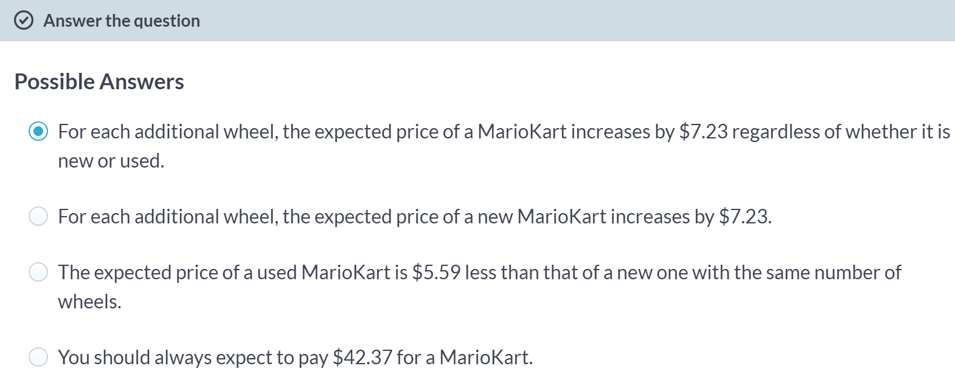



Regression models are abstract things, and as such we human being have developed various ways of characterizing them.



Models can be described by mathematical equations. In many cases, they can be visualized as geometric objects in two- or three- dimensions. And of course, they can be communicated to R via a suggestive syntax. Going forward, we will emphasize the connections between these three characterizations of models and illustrate how an understanding of one can lead to a deeper understanding of another.

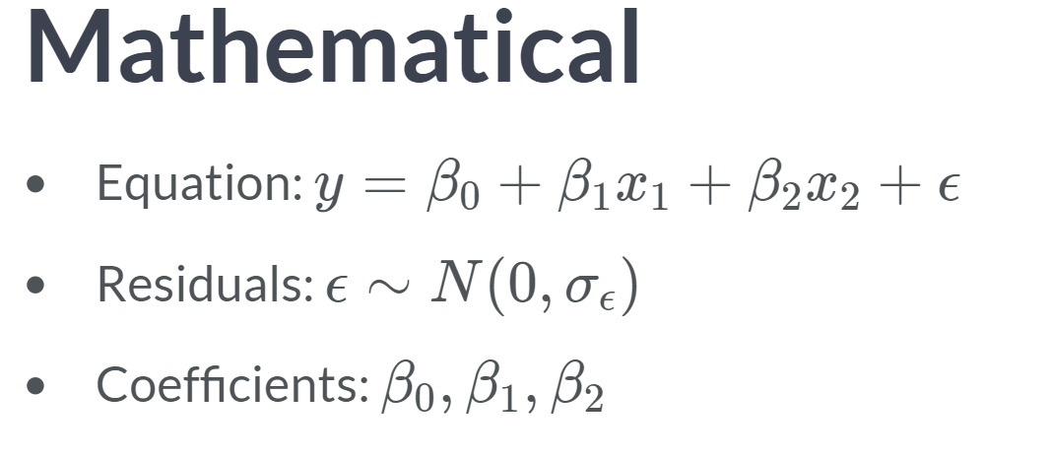  
A multiple regression model can be expressed as an equation for the response variable y in terms of some explanatory variables x1 and x2. The coefficients of the model - beta 0, beta 1, and beta 2 - allow us to translate our knowledge about x into information about y.

A statistical model will always include an error term like epsilon that captures our uncertainty. These error - which are manifest as residuals - are critical to the process of statistical inference - but that is a subject for a later course. In this course, we will focus on the variables and coefficients.

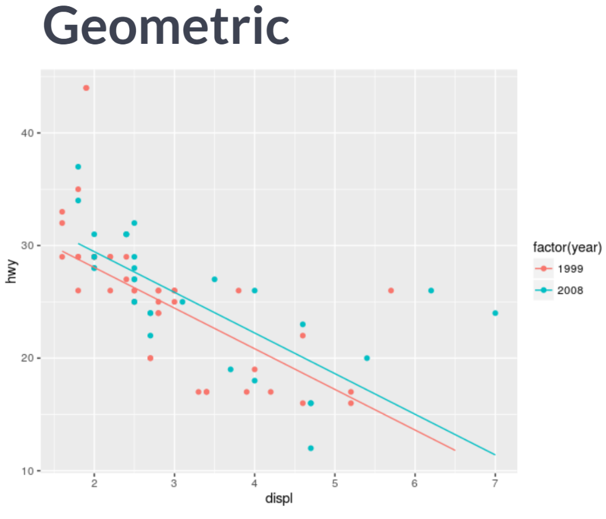  
Math isn't everyone's cup of tea, and while this doesn't make it any less important, we will develop geometric intuition about regression models in this course. Our data live in a "space", and we will refer to this as the "data space".

In this scatterplot, we viewed the highway gas mileage of several popular cars along with the corresponding size of their engines - as measured by displacement. Each point on the scatterplot represents an observation. A simple linear regression model can be visualized as a line through this data space.

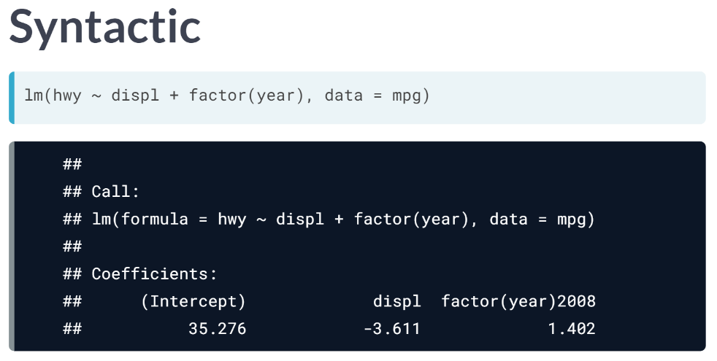  
Finally, R doesn't really understand math or geometry. But of course, R is really good at performing the computations that we will need to fit and visualize our models. We will use a special syntax - called a formula - to communicate models to R. This syntax is less specific and more suggestive than a mathematical equation but can be put into a 1-1 correspondence with it.

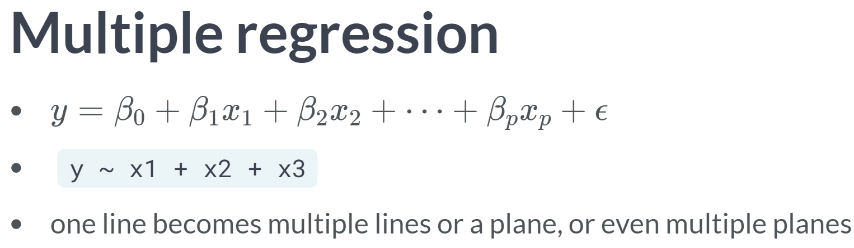As we extend the simple linear regression into multiple regression, we will add additional explanatory variables. Instead of just having x, we will have x1 and x2, even possibly even more.

The formula syntax will extend naturally, and additional coefficient will make their way into the mathematical equation. As we add complexity, the data space will increase from two to three and even more dimensions, and the class of geometric objects that we can use to describe models will broaden to include multiple lines, planes, and even multiple planes.

Unfortunately, while the mathematical and syntactic characterization will scale easily to an arbitrary number of explanatory variables, human beings are limited in our ability to visually process more than three numeric dimensions. We will get creative to push this boundary as far as we can, but we are doomed to fail.

# Syntax from math

The babies data set contains observations about the birthweight and other characteristics of children born in the San Francisco Bay area from 1960--1967.

We would like to build a model for birthweight as a function of the mother's age and whether this child was her first (parity == 0). Use the mathematical specification below to code the model in R:



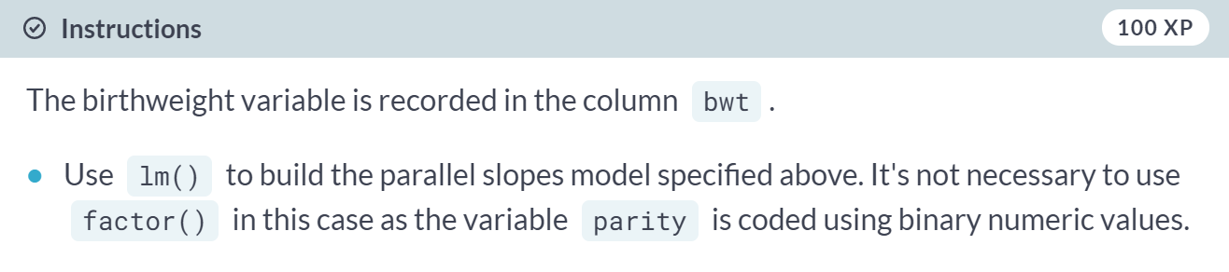  
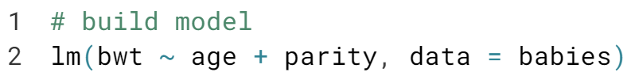

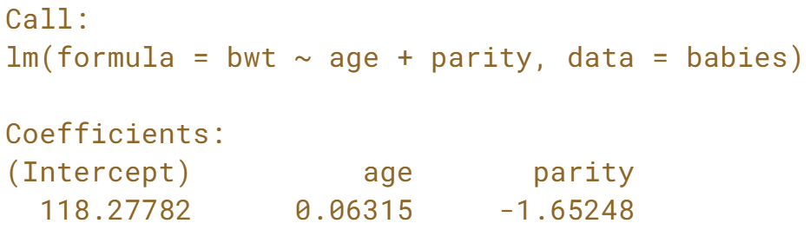  
You're parallel slopes pro! How big is the effect of parity compared to age?

# Syntax from plot

This time, we'd like to build a model for birthweight as a function of the length of gestation and the mother's smoking status. Use the plot to inform your model specification.

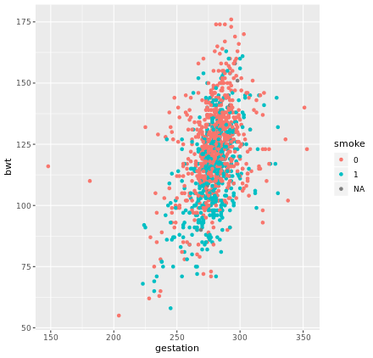  
  
  


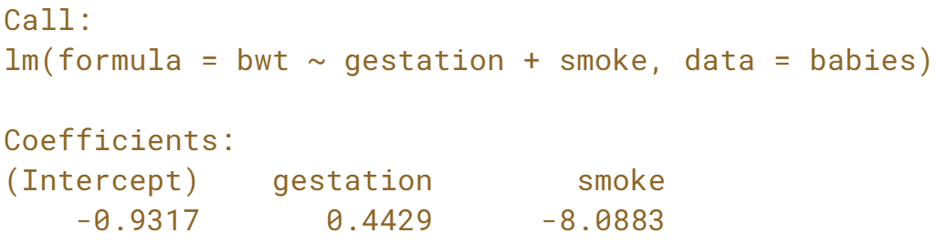

Great work! Visually examining your data is always a great place to start when you're building models.

**Evaluating and extending parallel slopes model**This chapter covers model evaluation. By looking at different properties of the model, including the adjusted R-squared, you'll learn to compare models so that you can select the best one. You'll also learn about interaction terms in linear models.



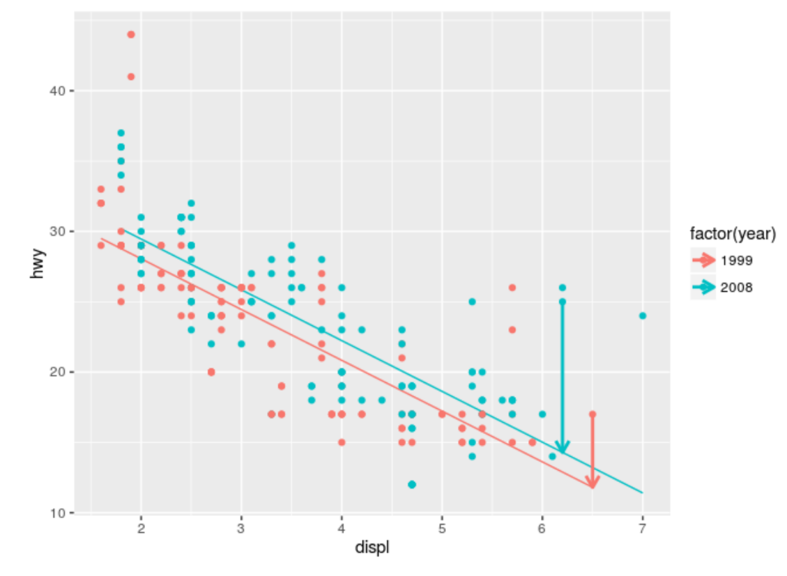

One of the most natural questions we might have about our model is: "how well does it fit?".

We measure this by computing - for each observation - the difference between the actual value of the response variable and the fitted value of from our model. This distance is called a residual.

Residuals for two observations are illustrated in this plot with vertical arrows. Just as in simple linear regression, the model fitting procedure will automatically minimize the length of those arrows across all of the points.

In a parallel slopes model, our model is represented by two lines, but only one of the lines is relevant for each observation. In the plot, the green points - each corresponding to a car made in 2008 - are compared to the green line, and the orange points - each corresponding to a car made in 1999 - are compared to orange line.

Note that this necessarily makes our parallel model more flexible than a simple linear regression model. The two lines are considered to be parallel, but we still have two instead of one.

If the best fit occurs when the two lines are very close together, then the coefficient of the categorical variable will be very small, and the parallel slope model would be very similar to the simple linear regression model.

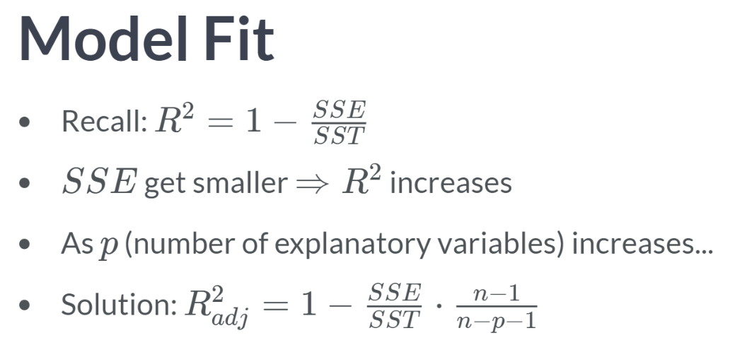  
The coefficient of determination - usually called R squared - carries over from simple linear regression. Recall that the sum of the squared residuals (or errors) is denoted SSE. If the model fits the data better, then the residuals are smaller, and the R squared value is higher.

Total sum of the squares - denoted SST - is a function of the response variable alone and doesn't depend on the model. In general, a higher R squared may be a sign of a better model fit, but the situation becomes more complicated in a multiples regression because additional explanatory variables will always increase R squared.

Thus, model fits in multiple regression are often compared using adjusted R squared value defined here. Note that only difference is that a penalty is applied as the number of explanatory variables *p* increases. Unlike R squared, adjusted R squared will not necessarily increases as new variables are added - it could go up or down.

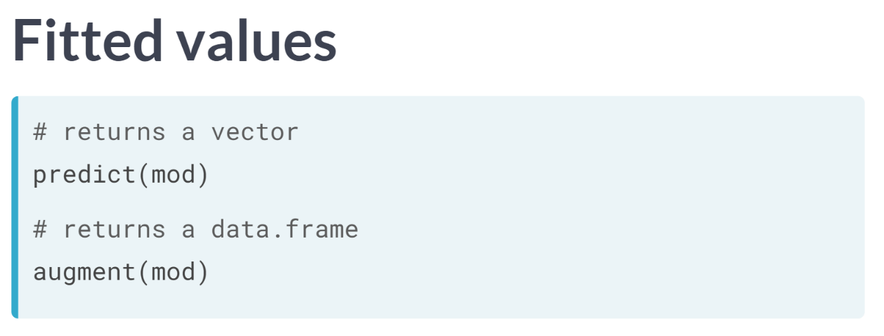  
Retrieving the fitted values produced by our model can be done in two different ways.

The ***predict()*** function will return the fitted value as a vector; while the ***augment()*** function from the broom package will return a data frame that contains the original observations, the fitted values, the residuals, and several other diagnostic computations. Since this course uses the tidyverse, we will generally prefer the latter method.

Another important bit of functionality is the ability to make out-of-sample predictions. This means using our model to make predictions about observations that weren't not part of the data set on which the model was fit.

  
For example, the instructor currently drives a 2008, Toyota matrix like the one we see here. However, this car isn't in our dataset. What does our model predict for the fuel economy of this car?

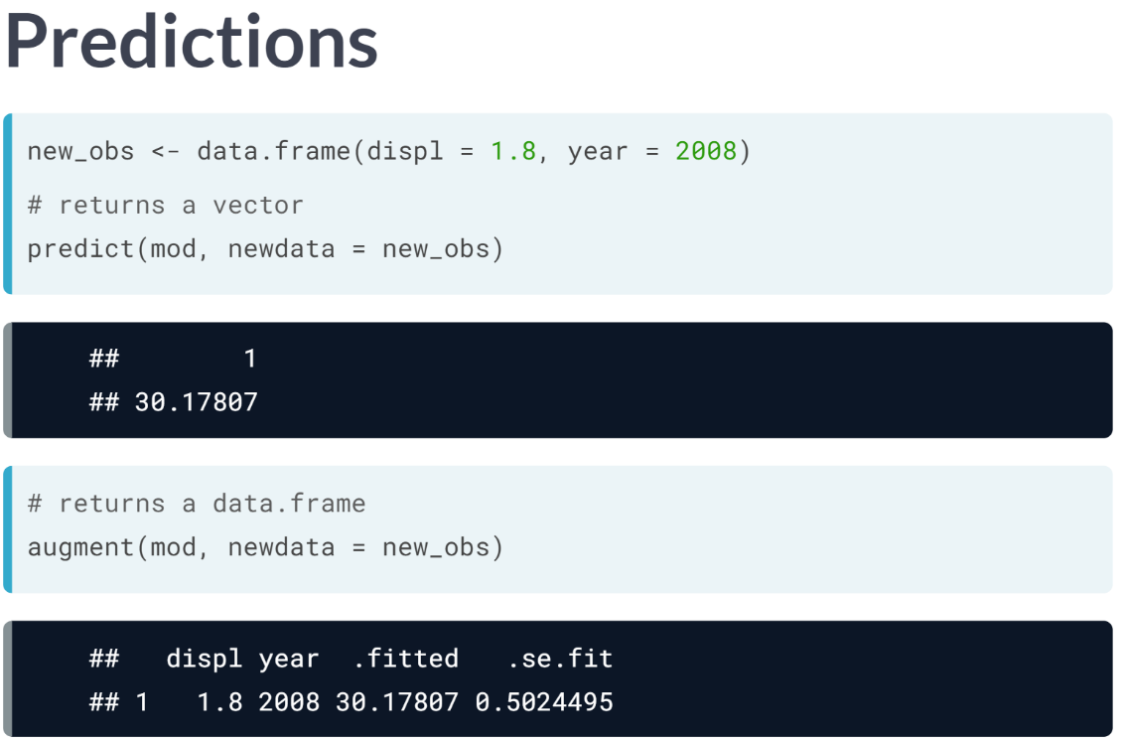  
To figure this out, we can simply input the values of the explanatory variables. In this case, his car has a 1.8-liter engine. We can create a new data frame with the information, and then feed it to ***predict()*** or ***argument()*** using the newdata argument.

Either function will return a predicted mileage of 30.18 mpg. This is slightly less than the manufacture's reported 33 mpg, giving us a residual of 2.82 mpg.

# R-squared vs. adjusted R-squared

Two common measures of how well a model fits to data are $R^{2}$  (the coefficient of determination) and the adjusted $R^{2}$ .

The former measures the percentage of the variability in the response variable that is explained by the model. To compute this, we define

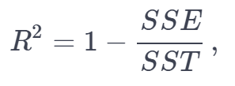

where $SSE$  and $SST$  are the sum of the squared residuals, and the total sum of the squares, respectively.

One issue with this measure is that the $SSE$  can only decrease as new variable are added to the model, while the $SST$  depends only on the response variable and therefore is not affected by changes to the model.

This means that you can increase $R^{2}$  by adding any additional variable to your model—even random noise.

The adjusted $R^{2}$  includes a term that penalizes a model for each additional explanatory variable (where $p$  is the number of explanatory variables).

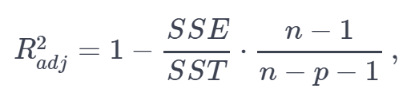

We can see both measures in the output of the summary() function on our model object.

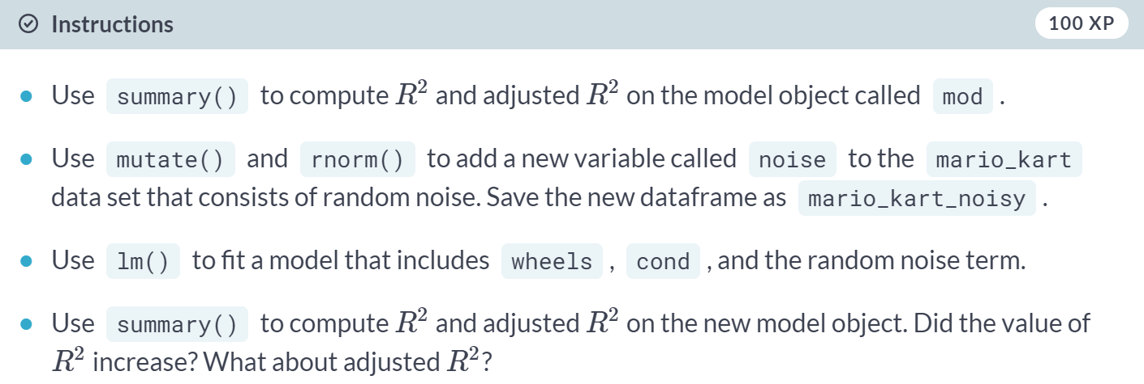

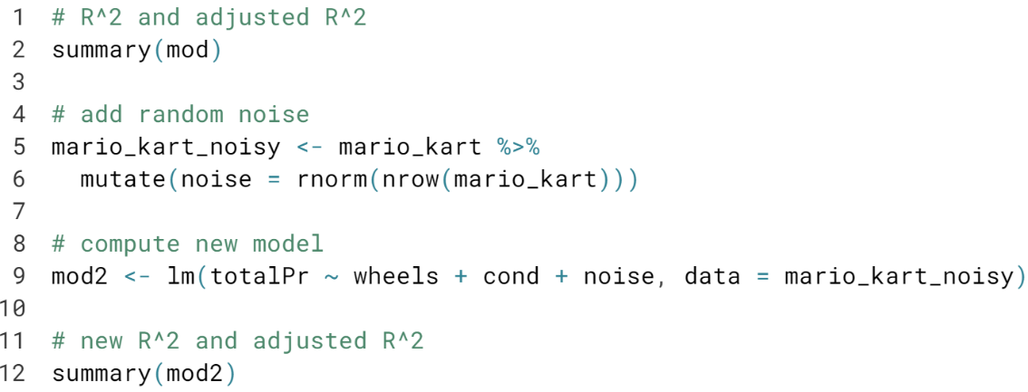

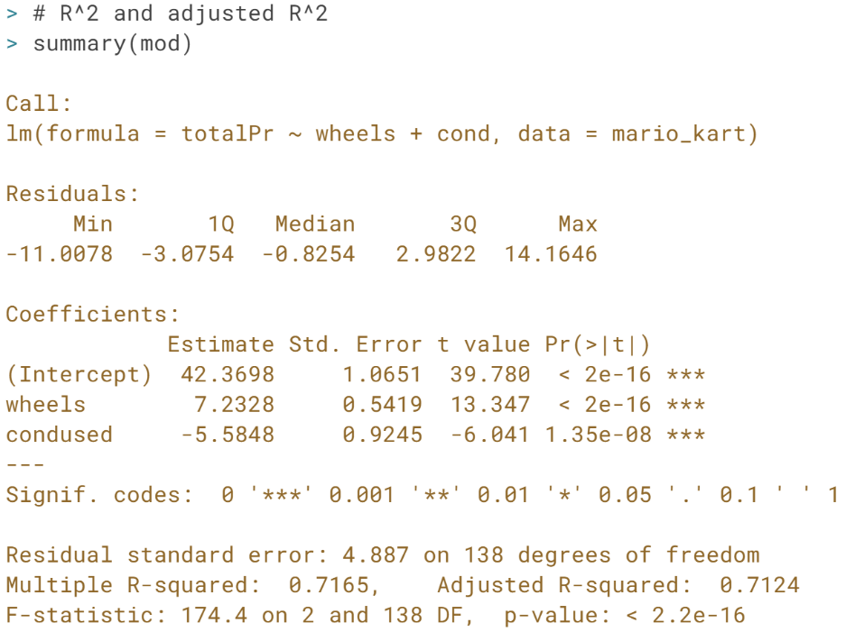

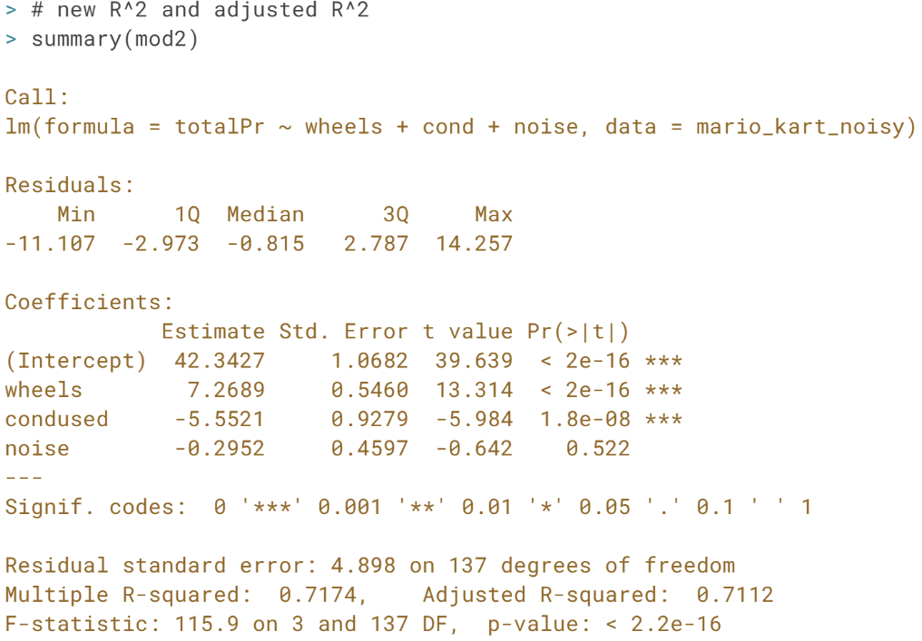  
Perfect! How did adding random noise change the value of $R^{2}$? And the adjusted $R^{2}$?

# Prediction

Once we have fit a regression model, we can use it to make predictions for unseen observations or retrieve the fitted values. Here, we explore two methods for doing the latter.

A traditional way to return the fitted values (i.e. the $\hat{y}'s$ ) is to run the predict() function on the model object. This will return a vector of the fitted values. Note that predict() will take an optional newdata argument that will allow you to make predictions for observations that are not in the original data.

A newer alternative is the augment() function from the broom package, which returns a data.frame with the response variable ($y$), the relevant explanatory variables (the $x's$), the fitted value ($\hat{y}$) and some information about the residuals ($e$). augment() will also take a newdata argument that allows you to make predictions.

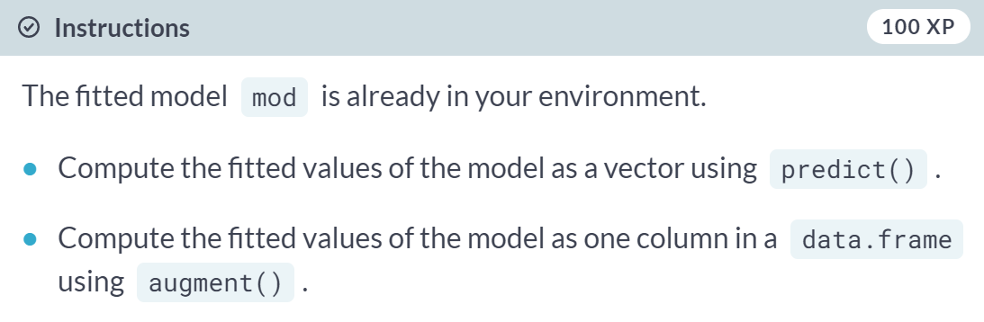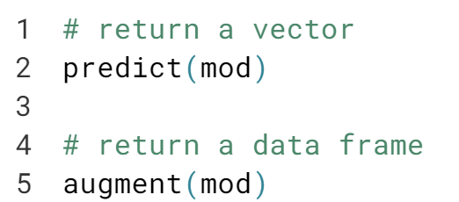

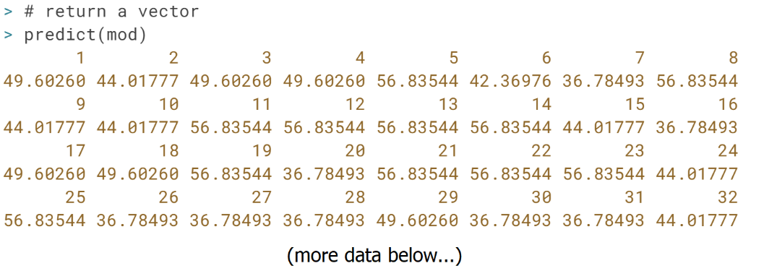  
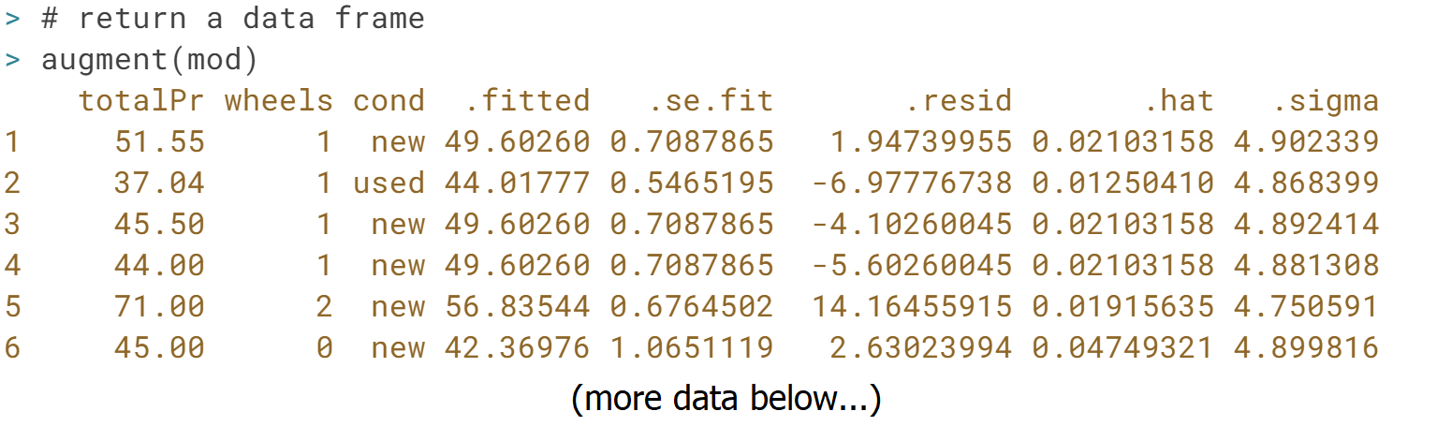

Perfect! Can you see the difference between the functions ***predict()*** and ***augment()***?



Thus far, we have considered models where the regression lines were constrained to be parallel. But what if the lines didn't have to be parallel?

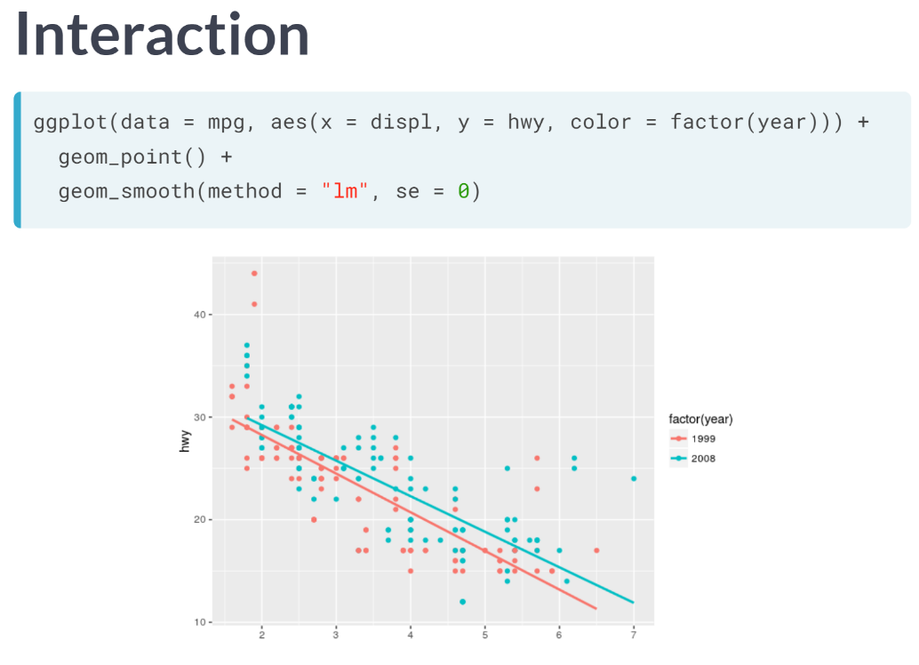  
In this plot, we illustrate the model when the lines are allowed to have their own slopes. Now, the relationship between fuel economy and engine size is not the same for the newer cars as it is for the older cars. The slope of that relationship now changes based on the year. Thus, engine size and year are allowed to "interact" in their relationship with fuel economy.

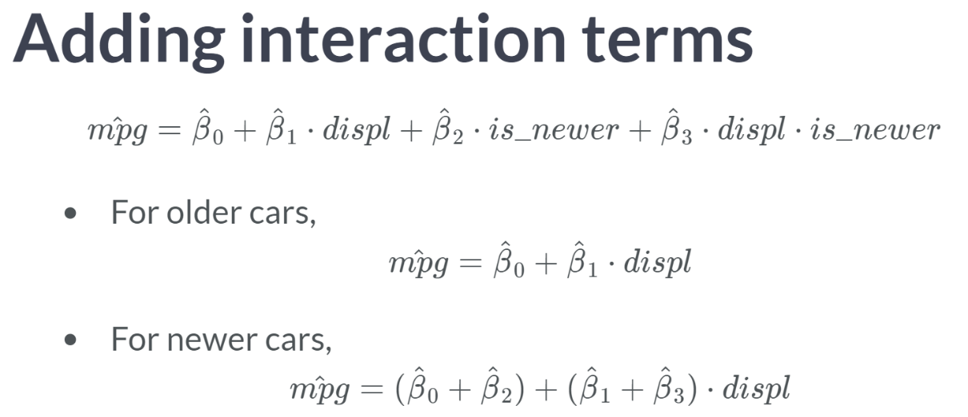

Mathematically, we achieve this by adding yet another term to our model. This third explanatory variable is the product of *displ* and *is_newer*, and it is called an interaction term.

The addition of this term results in the two regression lines shown above. Note that unlike in the previous model, now both the intercepts and the slopes are different.

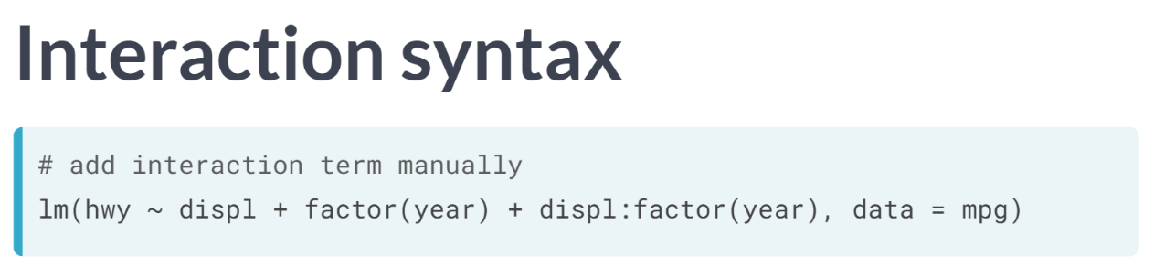

In R, we can add an interaction term using some new syntax. Here, we simply add a third term to our model, using colon to denote multiplication of the explanatory variables in the interaction term. This produces a model with four coefficients: one for the intercept, one for displacement, one for the year, and one for the interaction of displacement with year.

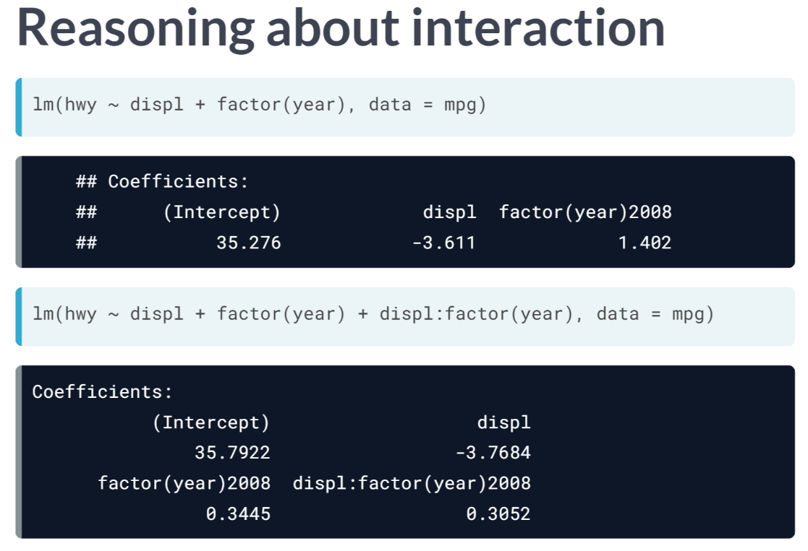  
Interpreting the coefficient in an interaction model becomes more complicated. Note the difference between the fitted coefficient of the parallel slopes model with the interaction model.

The original slope of -3.61 mpg per liter for all cars is now separated into two slopes: -3.77 mpg per liter for older cars, and -3.46 mpg per liter for newer cars. Thus, fuel economy for the older cars is not only lower overall, but it also declines more rapidly as a function of engine size.

This importantly changes the interpretation of the model. It suggests that the greater fuel economy of the 2008 cars is not just related to the fact that they had smaller engines, on average - a function mainly of consumer choice.

It suggests that the 2008 cars were also engineered better, in that they were able to maintain fuel economy slightly better even with larger engine sizes. Now, the size of the difference is small, and as the plot suggests, it doesn't appear to make a practical difference.

In this case, the difference is not statistically significant, and thus the parallel slopes model is probably a better representation of the data, but you will tackle that subtlety in another course.

# Thought experiments

Suppose that after going apple picking you have 12 apples left over. You decide to conduct an experiment to investigate how quickly they will rot under certain conditions.

You place six apples in a cool spot in your basement, and leave the other six on the window in the kitchen. Every week, you estimate the percentage of the surface area of the apple that is rotten or moldy.

Consider the following models:

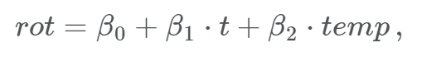

and



Where $t$ is time, measured in weeks, and $temp$  is a binary variable indicating either cool or warm.

If you decide to keep the interaction term present in the second model, you are implicitly assuming that:



# Fitting a model with interaction

Including an interaction term in a model is easy—we just have to tell lm() that we want to include that new variable. An expression of the form

lm(y ~ x + z + x:z, data = mydata)

will do the trick. The use of the colon (:) here means that the interaction between $x$ and $y$  will be a third term in the model.





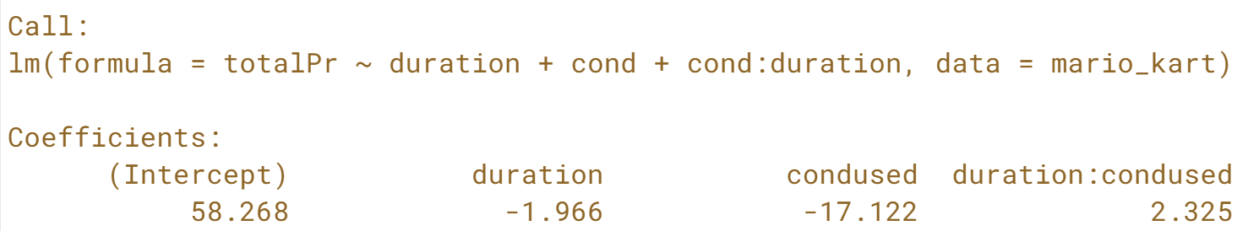

Great work! How does adding an interaction term affect the other coefficients in the model?

# Visualizing interaction models

Interaction allows the slope of the regression line in each group to vary. In this case, this means that the relationship between the final price and the length of the auction is moderated by the condition of each item.

Interaction models are easy to visualize in the data space with ggplot2 because they have the same coefficients as if the models were fit independently to each group defined by the level of the categorical variable. In this case, new and used MarioKarts each get their own regression line. To see this, we can set an aesthetic (e.g. color) to the categorical variable, and then add a geom_smooth() layer to overlay the regression line for each color.

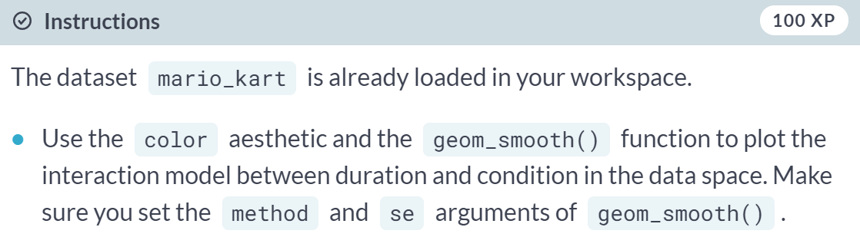

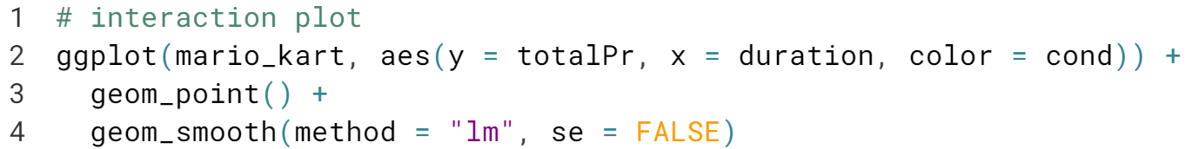

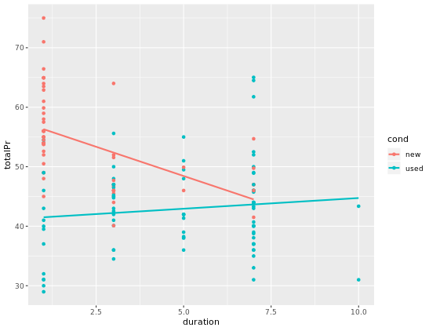  
Great work! How does the interaction model differ from the parallel slopes model?



It seems reasonable to think that by paying their teachers a high salary, schools could attract better teachers, which would lead to better student outcomes.

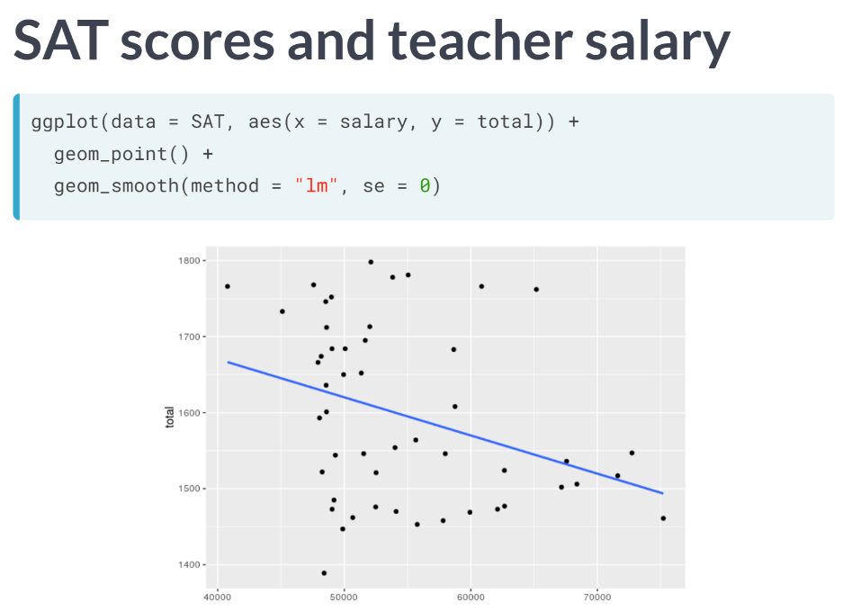  
Yet if we fit a simple linear regression model for the average SAT score among students as a function of average teacher salary across all US states, we see a negative slope. This suggests that states that pay higher teacher salaries - on average - are associated with lower student performance on the SAT. What gives?

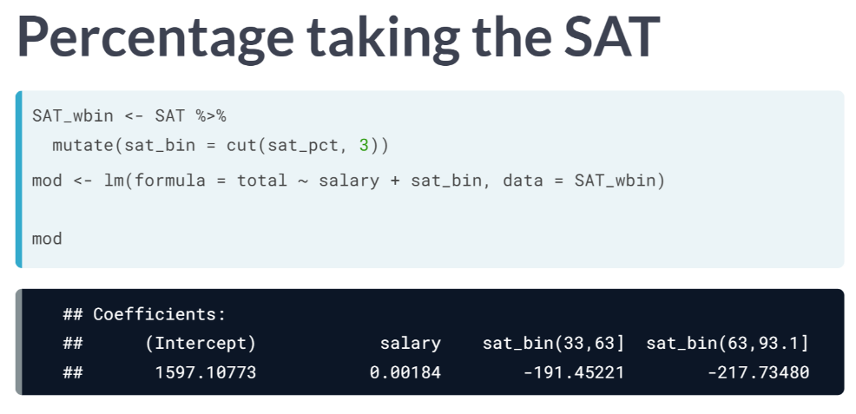  
It turns out that the rate at which students take the SAT has a moderating effect on this relationship. Consider how things change when we add a categorical variable to make this a parallel slopes model. In this case, we want to separate states into three groups based on how many of their students take the SAT.

First, we use the ***cut()*** function to add a new *sat_bin* variable to our data frame. Then, we fit the parallel slopes model. Note that in this case, the categorical variable *set_bin* is not binary - it has three levels. This results in another coefficient. How many lines do you think we will see in this plot?

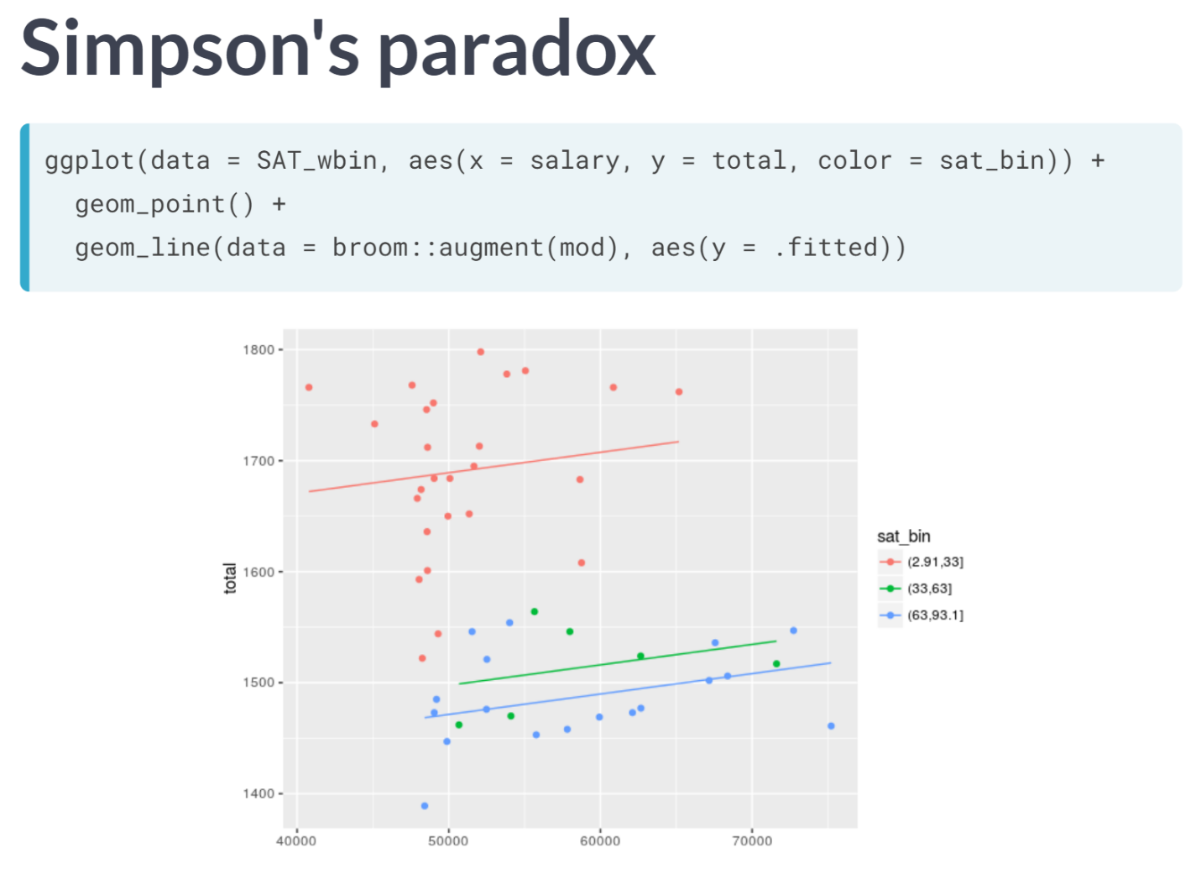If you guessed three, you are correct. But, now all three lines have a positive slope!

This phenomenon is known as **Simpson's paradox**, and it occurs widely in the social and natural sciences. When Simpson's paradox is present, the direction of the relationship between two variables changes if subgroups are considered.

Although the *y* variable may be positively associated with *x* within multiple groups, it may be the case that *y* is negatively associated with *x* when those groups are ignored.

When Simpson's paradox occurs, the group membership is an important confounder that must be controlled for in order to build an appropriate model.

# Consequences of Simpson's paradox

In the simple linear regression model for average SAT score, (total) as a function of average teacher salary (salary), the fitted coefficient was -5.02 points per thousand dollars. This suggests that for every additional thousand dollars of salary for teachers in a particular state, the expected SAT score for a student from that state is about 5 points lower.

In the model that includes the percentage of students taking the SAT, the coefficient on salary becomes 1.84 points per thousand dollars. Choose the correct interpretation of this slope coefficient.



# Simpson's paradox in action

A mild version of [**Simpson's paradox**](https://en.wikipedia.org/wiki/Simpson%27s_paradox) can be observed in the MarioKart auction data. Consider the relationship between the final auction price and the length of the auction. It seems reasonable to assume that longer auctions would result in higher prices, since—other things being equal—a longer auction gives more bidders more time to see the auction and bid on the item.

However, a simple linear regression model reveals the opposite: longer auctions are associated with lower final prices. The problem is that all other things are not equal. In this case, the new MarioKarts—which people pay a premium for—were mostly sold in one-day auctions, while a plurality of the used MarioKarts were sold in the standard seven-day auctions.

Our simple linear regression model is misleading, in that it suggests a negative relationship between final auction price and duration. However, for the used MarioKarts, the relationship is positive.

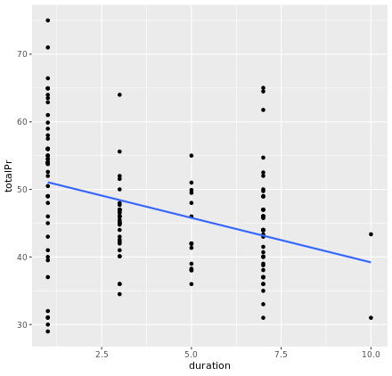

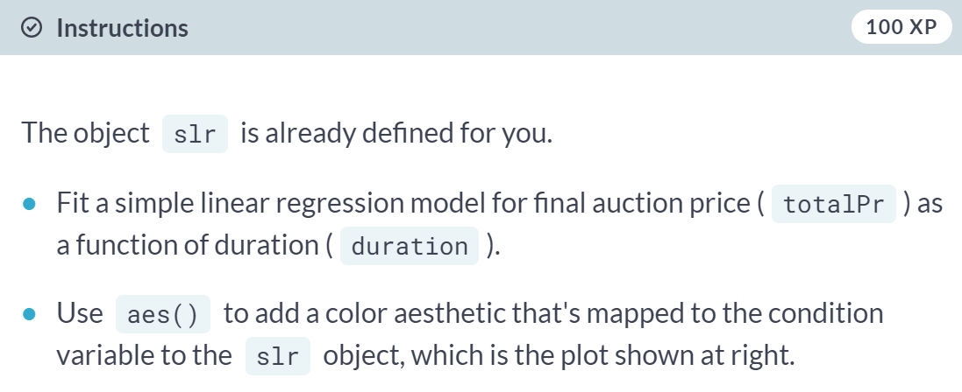

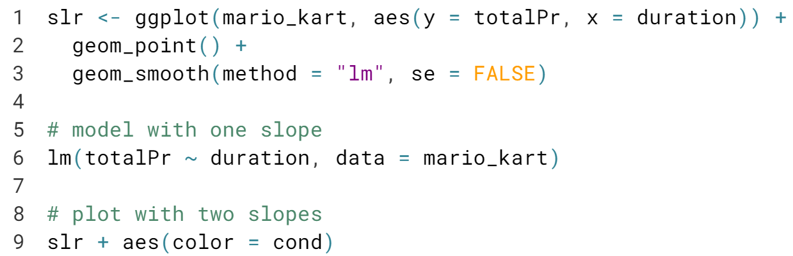

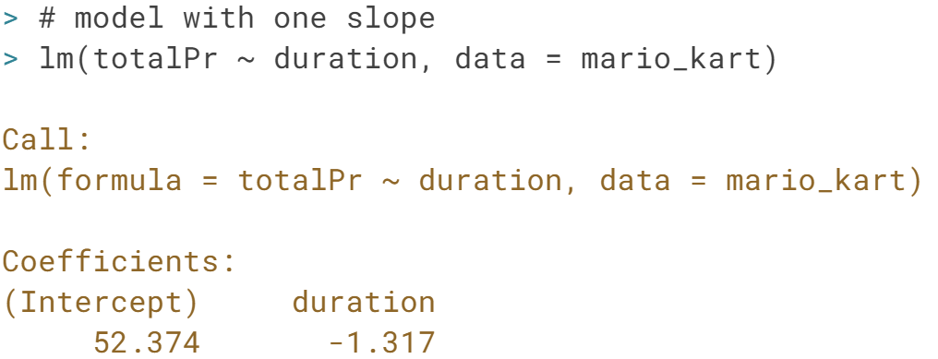

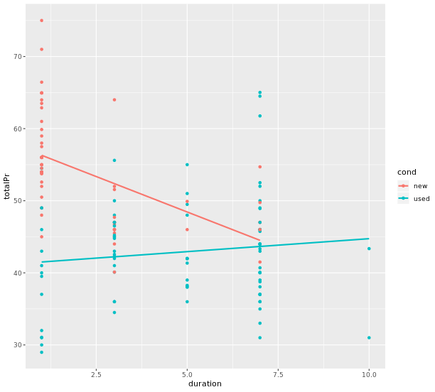  
Great work! Which of the two groups is showing signs of Simpson's paradox?

**Multiple Regression**This chapter will show you how to add two, three, and even more numeric explanatory variables to a linear model.



Thus far, we've only considered multiple regression models with one numeric explanatory variable. In this chapter, we will explore models that have at least two numeric explanatory variables.

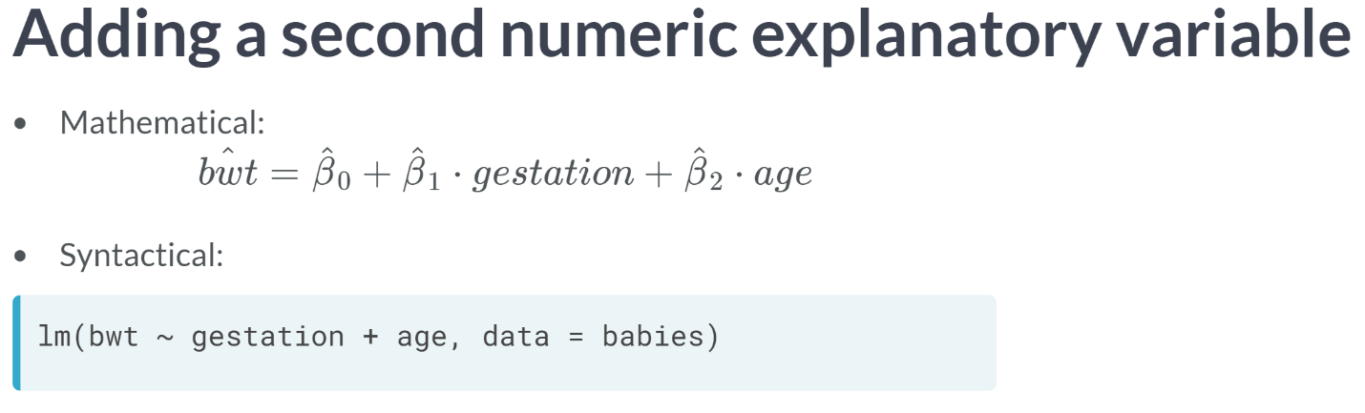

Mathematically, adding a second numeric explanatory variable is trivial - we just add another term to our model. In this example, we are modeling the birthweight of babies born in San Francisco as a function of their pregnancy's length of gestation (in weeks) and the mother's age (in years). Note that both gestation and age are numeric variables here, so this is not a parallel slopes model.

The syntax for fitting this model in R is similarly trivial - we simply extend the formula to incorporate both the gestation and age variables, just as we did before. Note also that since age is not categorical, we don't have to worry about using the factor() function, or converting a categorical variable into binary variables, like we had to with year and is_newer.

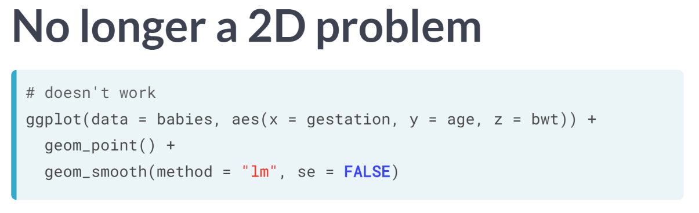  
Unfortunately, while the mathematically and syntactical formulations of multiple regression models are easy extensions of things we already know, a visual formation of these models becomes much trickier.

We might be tempted to visualize our model using a *ggplot* expression like this. But unfortunately, that will not work, because ggplot only handles 2D graphics, and thus there is no *z* aesthetic.

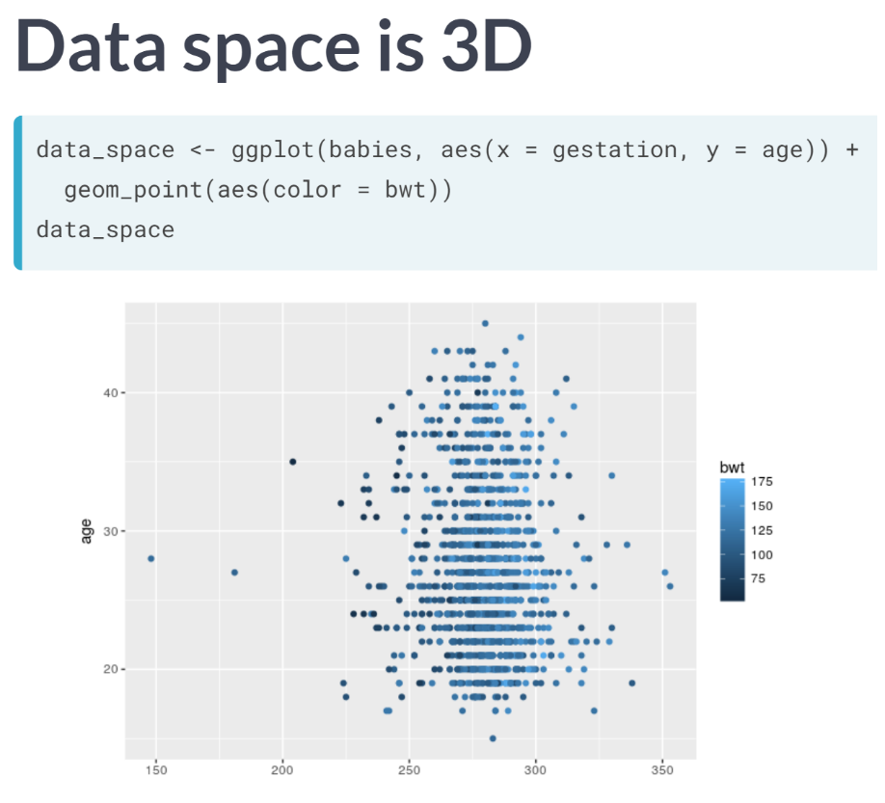  
Our data space is now three dimensional, because bwt, gestation and age are all numeric variables that our model encapsulates. So, we will need to get a little bit creative in order to create a meaningful visualization of our model. One way to visualize a 3D model is to tile the plane. That is, we will create a 2D plot that covers all combinations of our two explanatory variable, and we will use color to reflect the corresponding fitted values.

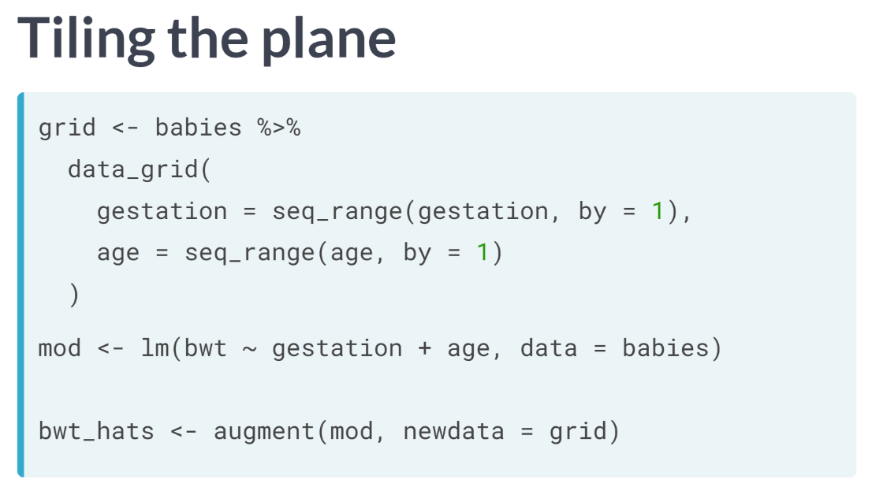  
Here, we created the grid of values using the ***data_grid()*** function, and then fed those into our model using the ***augment()*** function with the new data argument. These two steps create a data frame of all possible combinations of gestation and age values, along with the model prediction for each.

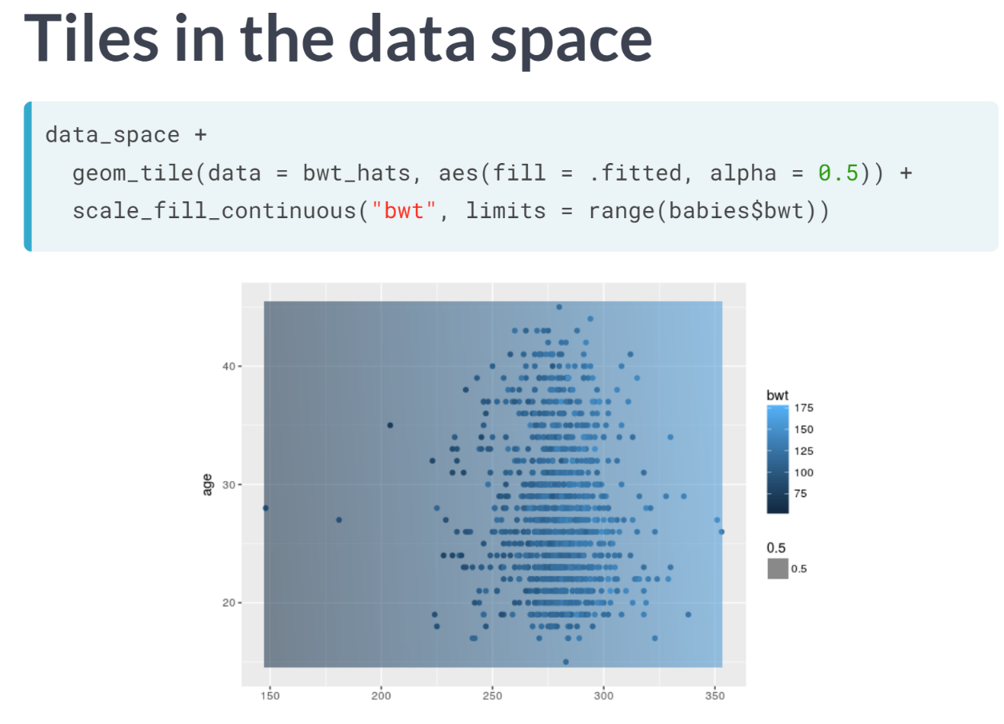  
We then use the ***geom_tile()*** function to superimpose these values on our data space.

Setting the *alpha* argument to 0.5 allows us to see both the actual observation as points and the model predictions as a smooth surface.

Note how the color of the tiles lighten as we get closer to the upper right corner.

This reflects that the model predicts heavier babies for older mothers with longer gestational periods.

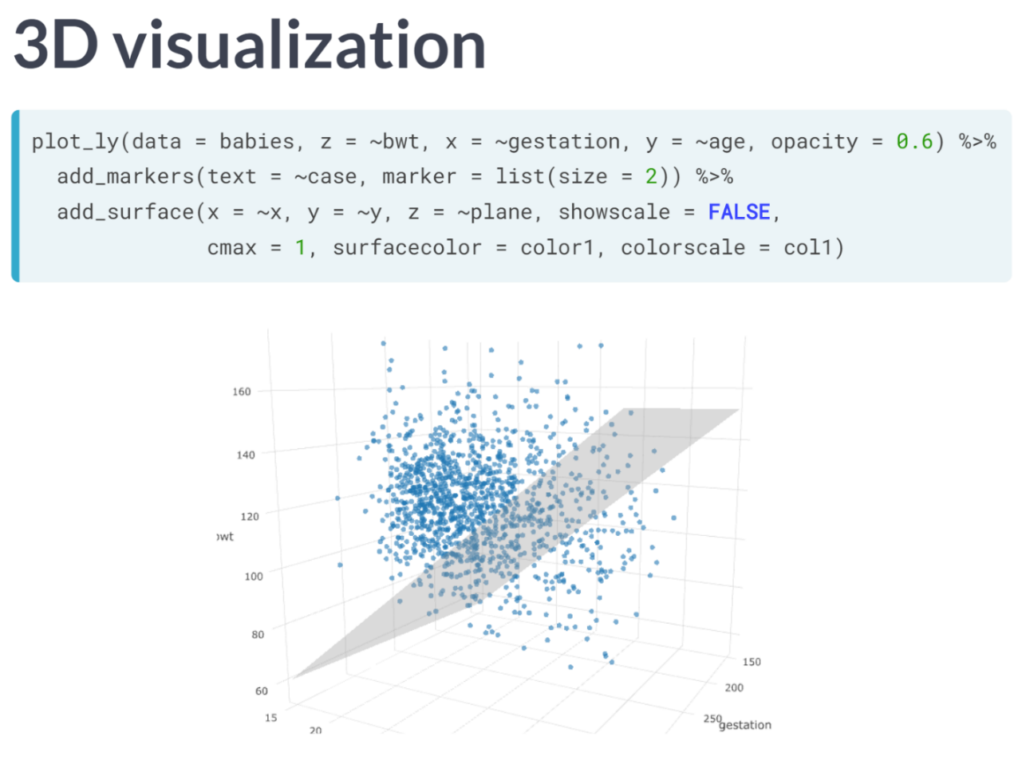  
A perhaps more natural way to visualize a multiple regression model is as a plane through a cloud of points in three dimensions.

Here, we use the *plotly* package to illustrate our model for the birthweight of babies.

Note how the plane cuts through the data points. The residual associated with each observation is the vertical distance between that point and the plane.

Believe it or not, this plane is the one that uniquely minimizes the sum of the squared residuals between itself and these data points.

The ***plot_ly()*** syntax is similar to that of ggplot. In this case, the ***add_markers()*** function draws the points, while the ***add_surface()*** function draws the plane.

The *x*, *y*, and *plane* objects were created in code that we aren't showing here due to its complexity.

# Fitting a MLR model

In terms of the R code, fitting a multiple linear regression model is easy: simply add variables to the model formula you specify in the lm() command.

In a parallel slopes model, we had two explanatory variables: one was numeric, and one was categorical. Here, we will allow both explanatory variables to be numeric.





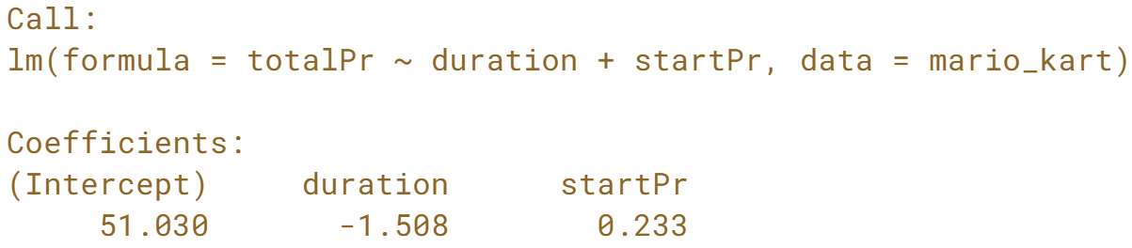

Awesome work! Using R to fit multiple regression models is just as simple as fitting simpler models.

# Tiling the plane

One method for visualizing a multiple linear regression model is to create a [**heatmap**](https://en.wikipedia.org/wiki/Heat_map) of the fitted values in the plane defined by the two explanatory variables. This heatmap will illustrate how the model output changes over different combinations of the explanatory variables.

This is a multistep process:

* First, create a grid of the possible pairs of values of the explanatory variables. The grid should be over the actual range of the data present in each variable. We've done this for you and stored the result as a data frame called grid.
* Use augment() with the newdata argument to find the $\hat{y}$ ’s corresponding to the values in grid.
* Add these to the data_space plot by using the fill aesthetic and geom_tile().

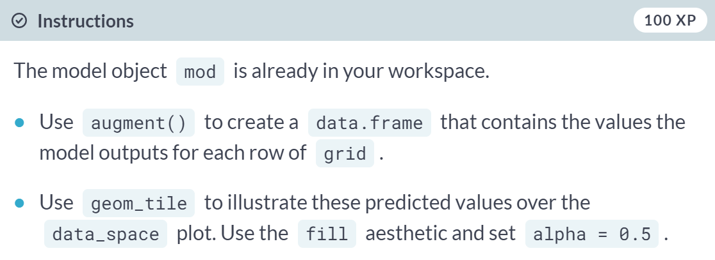

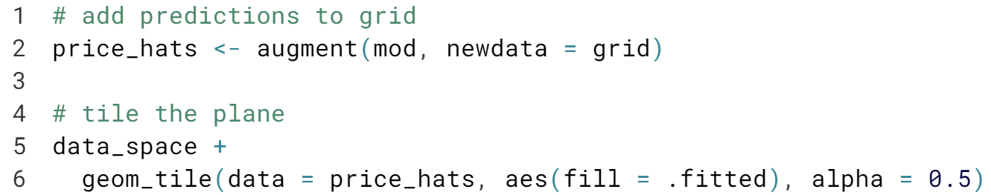  
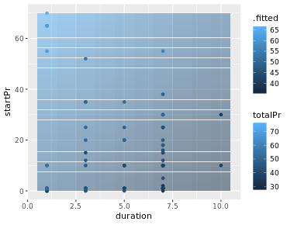

# Models in 3D

An alternative way to visualize a multiple regression model with two numeric explanatory variables is as a plane in three dimensions. This is possible in R using the plotly package.

We have created three objects that you will need:

* x: a vector of unique values of duration
* y: a vector of unique values of startPr
* plane: a matrix of the fitted values across all combinations of x and y

Much like ggplot(), the plot_ly() function will allow you to create a plot object with variables mapped to x, y, and z aesthetics. The add_markers() function is similar to geom_point() in that it allows you to add points to your 3D plot.

Note that plot_ly uses the pipe (%>%) operator to chain commands together.

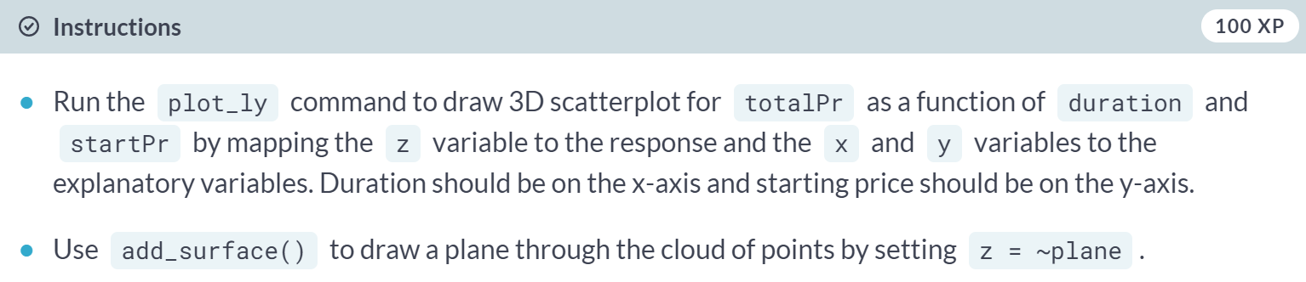

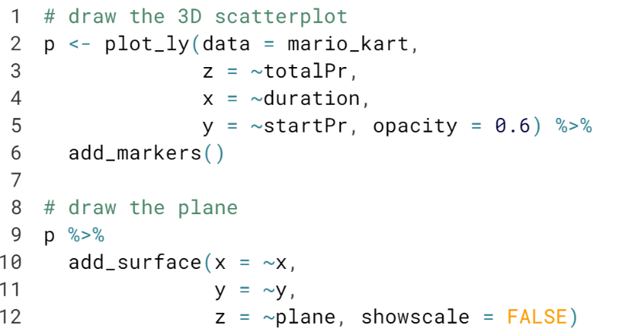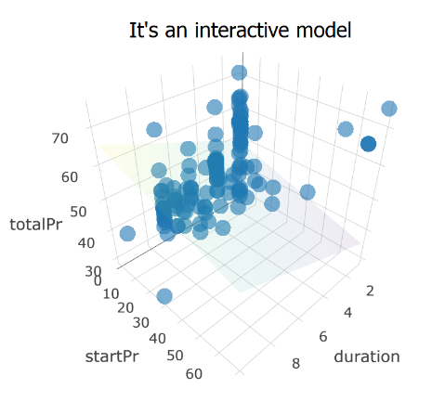

What a plot! You've added a whole new dimension to regression!



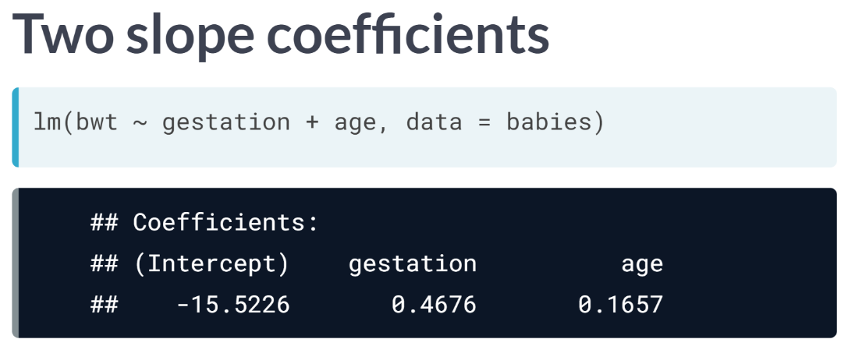  
What do coefficients in a linear regression model mean? Consider the fitted coefficients for our model for the birthweight of babies shown above. Since both of our explanatory variables are numeric, the coefficients of both gestation and age represent slopes.

But slopes of what? A line certainly can't have two slopes, but as we saw previously, our model is not a line: it is a plane. And a plane can have two slopes. Note that in this case, both slopes are positive, but have different magnitudes.

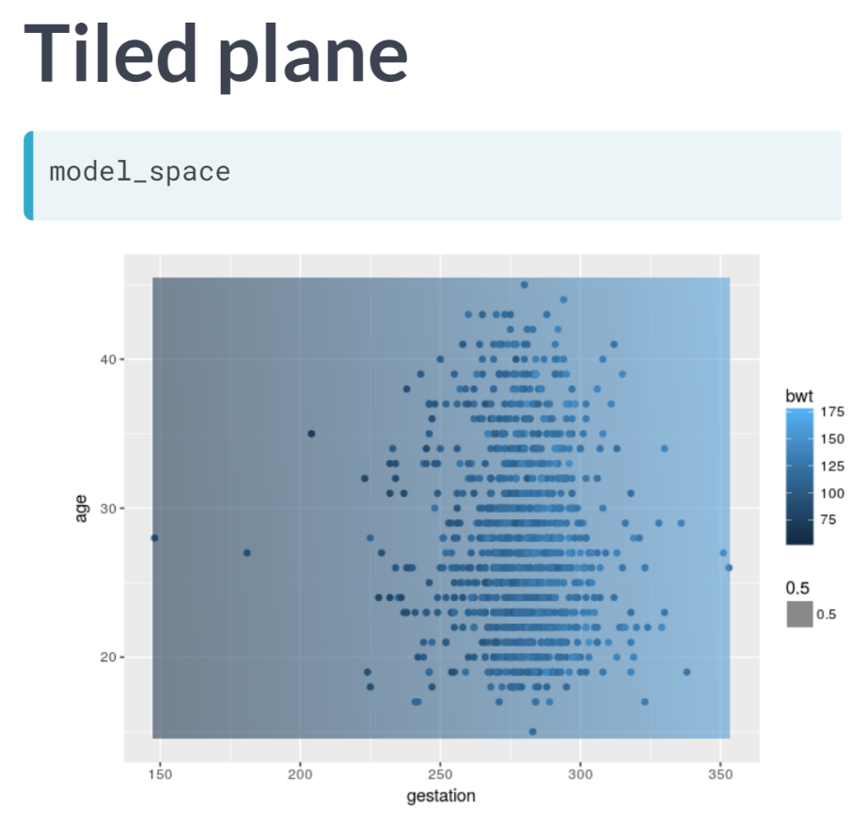  
When we depicted our models as a tilted surface in the plane, we noticed that the color of the tiles got lighter and blue as we moved towards the upper right-hand corner of the plot. This reflects that fact that our model predicts higher birthweights for babies with longer gestational periods born to older mothers.

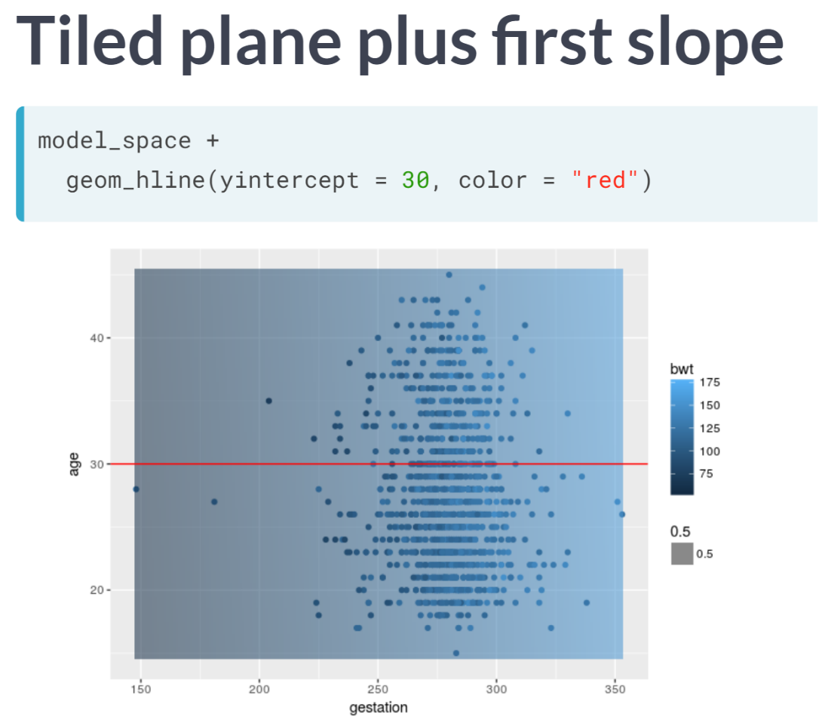  
But at what rate does this color change?

For a 30 y/o mother, the increase in expected birthweight is 0.47 oz/day, and this can be viewed on the plot as the rate of color change as we move horizontally through the plot along a straight line. It is in this sense that the coefficient of gestation is a slope. However, this rate of changes is constant across mothers of all ages.

It doesn't matter whether you are 20, 30, or 40. While the expected birthweight does depend on the mother's age, the rate of change in birthweight with respect to gestational length does not depend on the mother's age. Thus, the coefficient of 0.47 oz/day on gestation reflects the slope of the plane for a fixed value of age. And since this slope doesn't change with respect to age, we often say that it reflects the effect of gestational length upon birthweight, while holding age constant.

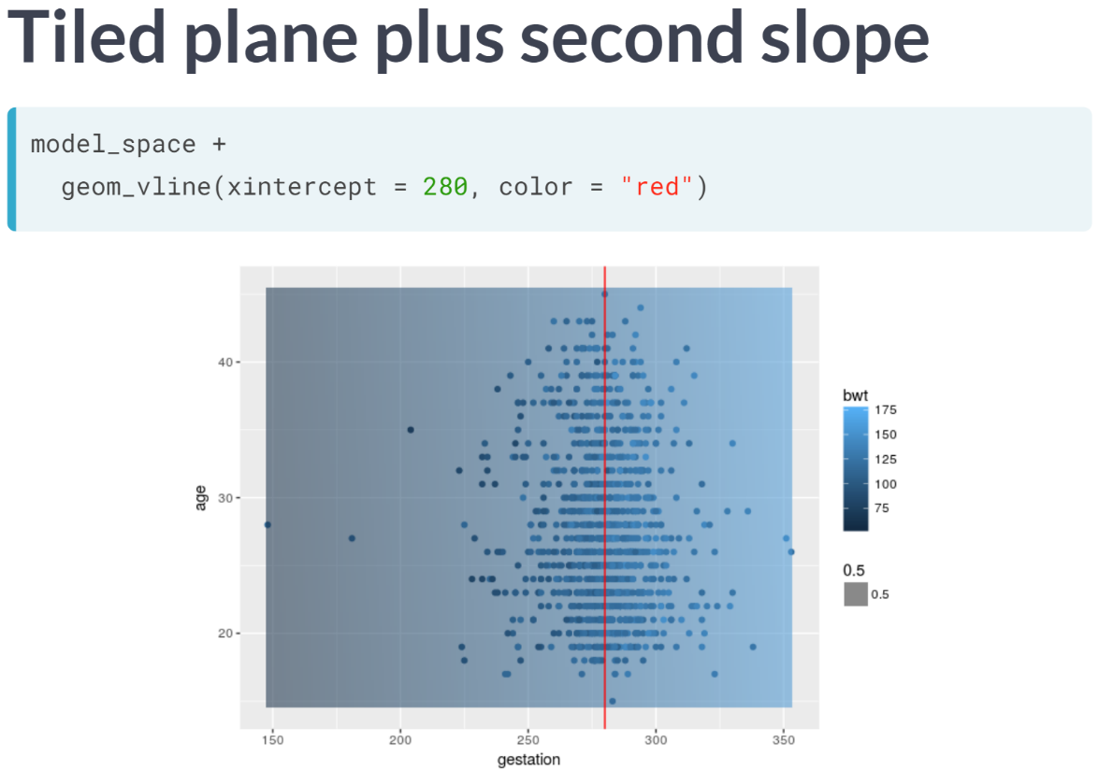  
Similarly, at the typical gestational length of 40 weeks (or 280 days), the expected birthweight increases at a rate of 0.17 ounces per year of the mother's age. That is, our model predicts that the birthweight of a 36 y/o mother is about 1/6 of an ounce heavier than the birthweight of a 35 y/o mother, when both members carry full term.

But again, that rate of change is the same irrespective of the gestational length, so we would expect the same difference for babies born at 35 weeks, 40 weeks, and 42 weeks.

So, the coefficient of 0.17 ounces per year is the slope of the plane for a fixed length of gestation. Again, since this slope is the same for all gestational lengths, we can interpret this coefficient as the effect of the mother's age on birthweight, while holding gestational length constant.

It's also apparent from the plot that the colors change more rapidly as you move horizontally as opposed to vertically.

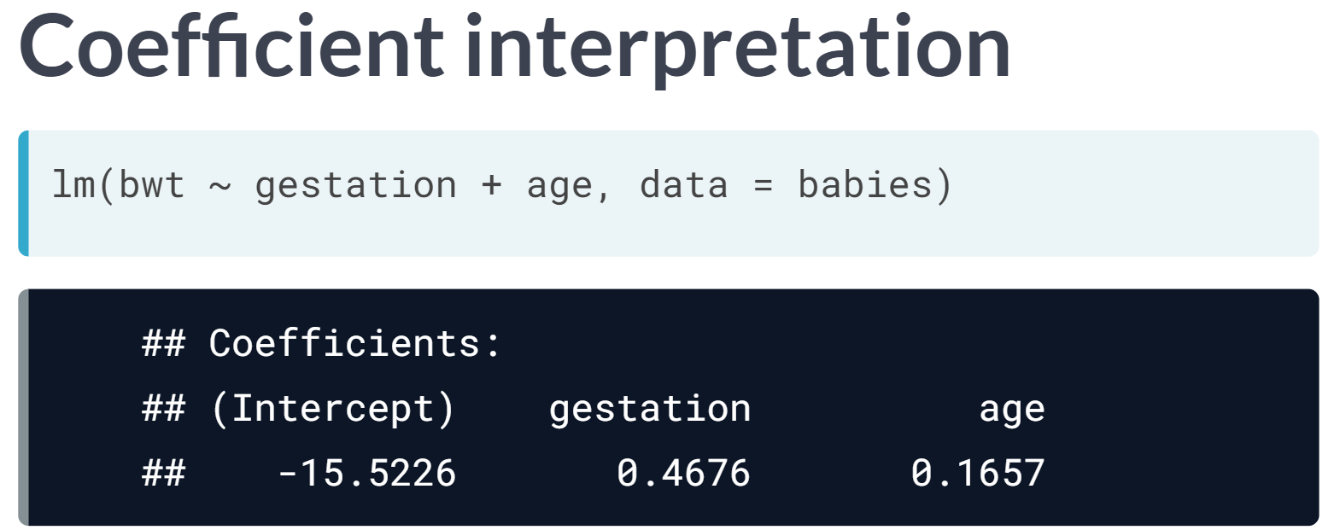  
This reflects the fact that the coefficient on gestation is bigger than the coefficient on age. Now we might be tempted to think that bigger coefficients are always more important, but this isn't true.

The value of coefficient depends on the units of the explanatory variables. In this case, one variable is in the units of days (of gestational length), while the other is in the unit of years (of mother's age). They aren't directly comparable.

When you interpret coefficient from a multiple regression model, be sure to always include a phrase to the effect of "holding x constant". Another good alternative is "after controlling for x". This information is crucial to having a valid understanding of a regression model.

# Coefficient magnitude

The coefficients from our model for the total auction price of MarioKarts as a function of auction duration and starting price are shown below.

Call:

lm(formula = totalPr ~ duration + startPr, data = mario_kart)

Coefficients:

(Intercept) duration startPr

51.030 -1.508 0.233

A colleague claims that these results imply that the duration of the auction is a more important determinant of final price than starting price, because the coefficient is larger. This interpretation is false because:



A and D are wrong because sign does not matter.

B is wrong because it depends on the units.

# Practicing interpretation

Fit a multiple regression model for the total auction price of an item in the mario_kart data set as a function of the starting price and the duration of the auction. Compute the coefficients and choose the correct interpretation of the duration variable.

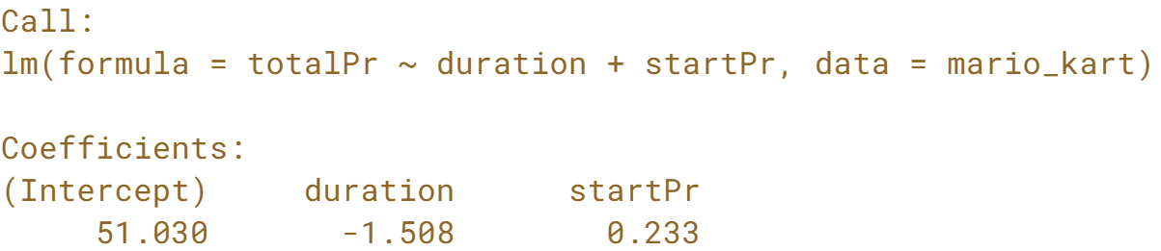

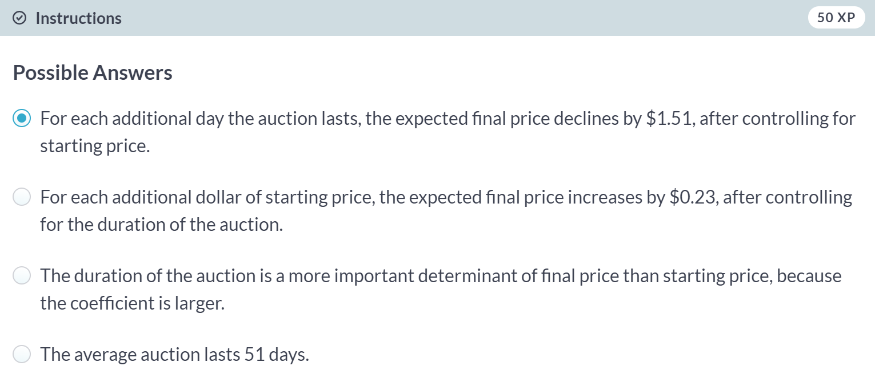

Statement B is true, but refers to the other variable.



No study of birthweight is complete without some discussion on the effect of smoking, which is known to have all kinds of undesirable health consequences.

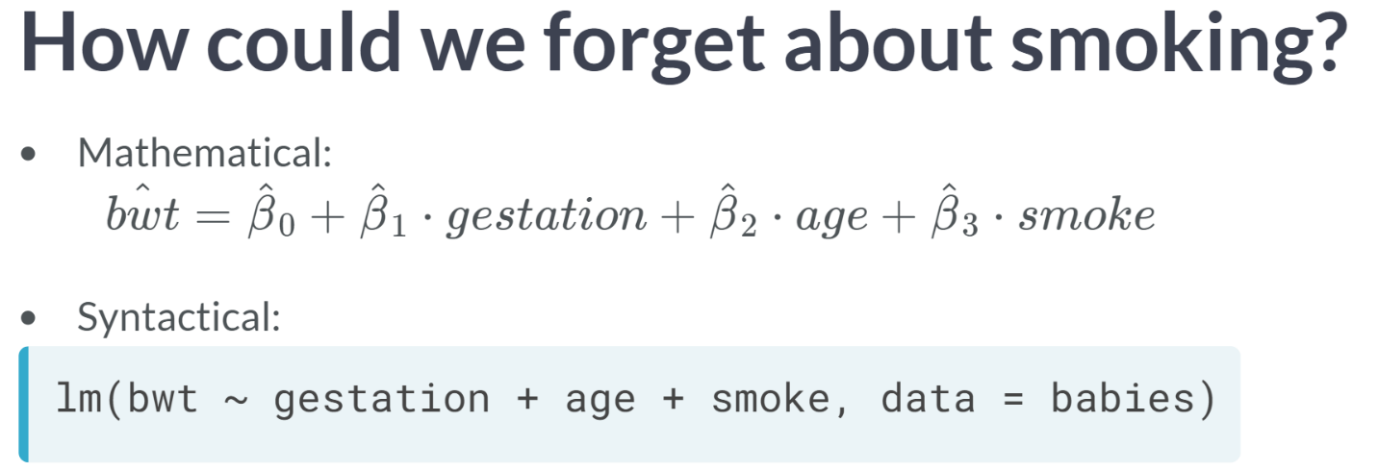

Mother's in the baby’s data set have their smoking status recorded as a binary variable: either she was or was not a smoker. Adding this third explanatory variable to our model is again easy. Since this variable is encoded as 0 or 1, no transformation is necessary, and we can simply add another term to the mathematical model and the formula syntax to specify our new model.

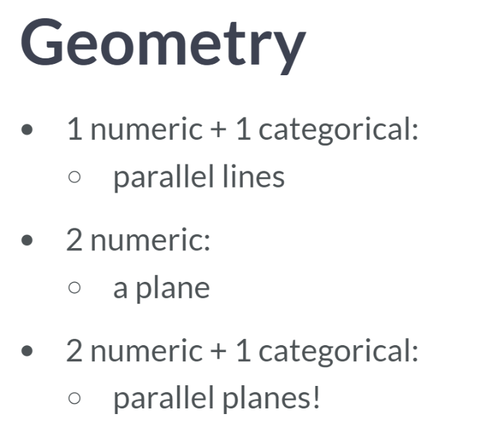But here again, the geometric changes aren't as easy to see. However, our emphasis on the geometry of these models should give us some intuition.

Recall that the addition of a categorical explanatory variable to a numeric explanatory variable changed to a line into parallel lines. Moreover, a model with two numeric explanatory variables was a plane.

Can you guess how the addition of a categorical explanatory variable will change the geometry of a model with two numeric explanatory variables? If you guess parallel planes, you're right.

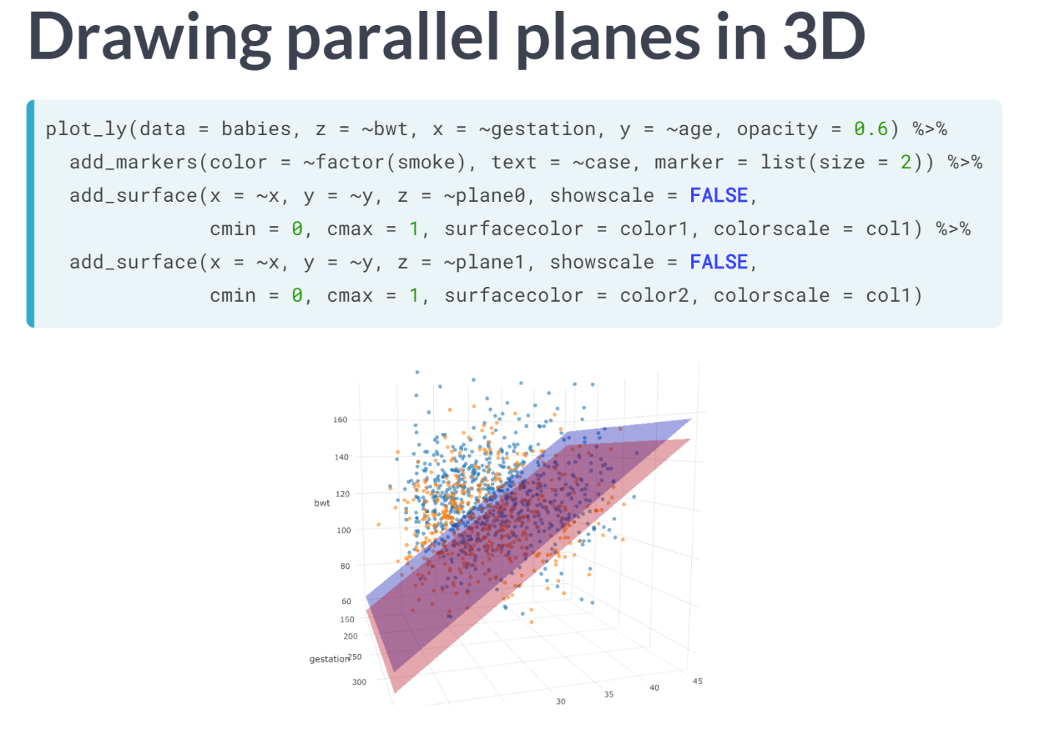  
Once again, we can use plotly to create a 3D image of our model in the data space. Here we have used the ***add_surface()*** function twice: once to add a plane for non-smokers, and again to add another plane for smokers.

The plane on "top" is the one for non-smokers - can you think of why this might be the case? We'll return to this question in a minute.

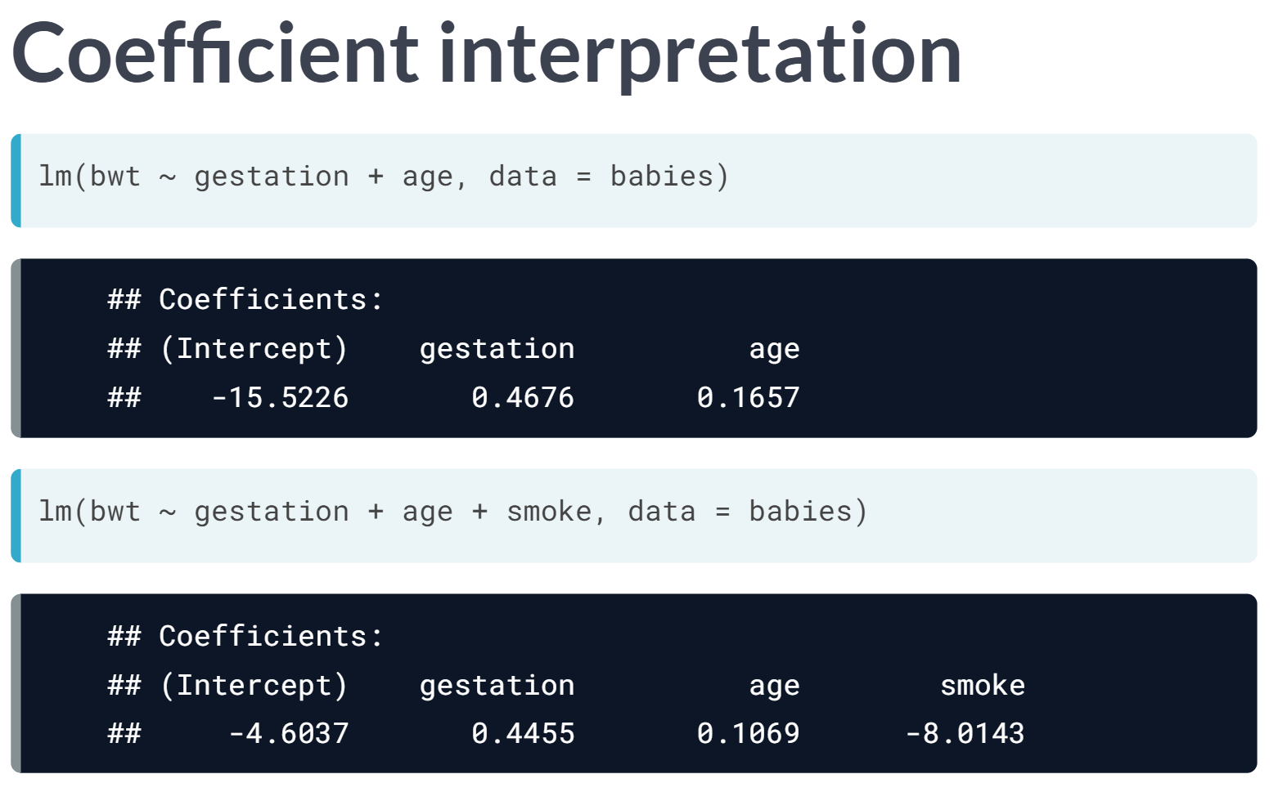The interpretations that we developed previously still hold - we just need to think carefully about how they apply to our new model. The coefficients on gestations and age still reflect slopes. And since the planes are parallel, both slopes are the same in both planes. The coefficient on smoke is the distance between the two planes, and this distance is constant across all possible values of gestation and age.

In this sense, we are modeling the effect of smoking as being the same regardless of gestational length and the mother's age. However, we have estimated that the size of that effect in the context of gestational length and the mother's age. The coefficient of gestation is 0.45 oz per day, which is only slightly less than it was in our previous model that did not consider smoking. Our interpretation is that each additional day of gestation was associated with an increase in expected birthweight of 0.45 oz, after controlling for the mother's age and smoking status.

Each additional year of the mother's age was associated with an increase in expected birthweight of just 0.11 oz per year, after controlling for gestational length and the mother's smoking status. Note that the effect of the mother's age on birthweight appears lower than in the previous model. Let's focus now on the effects of smoking.

The coefficient on smoke is -8.01 ounces. Thus, our model predicts that mothers who smoke will deliver babies that weigh 8 ounces less, on average, than mothers of the same age and gestational length who don't smoke. That is, the negative effect of smoking on expected birthweight is 8 ounces (or half a pound) after controlling for gestational length and the mother's age. This is a huge effect compared to the influence of the other two variables we have considered.

# Visualizing parallel planes

By including the duration, starting price, and condition variables in our model, we now have two explanatory variables and one categorical variable. Our model now takes the geometric form of two parallel planes!

The first plane corresponds to the model output when the condition of the item is new, while the second plane corresponds to the model output when the condition of the item is used.

The planes have the same slopes along both the duration and starting price axes—it is the $z$ -intercept that is different.

Once again, we have stored the x and y vectors for you. Since we now have two planes, there are matrix objects plane0 and plane1 stored for you as well.

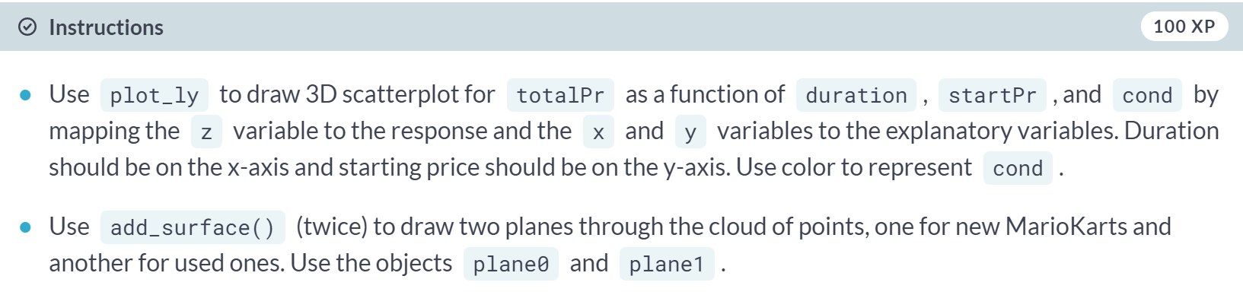

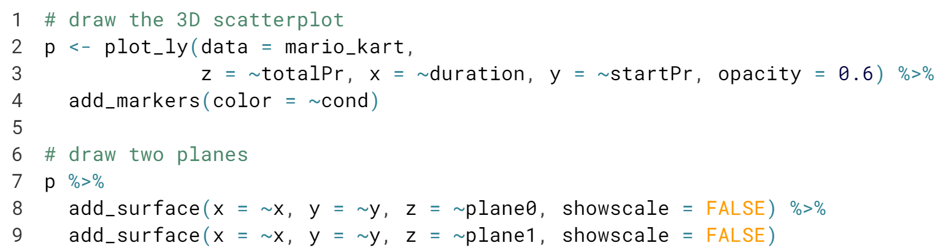

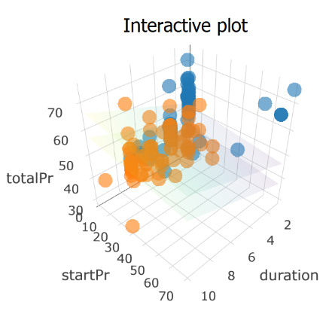  
Awesome! A parallel planes model is about as complicated a model as we're able to visualize.

# Parallel plane interpretation

The coefficients from our parallel planes model is shown below.

Call:

lm(formula = totalPr ~ duration + startPr + cond, data = mario_kart)

Coefficients:

(Intercept) duration startPr condUsed

53.3448 -0.6560 0.1982 -8.9493

Choose the right interpretation of $β_{3}$  (the coefficient on condUsed):





By now, we may have caught on to the fact that there are no mathematical or syntactical hurdles to adding more variables to a multiple regression model.

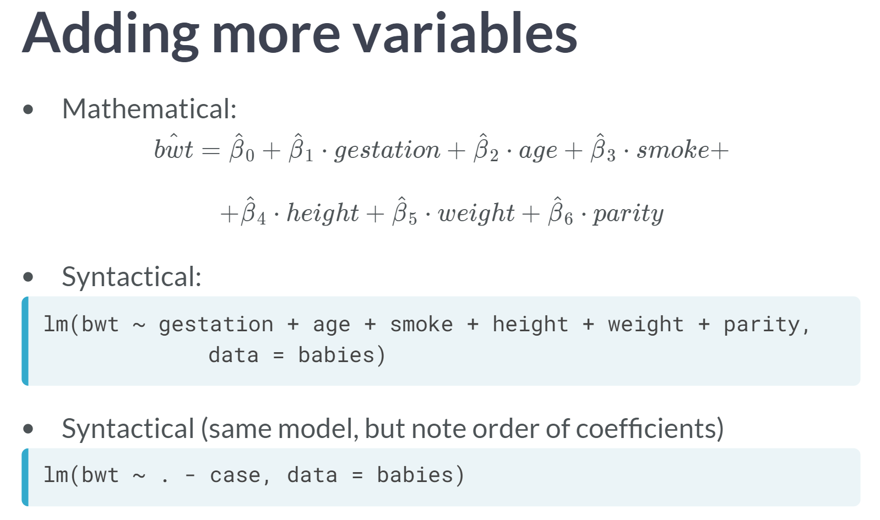

You can add as many terms as you want, and R will happily fit the model for you.

In this case, we added explanatory variables for the mother's height and weight, and a variable called parity that denotes whether the child was her first pregnancy.

It seems reasonable to think that any of these variables might play a role in determining a child's birthweight, and so there may be valid scientific reasons for including any or all of these variables in our model.

In R, we can use the dot operator in a formula to mean "all other variables in the data frame". In the last expression above, we have built the "kitchen sink" model by throwing everything in with the dot operator - with one exception.

There are often variables that are recorded that will not make sense to include in a model. The case variable in the *babies* dataset simply identifies each case - it isn't an observed property of each birth. Therefore, we exclude it explicitly.

You can read the *.-case* formula as "all variables except for the one named case".

  
You may also have caught on to the fact that a geometric interpretation of these higher order models is extremely difficult. There are things called hyperplanes, which generalize the notion of a plane to a higher dimension, but since we humans can't visualize more than three spatial dimensions anyway, there isn't much hope of visualizing our higher dimensional in their full glory.

We can of course employ tricks such as mapping variables to color, creating small multiples for categorical variables, and projecting into a lower-dimensional space by hard-coding the values of some variables. We won't explore that further here since these plots are unlikely to reinforce our geometric intuition.

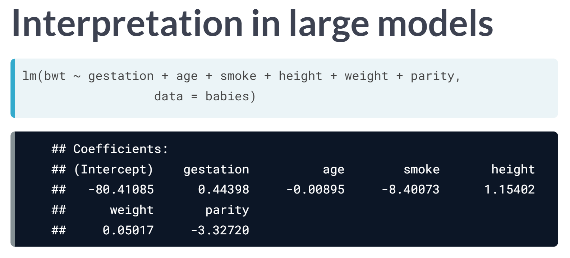  
The interpretation of the coefficients in larger models remains the same. We can think of the coefficients on numeric explanatory variables as being slopes, and we can still think of the coefficients on the categorical explanatory variables as being intercepts.

The main thing we have to remember is to include language specifying the other variables in the model. Here, our main finding would likely be that the expected birthweight of babies born to mothers who smoke is 8.4 ounces lower than mothers who don't, after controlling for gestational length, and her age, height, weight, and whether she had previous pregnancies.

# Interpretation of coefficient in a big model

This time we have thrown even more variables into our model, including the number of bids in each auction (nBids) and the number of wheels. Unfortunately, this makes a full visualization of our model impossible, but we can still interpret the coefficients.

Call:

lm(formula = totalPr ~ duration + startPr + cond + wheels + nBids,

data = mario_kart)

Coefficients:

(Intercept) duration startPr condused wheels nBids

39.3741 -0.2752 0.1796 -4.7720 6.7216 0.1909

Choose the correct interpretation of the coefficient on the number of wheels:



**Logistic Regression**In this chapter you'll learn about using logistic regression, a generalized linear model (GLM), to predict a binary outcome and classify observations.



Thus far, we have only built models for a numeric response variable.

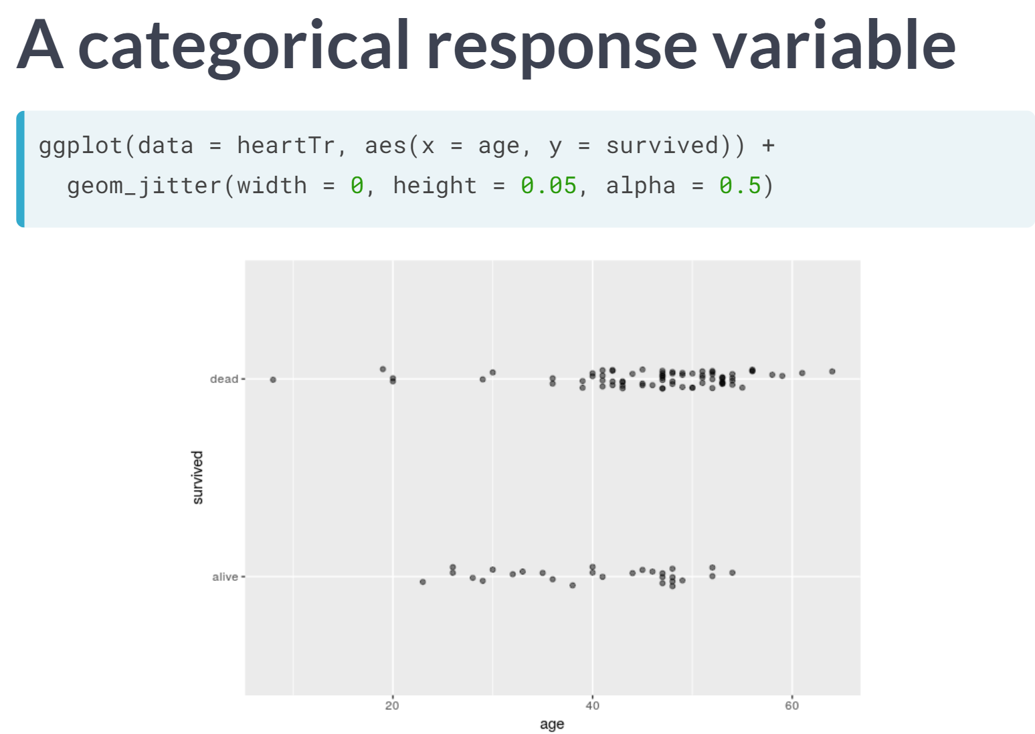  
A well-known Stanford University study on heart transplants tracked the five-year survival rate of patients with dire heart ailments. The purpose of the study was to access the efficacy of heart transplants, but for now we will simply focus on modeling the survival rates of these patients. This plot illustrates how those patients who were older when the study began were more likely to be dead when the study ended (five years later).

Note that we have used the ***geom_jitter()***function to create the illusion of separation in our data. Because the y value is categorical, all of the points would either lie exactly on "dead" or "alive", making the individual points hard to see. To counteract this, ***geom_jitter()***will move the points a small random amount up or down. If you fit a regression line to these data, what would it look like?

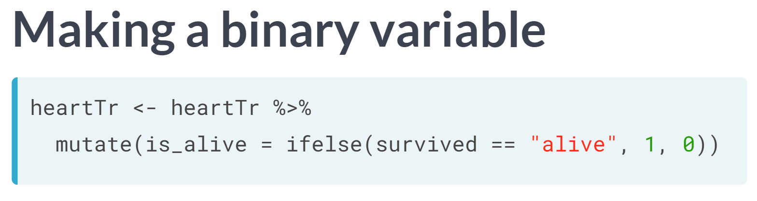  
First, we have a technical problem, in that the levels of our response variable are labels, and you can't build a regression model to a variable that consists of words! We can get around this by creating a new variable that is binary (either 0 or 1), based on whether the patient survived the study. We call this new variable *is_alive*.

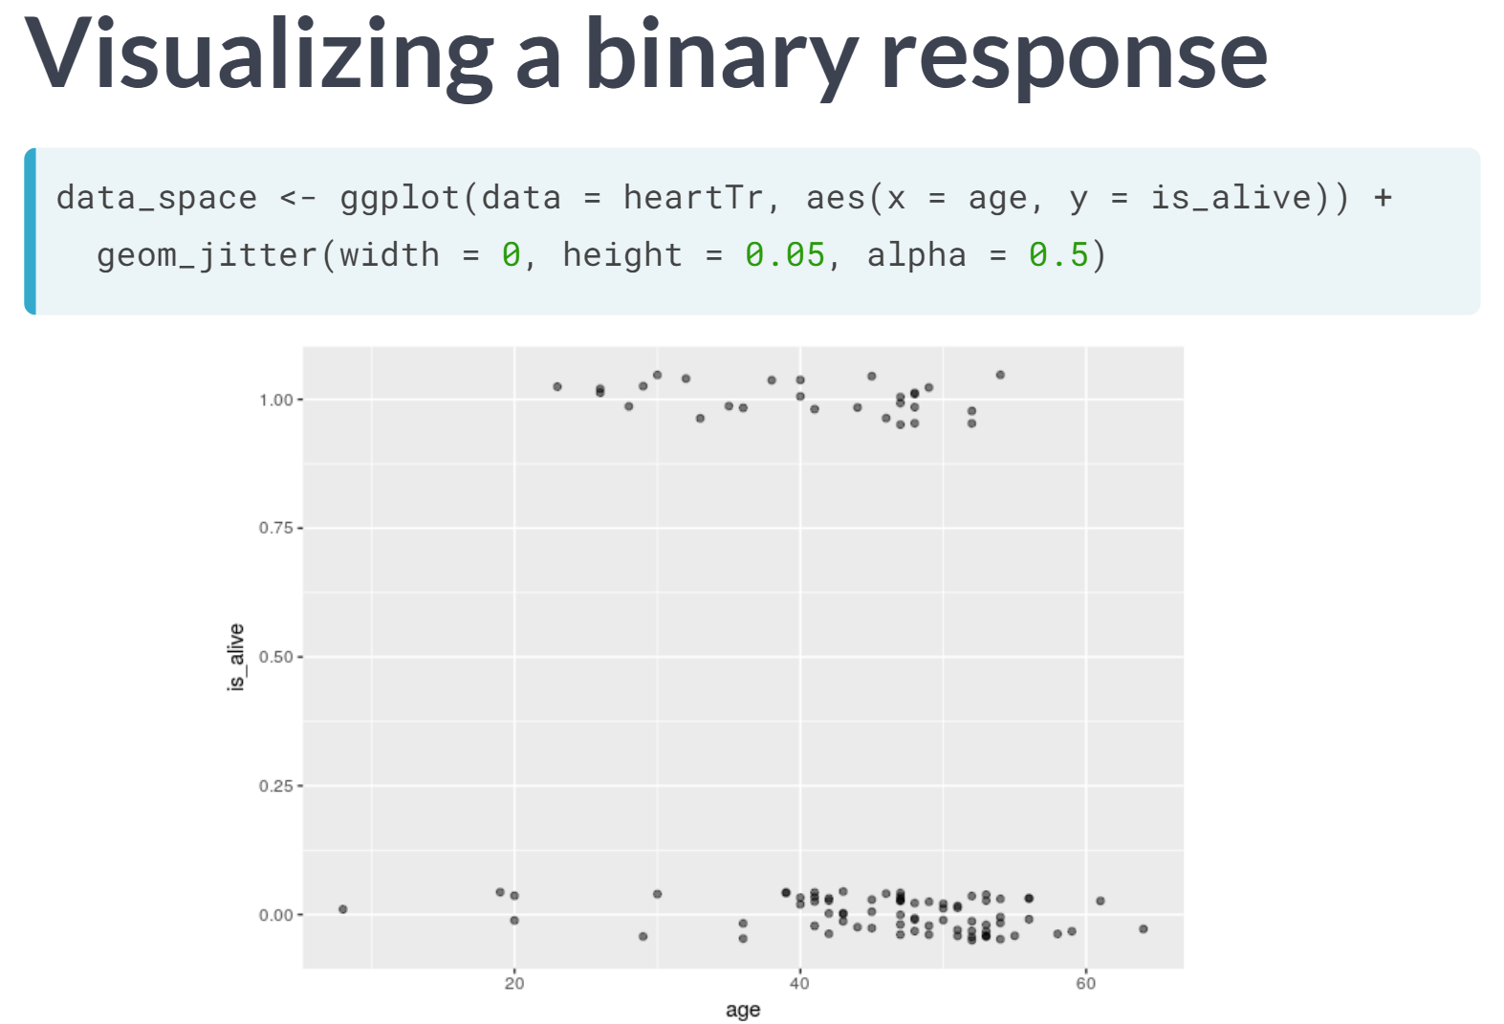  
We can then visualize our *data_space*. The vertical axis can now be thought of as the probability of being alive at the end of the study, given one's age at the beginning.

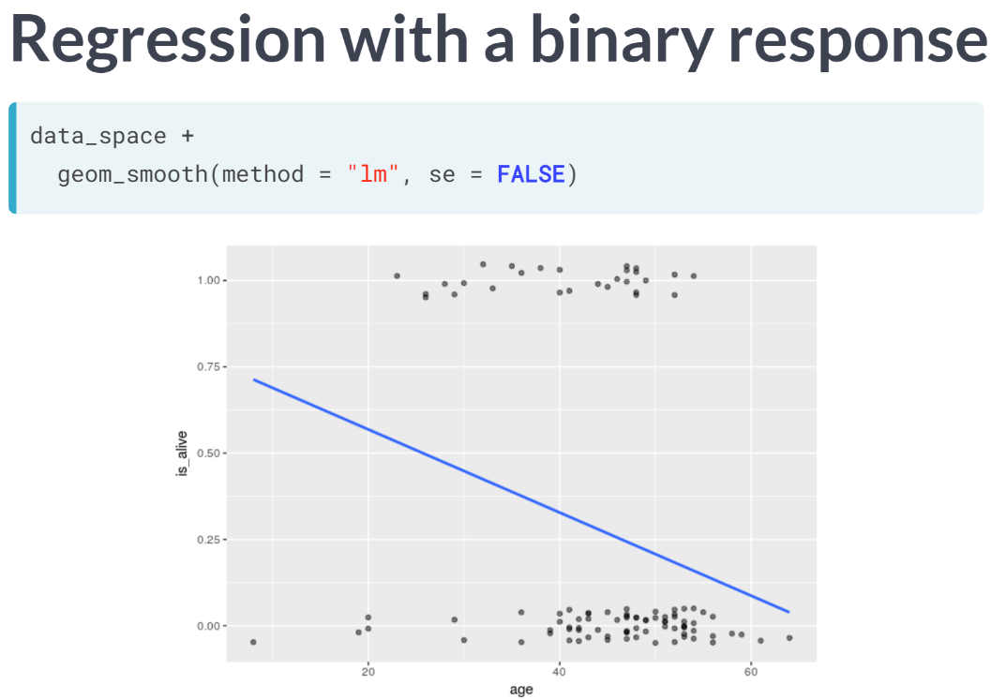  
Now there is nothing preventing us from fitting a simple linear regression model to these data, and in fact, in certain cases this may be an appropriate thing to do. But it's not hard to see that the line doesn't fit very well. There are other problems as well.

  
What would this model predict as the probability of a 70-year-old patient being alive?

It would be a number less than zero, which doesn't make sense as a probability.

Because of the regression line always extends to infinity in either direction, it will make predictions that are not between 0 and 1, sometimes even for reasonable values of the explanatory variable.

Second, the variability in a binary response may violate a number of other assumptions that we make when we do inference in multiple regression.

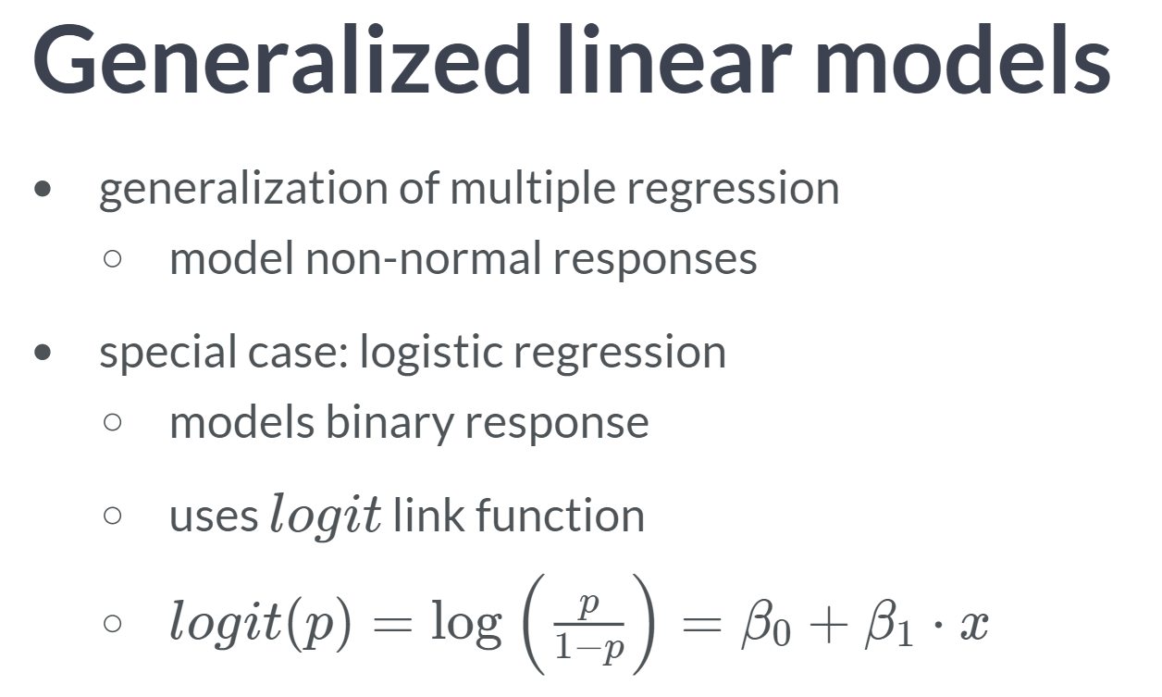  
Thankfully, a modeling framework exists that generalizes regression to include response variables that are non-normally disturbed. This family is called generalized linear models or GLMs for short.

One member of the family of GLMs is called logistic regression, and this is the one that models a binary response variable. A full treatment of GLMs is beyond the scope of this course, but the basic idea is that we apply a so-called link function to appropriately transform the scale of the response variable to match the output of a linear model. The link function used by logistic regression is the ***logit()*** function.

This constrains the fitted values of the model to always lie between 0 and 1, as a valid probability must.

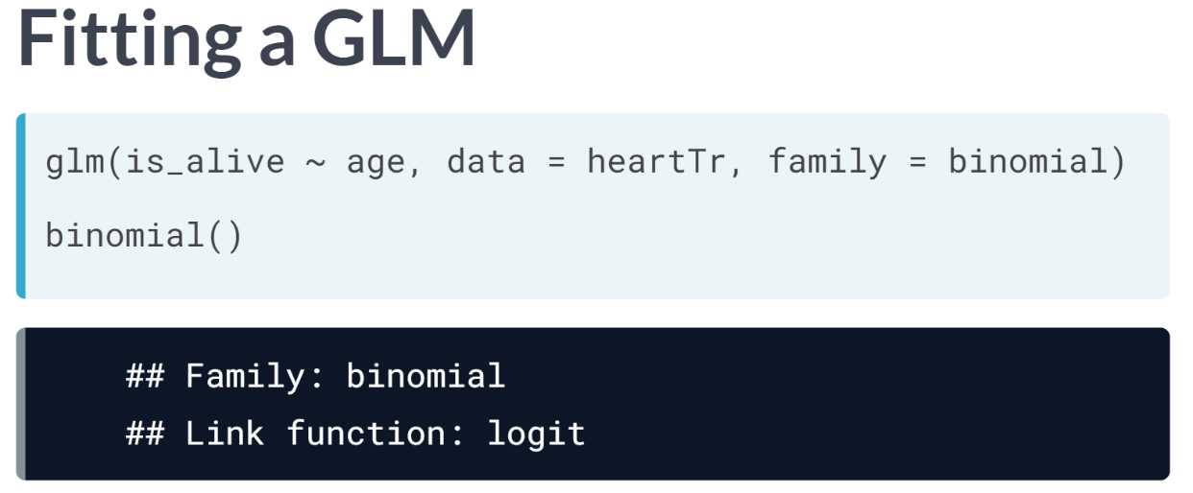

Fitting a GLM in G requires only two small changes from fitting a regression model using ***lm()***. First, the function is called ***glm()*** instead of ***lm()***.

Second, we have to specify which kind of GLM we want using the family argument. For logistic regression, we specify the binomial() family, which uses the ***logit()*** function.

# Fitting a line to a binary response

When our response variable is binary, a regression model has several limitations. Among the more obvious—and logically incongruous—is that the regression line extends infinitely in either direction.

This means that even though our response variable $y$  only takes on the values 0 and 1, our fitted values $\hat{y}$  can range anywhere from $-∞$  to $∞$ . This doesn't make sense.

To see this in action, we'll fit a linear regression model to data about 55 students who applied to medical school. We want to understand how their undergraduate $GPA$  relates to the probability they will be accepted by a particular school $(Acceptance)$  .

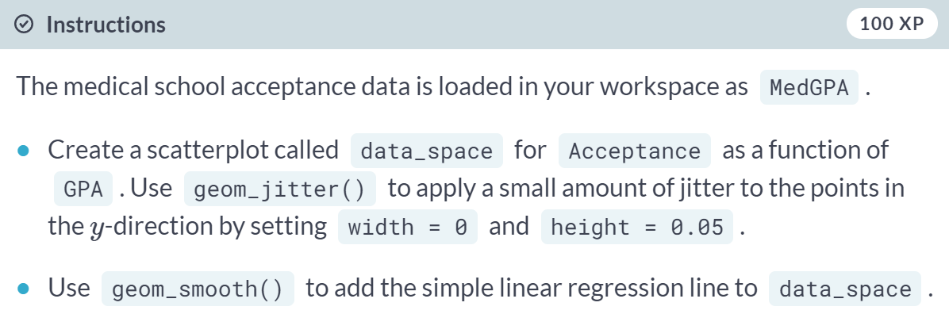

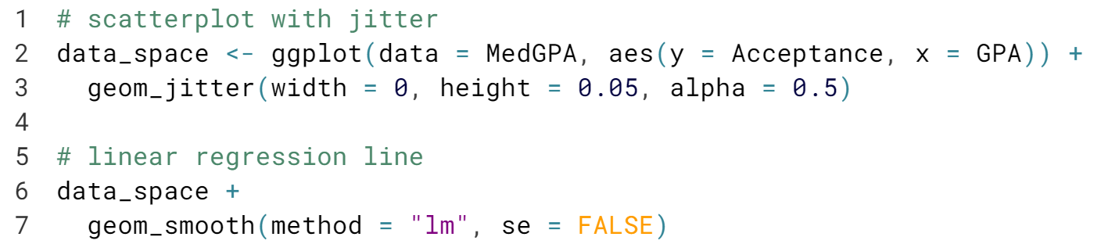

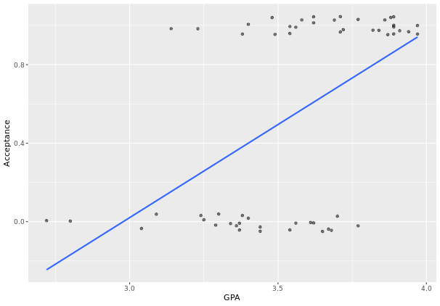

# Fitting a line to a binary response (2)

In the previous exercise, we identified a major limitation to fitting a linear regression model when we have a binary response variable. However, it is not always inappropriate to do so.

Note that our regression line only makes illogical predictions (i.e. $\hat{y}<0$  or $\hat{y}>1$) for students with very high or very low GPAs. For GPAs closer to average, the predictions seem fine.

Moreover, the alternative logistic regression model — which we will fit next — is very similar to the linear regression model for observations near the average of the explanatory variable. It just so happens that the logistic curve is very straight near its middle. Thus, in these cases a linear regression model may still be acceptable, even for a binary response.

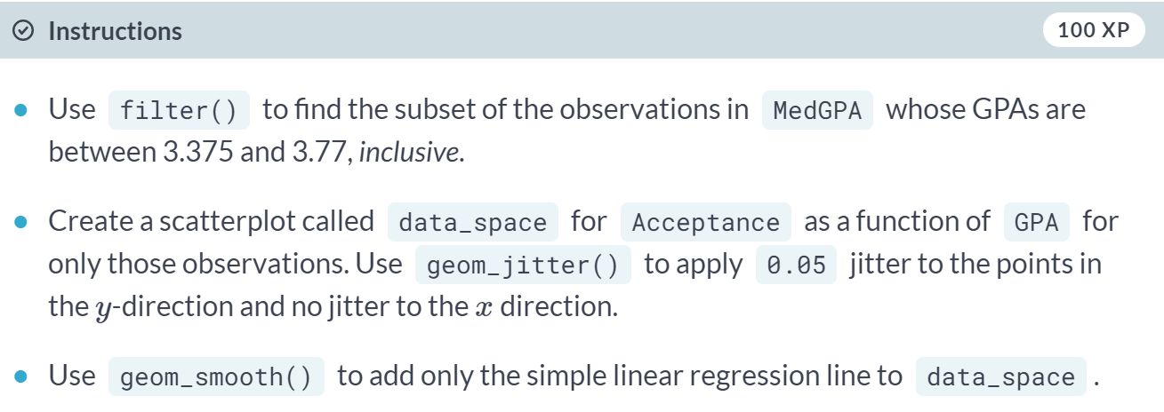

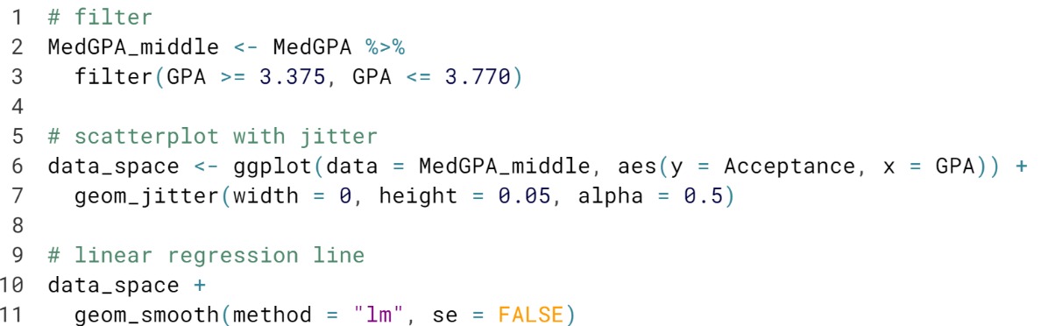  
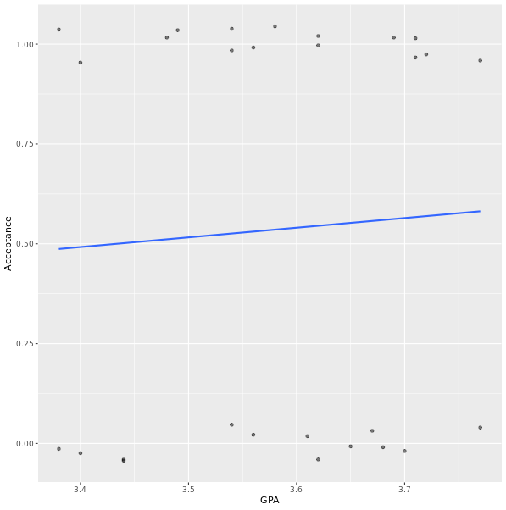

# Fitting a model

Logistic regression is a special case of a broader class of [**generalized linear models**](https://en.wikipedia.org/wiki/Generalized_linear_model), often known as GLMs. Specifying a logistic regression model is very similar to specify a regression model, with two important differences:

* We use the glm() function instead of lm()
* We specify the family argument and set it to binomial. This tells the GLM function that we want to fit a logistic regression model to our binary response. [The terminology stems from the assumption that our binary response follows a [**binomial distribution**](https://en.wikipedia.org/wiki/Binomial_distribution).]

We still use the formula and data arguments with glm().

Note that the mathematical model is now:

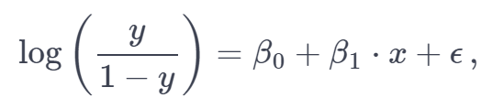

where $ϵ$  is the error term.





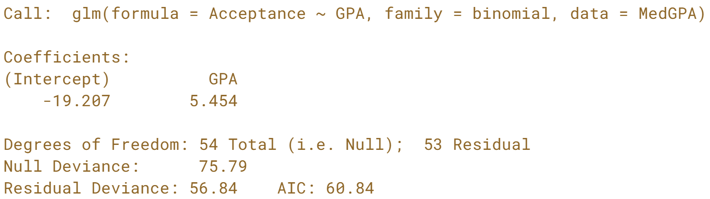

Awesome! Fitting a GLM isn't much harder than a regular linear model.



Let's return to our heart transplant data.

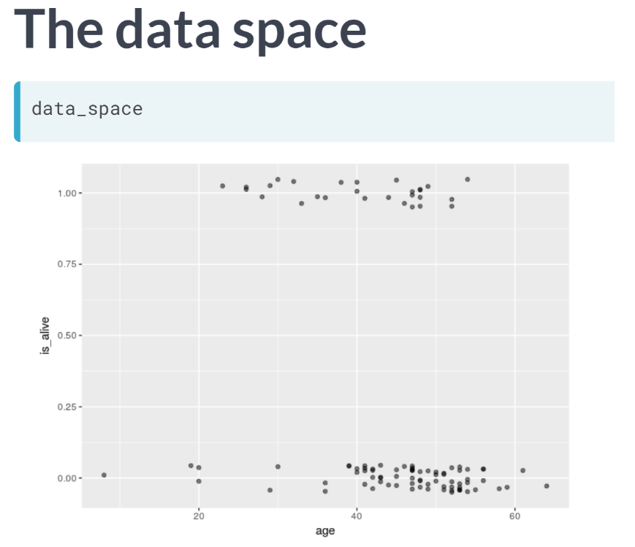  
In the data space, we can see the relationship between age and our binary response variable: whether the patient was alive when the study ended. Here again, we've added some jitter and transparency to the points to make the individual observations easier to see.

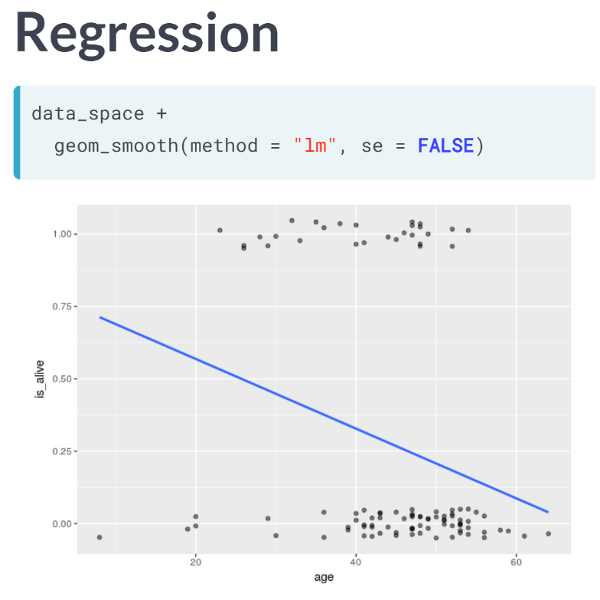  
When we fit the simple linear regression line previously, we noted how the line was headed towards illogical predictions: the expected probability of a 70-year-old would be less than 0.

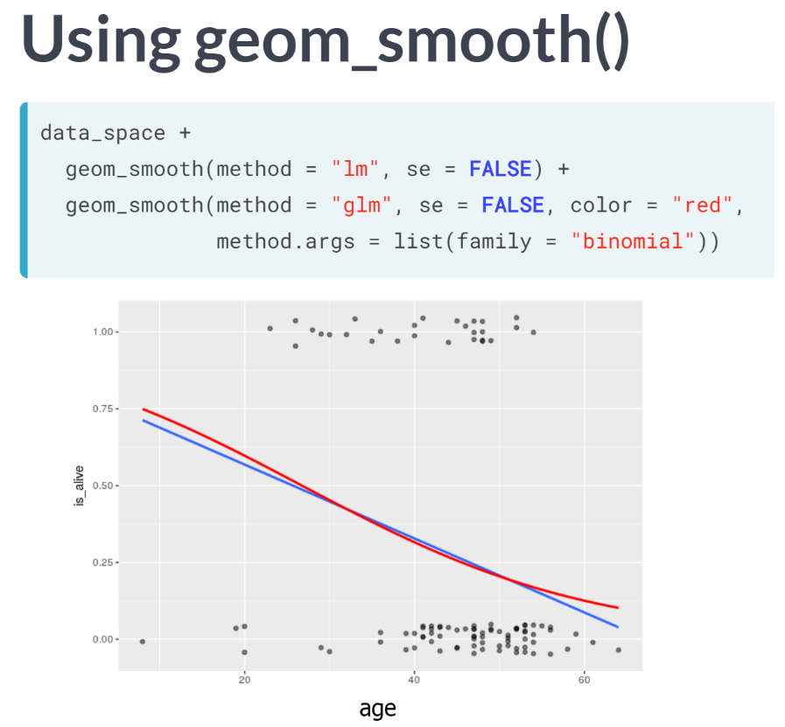  
In contrast, notice how the logistic regression line is curved - most noticeably at the ends.

The red logistic regression line will never reach 0 or 1, eliminating those invalid predicted probabilities.

In this case, for most ages, the simple linear regression line and the logistic regression line don't differ by very much, and you might not lose much by using the simpler regression model. But for older people, the logistic model should perform much better.

How can we visually assess how well the logistic model fits the data?

Since the actual observations are all at 0 or 1, but our predictions are always between 0 and 1, we will always be off by some amount.

In particular, our model predicts a 50 percent chance of survival for patients that are about 27 years old. Is that accurate?

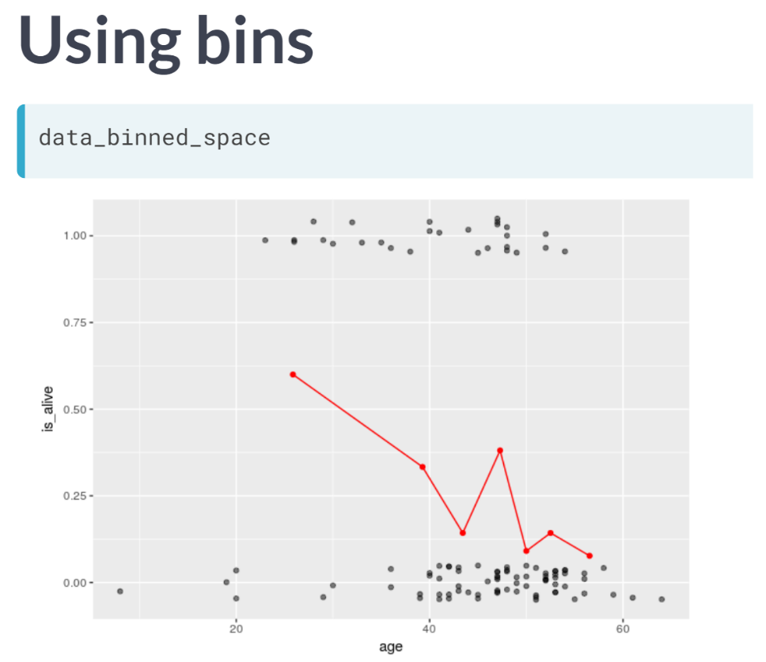  
One way to address this question is to separate the observations into bins based on age, and then compute the average probability of being alive for each age group.

Here, we separate the data into seven bins such that each bin contains roughly the same number of observations.

The choice of how to define the bins is somewhat arbitrary, but this choice seems to provide us with a reasonable picture of what is happening.

In general, it seems clear that the probability of being alive declines with age.

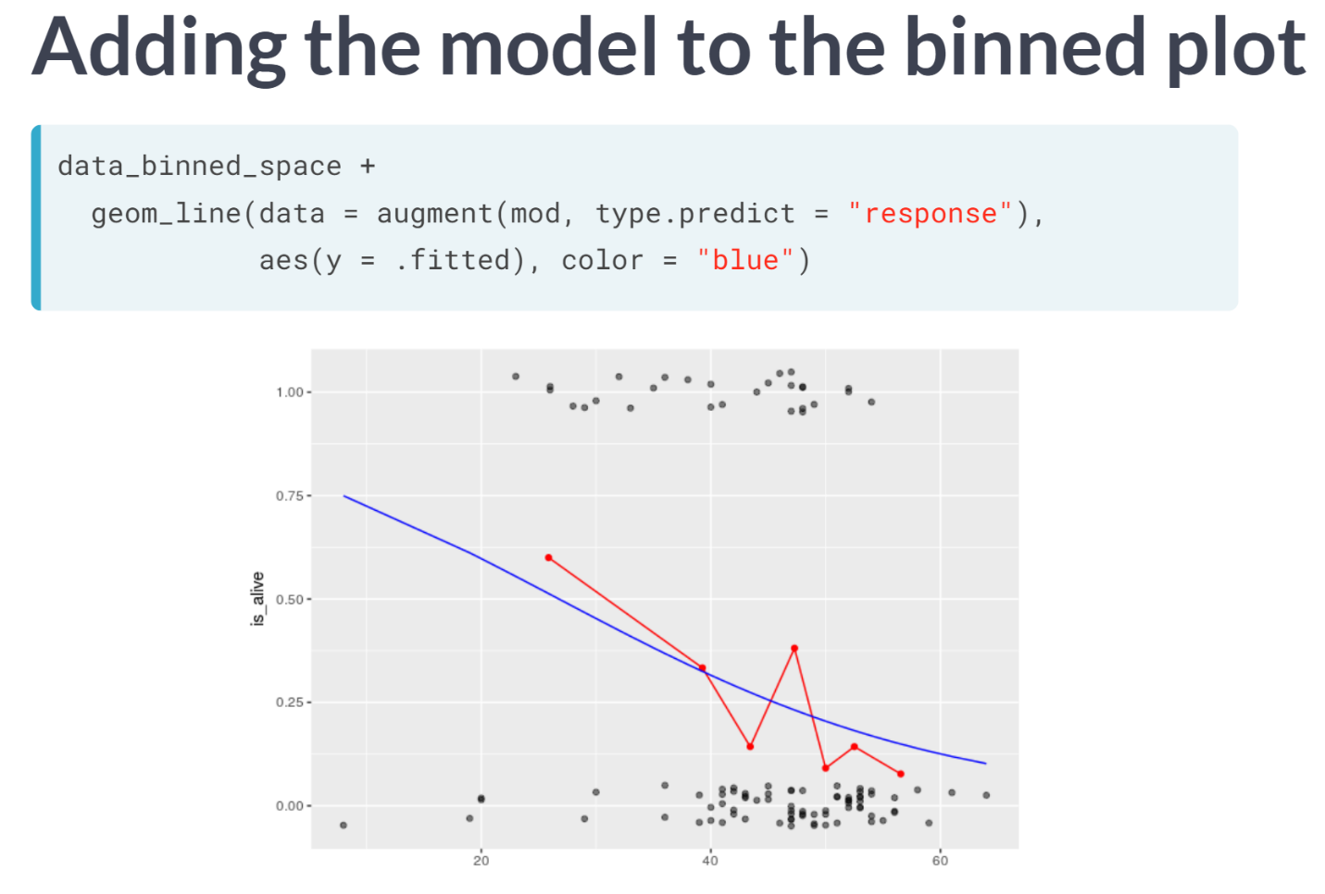  
To add our model to the plot, we will employ the same technique that we used for the parallel slopes models. First, we use the ***augment()*** function from the broom package to compute the fitted values for our original observations based on our model.

Note that we have set the *type.predict* argument to ensure that the fitted values are on the same scale as the response variable.

Second, we use the ***geom_line()*** function to draw a blue line through these points.

This blue line is the same as the one we drew previously using ***geom_smooth()***.

With the binned observations in red, we can now see how the blue logistic regression line fits "through" these binned points.

# Using geom_smooth()

Our logistic regression model can be visualized in the data space by overlaying the appropriate logistic curve. We can use the geom_smooth() function to do this. Recall that geom_smooth() takes a method argument that allows you to specify what type of smoother you want to see. In our case, we need to specify that we want to use the glm() function to do the smoothing.

However, we also need to tell the glm() function which member of the GLM family we want to use. To do this, we will pass the family argument to glm() as a list using the method.args argument to geom_smooth(). This mechanism is common in R and allows one function to pass a list of arguments to another function.

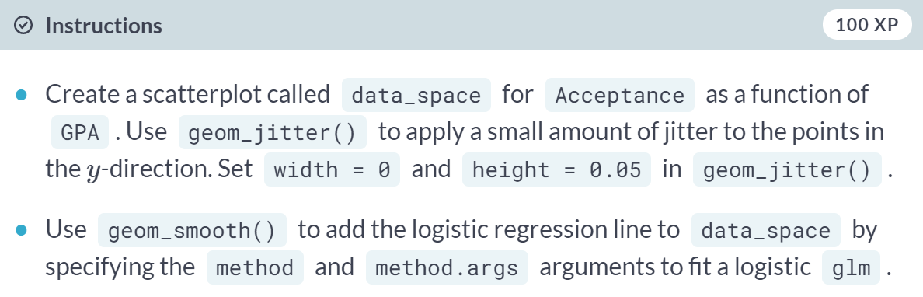

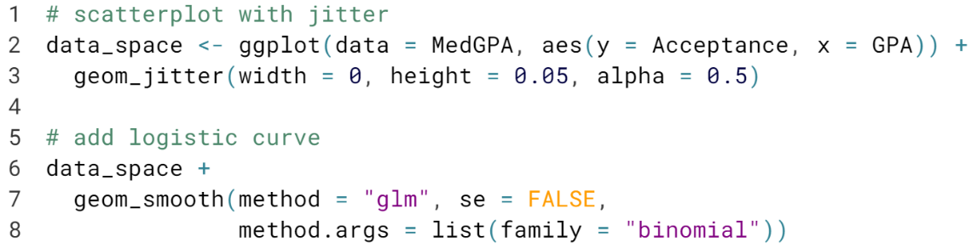  
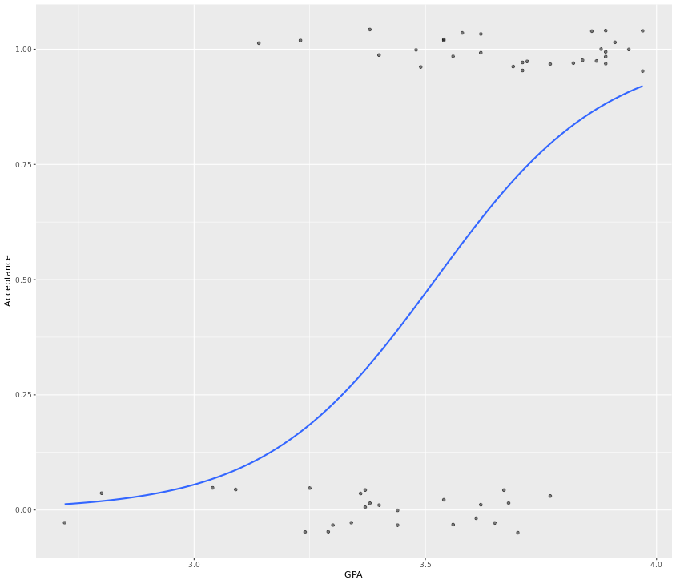  
What a plot! What differences can you spot between this curve and the linear model earlier?

# Using bins

One of the difficulties in working with a binary response variable is understanding how it "changes." The response itself ($y$) is either  0 or 1, while the fitted values ($\hat{y}$)—which are interpreted as probabilities—are between  0 and 1.

But if every medical school applicant is either admitted or not, what does it mean to talk about the probability of being accepted?

What we'd like is a larger sample of students, so that for each GPA value (e.g. 3.54) we had many observations (say $n$ ), and we could then take the average of those $n$  observations to arrive at the estimated probability of acceptance.

Unfortunately, since the explanatory variable is continuous, this is hopeless—it would take an infinite amount of data to make these estimates robust.

Instead, what we can do is put the observations into bins based on their GPA value.

Within each bin, we can compute the proportion of accepted students, and we can visualize our model as a smooth logistic curve through those binned values.

We have created a data.frame called MedGPA_binned that aggregates the original data into separate bins for each 0.25 of GPA. It also contains the fitted values from the logistic regression model.

Here we are plotting $y$  as a function of $x$ , where that function is

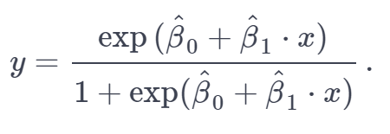

Note that the left-hand side is the expected probability $y$  of being accepted to medical school.

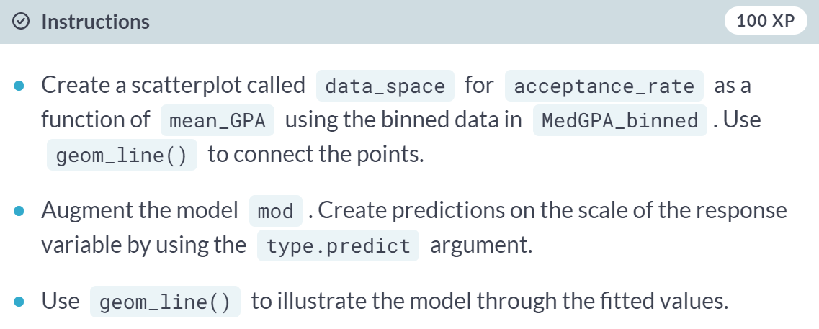

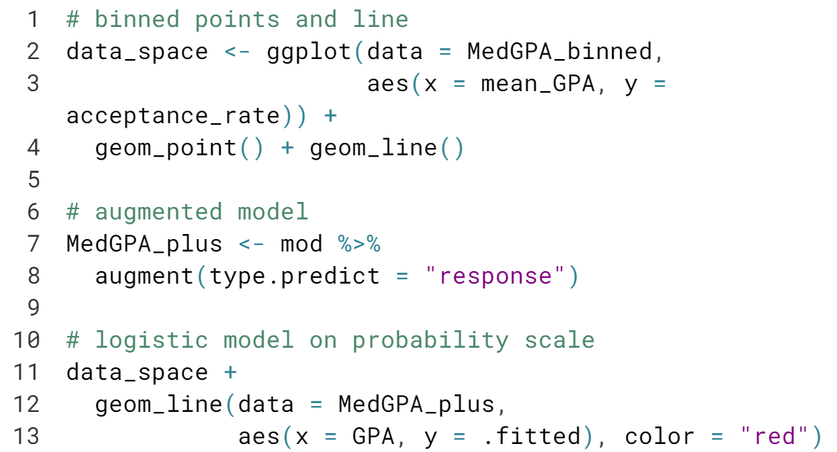

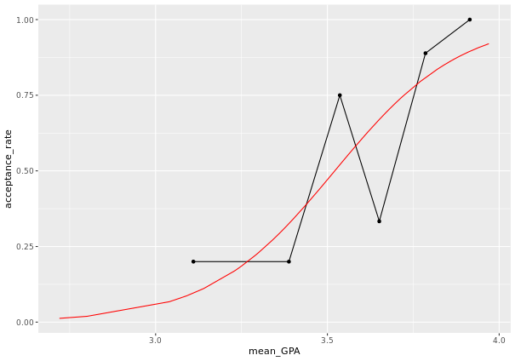

Great work! The logistic predictions seem to follow the binned values pretty well.



For the Stanford heart transplant patients, we've observed how the probability of survival seems to decline with age.

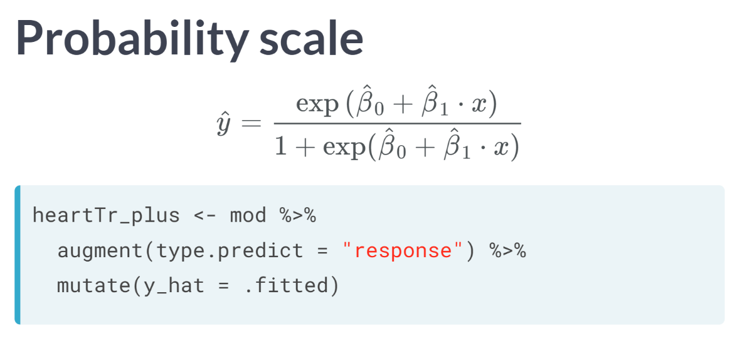  
The notion of probability here is very intuitive: it's easy to understand what we mean when we say that the five-year survival rate is 75%. Here, we computed the fitted probabilities using the ***augment()*** function. Unfortunately, since our model is now non-linear, it's harder to succinctly characterize how those probability decline.

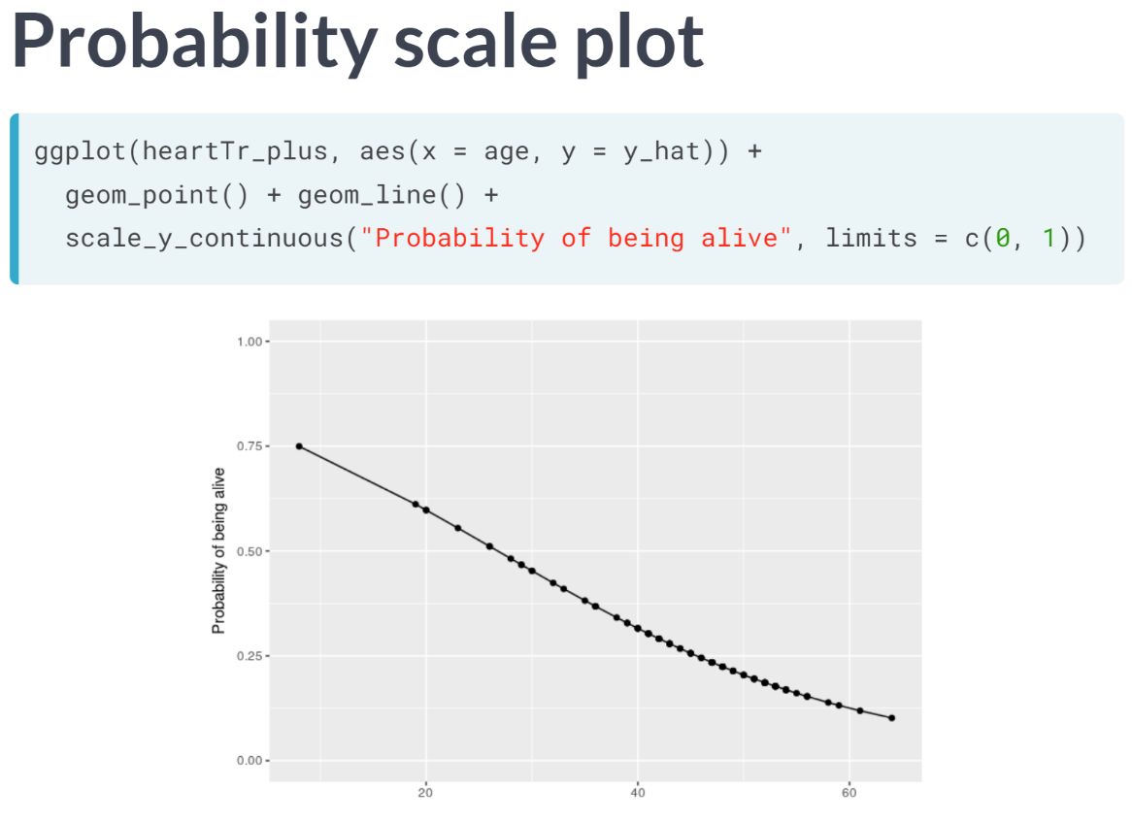  
We can no longer say that "each additional year of age is associated with a particular change in the probability of surviving," because that change in probability is not constant across ages. Thus, while the probability scale is natural, it can be cumbersome to work with.

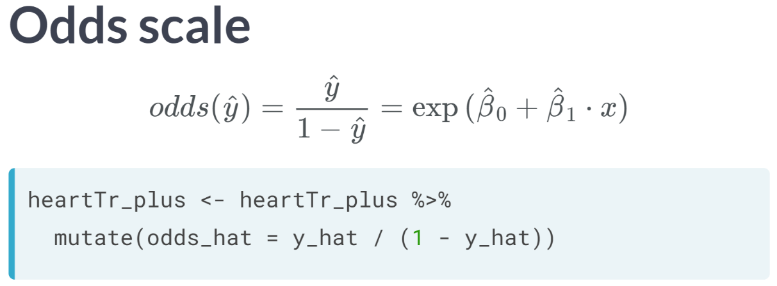  
To combat this, we can change the scale of the variable on the y-axis. Instead of thinking about the probability of survival, we can think about the odds.

While these two concepts are often conflated, they aren't the same. They're however related by this simple formula above.

The odds of a binary event are the ratio of how often it happens, to how often it doesn't happen. Thus, if the probability of survival is 75%, then the odds of survival are 3:1, since we are three times more likely to survive than you are to die.

Odds are commonly used to express uncertainty in a variety of contexts, most notably gambling.

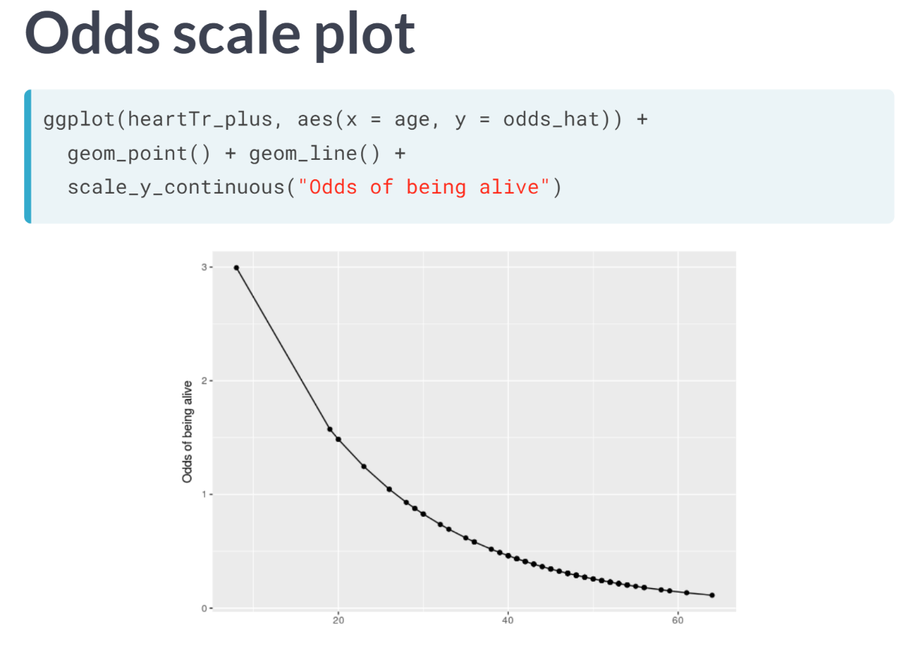  
If we change the y-scale to odds, then our model must change shape as well. In fact, our model now has the form of an exponential function.

In this case, the odds of survival decrease exponentially as people age. While the odds scale is more useful than the probability scale of certain things, it isn't entirely satisfying.

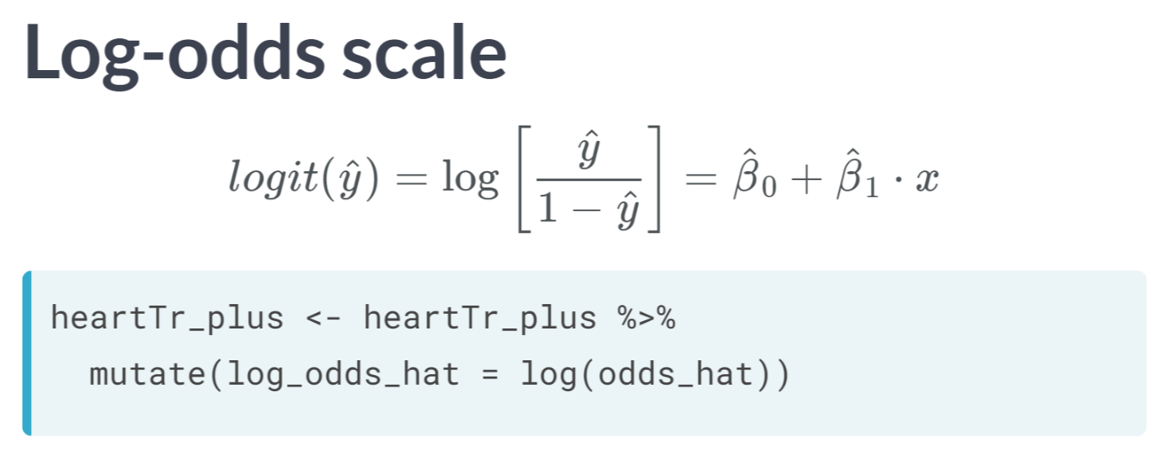  
Statisticians also think about logistic regression models on the log-odds scale, which is formed by taking the natural log of the odds.

The benefit to this approach is clear: now the logistic regression model can be visualized as a line.

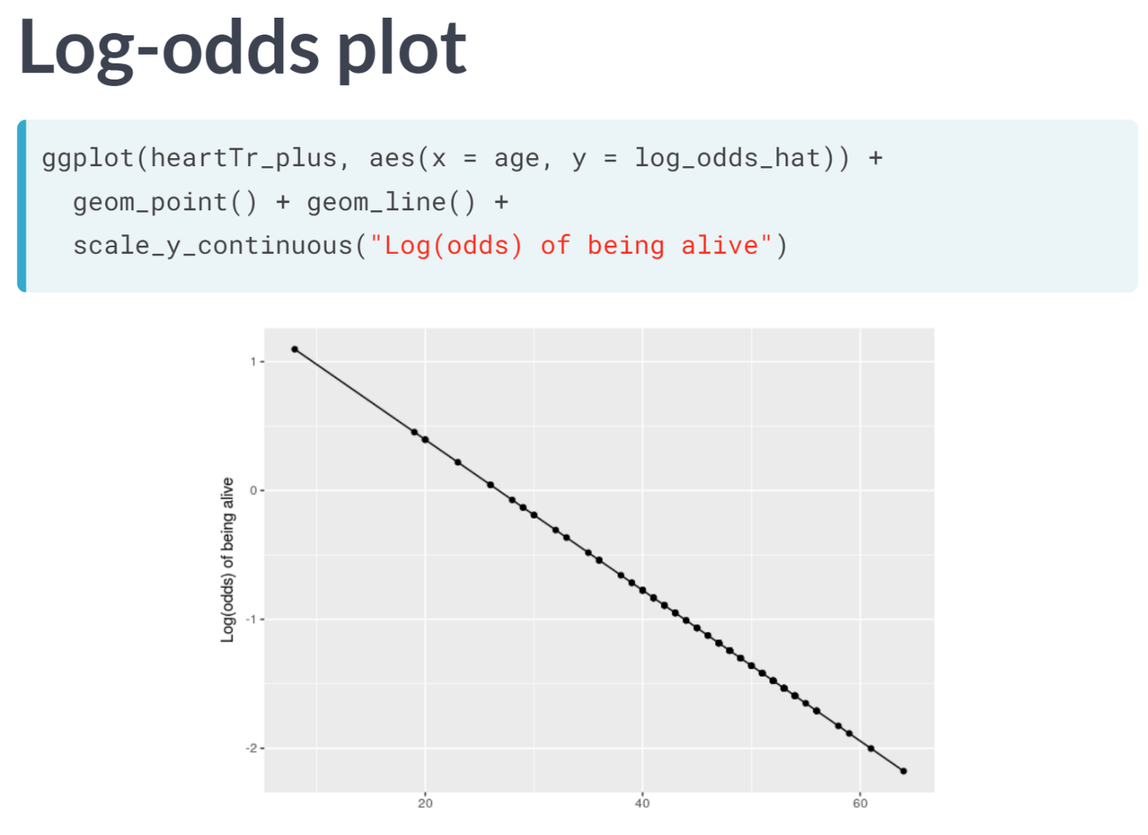  
The benefit of this approach is clear: now the logistic regression model can be visualized as a line. Unfortunately, understanding what the log of the odds of an event means is very difficult for humans

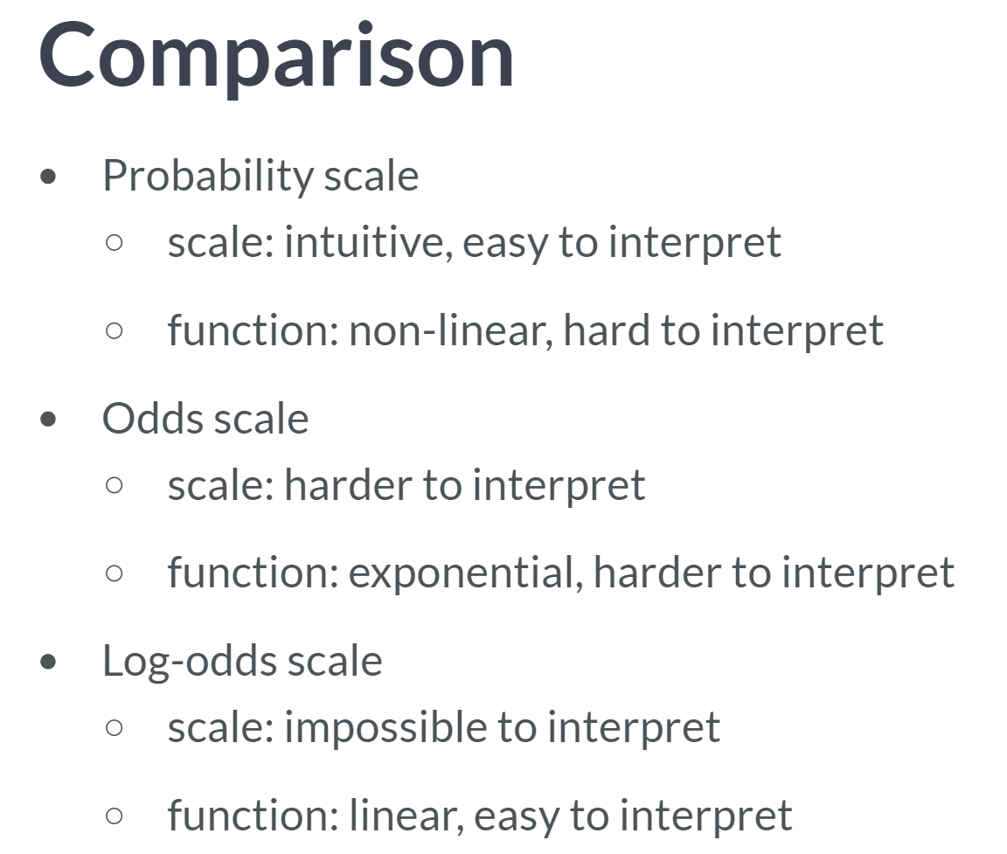  
So, we've identified three different scales when working with logistic regression models.

Each has its own strengths but also weakness, and so you really can't stick with one scale and ignore the others. The probability scale is the easiest to understand, but it makes the logistic difficult to interpret.

Conversely, the logistic function becomes a line on the log-odds scale. This makes the function easy to interpret, but the log of the odds is hard to grapple with.

The odd scale lies somewhere in between. Moreover, it is the odds scale that leads to the most common interpretation of the coefficients in a logistic regression model.

As noted previously, interpreting the coefficients on the probability scale is hard because the model is non-linear, while interpreting them on the log-odds scale is hard because the scale is abstruse.

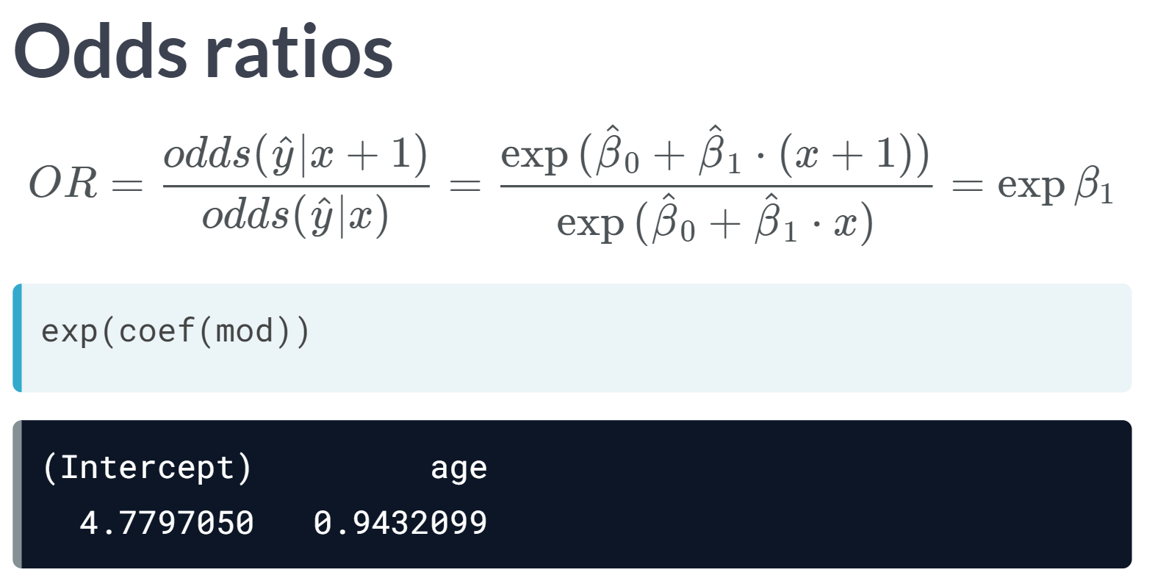  
However, on the odds scale we can form the ratio of the odds when the explanatory variable increases by one unit. This works out mathematically to be equal to the exponential of beta 1, the "slope" coefficient.

Our interest is in how this number differs from 1. If it's greater than one, then the odds increase.

Conversely, if it's less than one, then the odds decrease. In our case, our model suggests that each additional year of age is associated with a 6% decrease in the odds of survival. Keeping careful track of which scale you are working on will help you get these interpretations right.

# Odds scale

For most people, the idea that we could estimate the probability of being admitted to medical school based on undergraduate GPA is fairly intuitive.

However, thinking about how the probability changes as a function of GPA is complicated by the non-linear logistic curve.

By translating the response from the probability scale to the [**odds**](https://en.wikipedia.org/wiki/Odds) scale, we make the right hand side of our equation easier to understand.

If the probability of getting accepted is $y$ , then the odds are $\frac{y}{1-y}$ .

Expressions of probabilities in terms of odds are common in many situations, perhaps most notably gambling.

Here we are plotting $\frac{y}{1-y}$  as a function of $x$ , where that function is

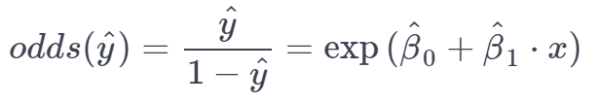

Note that the left hand side is the expected odds of being accepted to medical school. The right hand side is now a familiar exponential function of $x$ .

The MedGPA_binned data frame contains the data for each GPA bin, while the MedGPA_plus data frame records the original observations after being augment()-ed by mod.

(exercise on the next page)



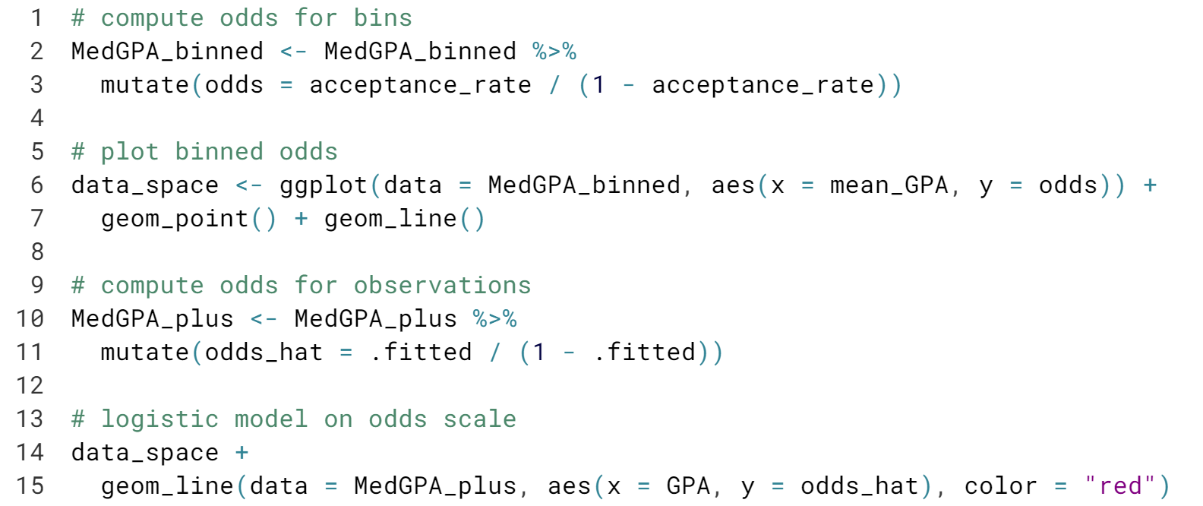

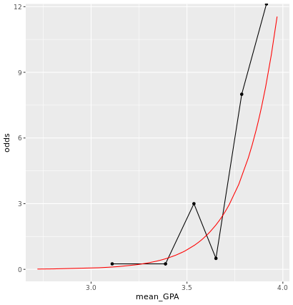  
Fantastic job! Being able to move back and forth between different scales is essential to interpreting logistic regression models.

# Log-odds scale

Previously, we considered two formulations of logistic regression models:

* on the probability scale, the units are easy to interpret, but the function is non-linear, which makes it hard to understand
* on the odds scale, the units are harder (but not impossible) to interpret, and the function in exponential, which makes it harder (but not impossible) to interpret

We'll now add a third formulation:

* on the log-odds scale, the units are nearly impossible to interpret, but the function is linear, which makes it easy to understand

As you can see, none of these three is uniformly superior. Most people tend to interpret the fitted values on the probability scale and the function on the log-odds scale.

The interpretation of the coefficients is most commonly done on the odds scale. Recall that we interpreted our slope coefficient $β_{1}$  in linear regression as the expected change in $y$  given a one-unit change in $x$ .

On the probability scale, the function is non-linear and so this approach won't work. On the log-odds, the function is linear, but the units are not interpretable (what does the $log$  of the odds mean??).

However, on the odds scale, a one-unit change in $x$  leads to the odds being multiplied by a factor of $β_{1}$ . To see why, we form the [**odds ratio**](https://en.wikipedia.org/wiki/Odds_ratio):

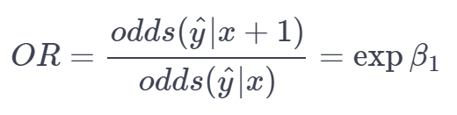

Thus, the exponentiated coefficient $β_{1}$  tells us how the expected odds change for a one unit increase in the explanatory variable.

It is tempting to interpret this as a change in the expected probability, but this is wrong and can lead to nonsensical predictions (e.g. expected probabilities greater than 1).

(Exercise on the next page)

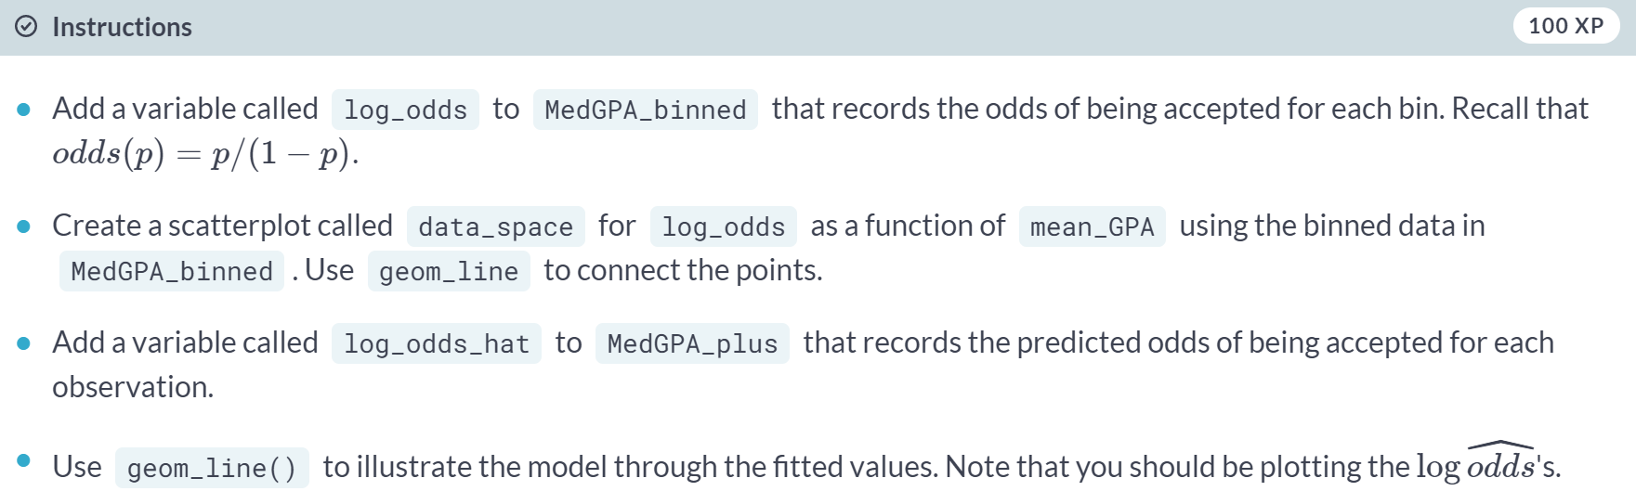

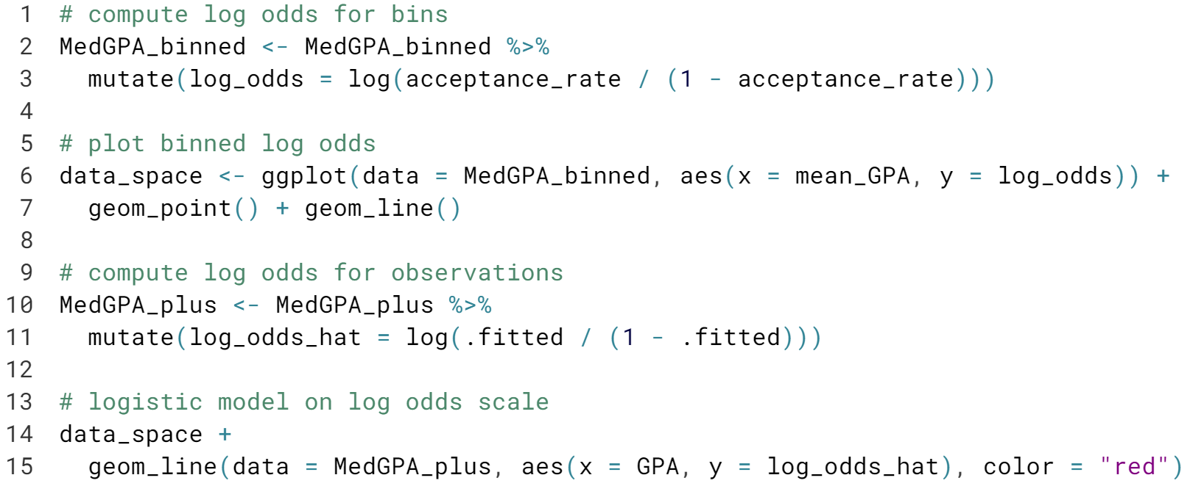

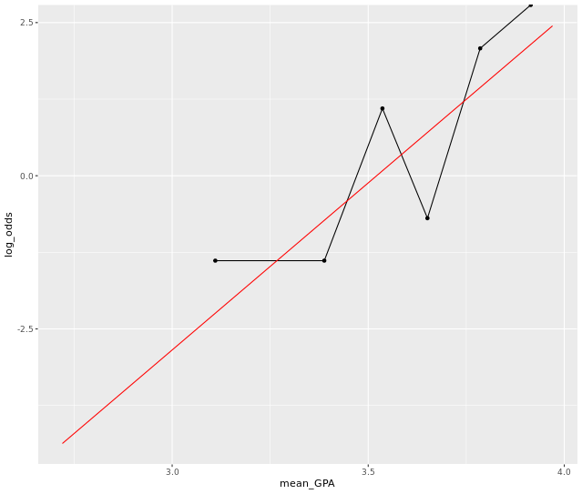  
Amazing work! When you're on the log-odds scale, your model is a simple linear function.

# Interpretation of logistic regression

The fitted coefficient $β_{1}$  from the medical school logistic regression model is 5.45. The exponential of this is 233.73.

Donald's GPA is 2.9, and thus the model predicts that the probability of him getting into medical school is 3.26%.

The odds of Donald getting into medical school are 0.0337, or—phrased in gambling terms—29.6:1. If Donald hacks the school's registrar and changes his GPA to 3.9, then which of the following statements is **FALSE**:

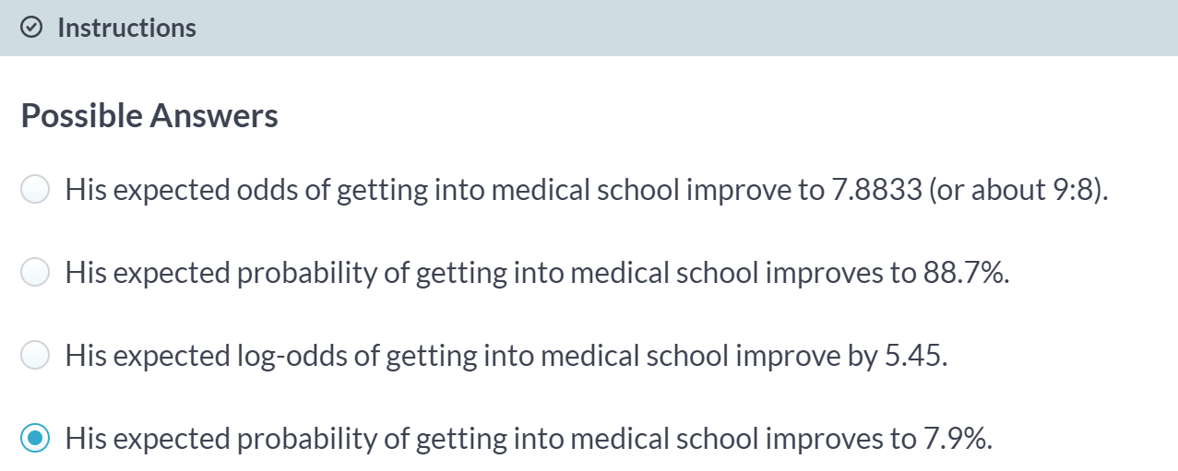



One important reason to build a model is to learn from the coefficients about the underlying random process.

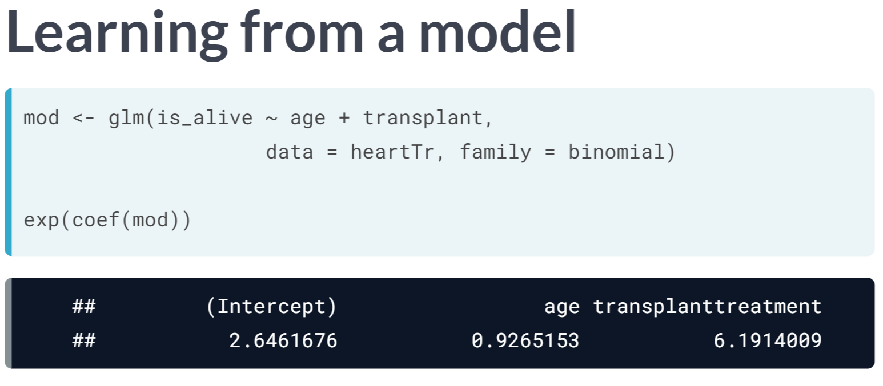  
For example, in the Standard heart transplant study, we were able to estimate the effect of age on the five-year survival rate.

This simple model shed no light on the obvious purpose of the study, which was to determine whether those patients who received heart transplants were likely to live longer than the control group that received no transplant.

By including the transplant variable in our model and exponentiating the coefficients, we see a huge effect.

Patients who received a heart transplant saw their odds of survival improve by a factor of 6.2, even after controlling for age.

Note that as expected, age still has a deleterious effect on morality.

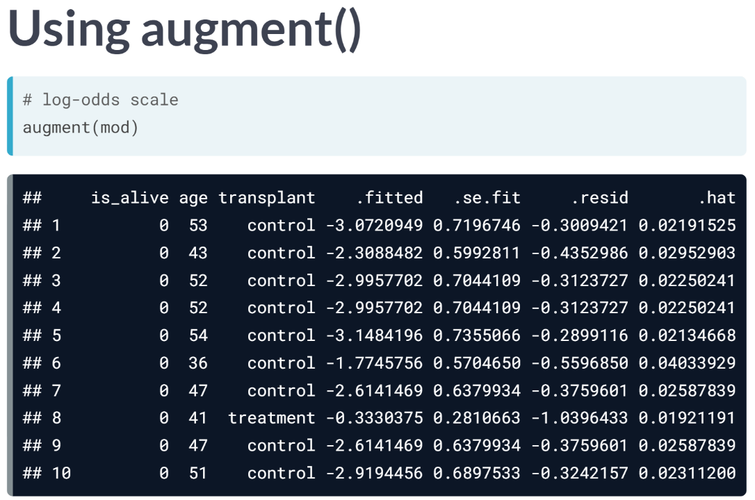  
As we have seen, running the ***augment()*** function on the model object will return a data frame with - among other things - the fitted values. However, when we run this with the default options, the fitted values sure don't look like probabilities! These are the fitted values on the log-odds scale, which aren't terribly useful to us.

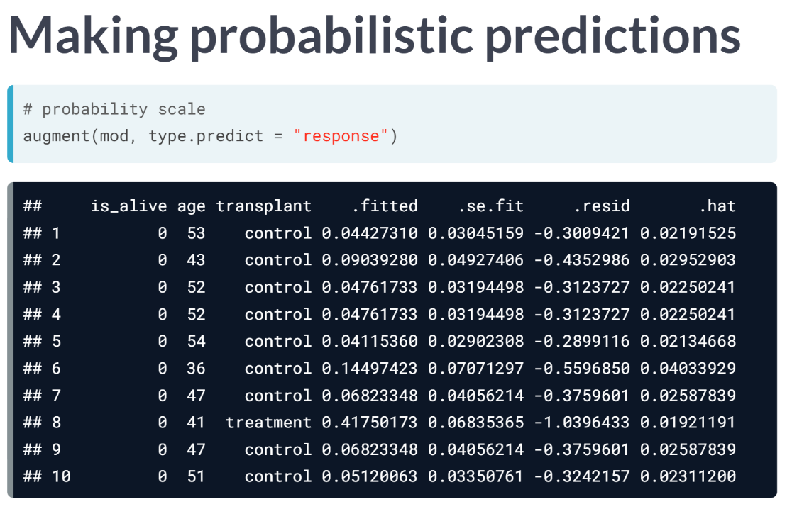  
However, if we set the *type.predict* argument to "response", we retrieve the fitted values on the familiar probability scale. Of course, making predictions about the probability of survival for those patients who took part in the study is of somewhat limited value.

We already know whether they survived! Aside from learning about the efficacy of the treatment, another common purpose for modeling is to make predictions for observations that are not part of our data set. These are called out-of-sample predictions.

  
For example, former Vice President Dick Cheney famously received a heart transplant in March of 2012 at the age of 71.

More than five years later, Cheney is still alive, but what does our model predict for his five-year survival rate?

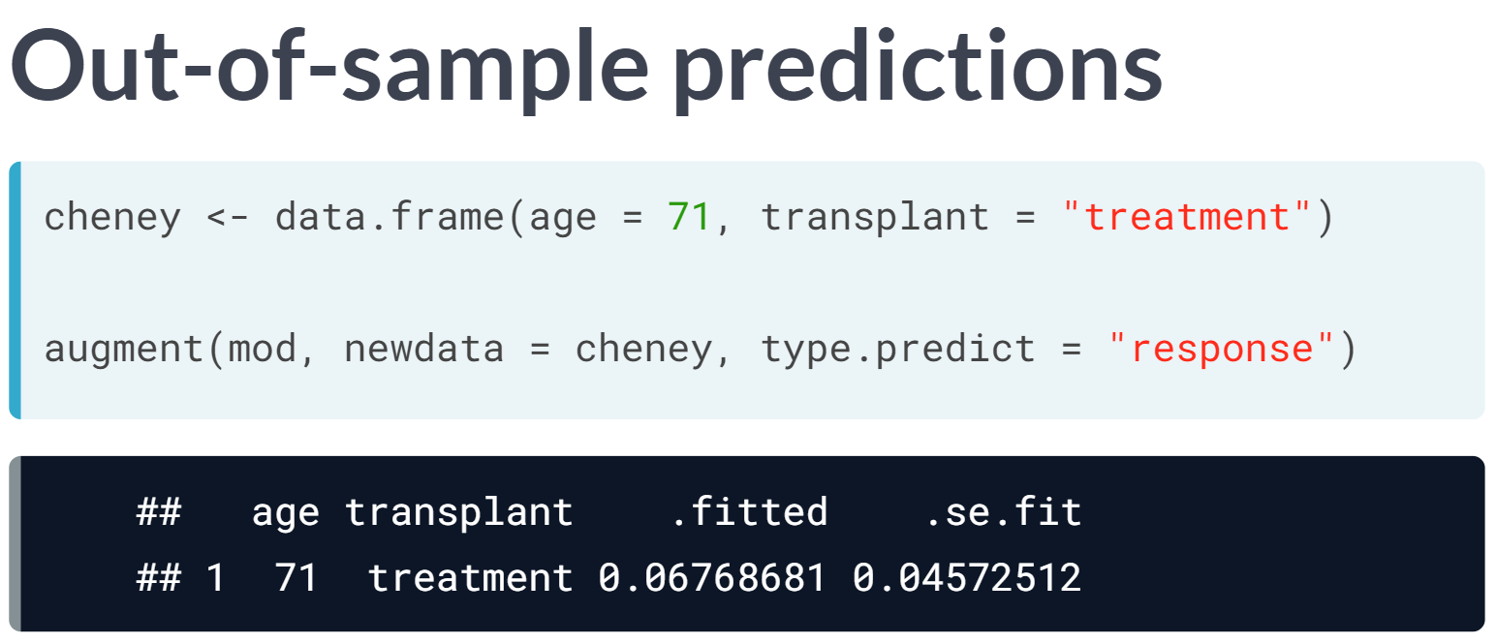  
To compute this, we build a data frame with Cheney's data, and run it through our model using the newdata argument to ***augment()***. The results suggest that Cheney had only a 6.8% of survival.

Either Cheney is quite lucky to be alive, or - more likely - the survival rates of all heart transplant patients have improved considerably since the Stanford study was completed in 1973.

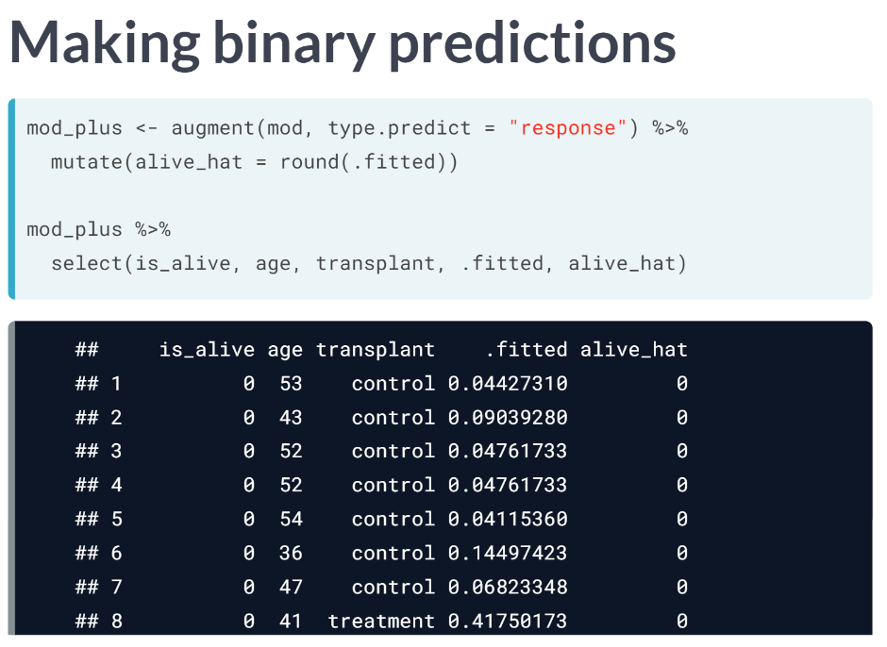  
If our response variable is binary, then why are we making probabilistic predictions? Shouldn't we be able to make binary predictions? That is, instead of predicting the probability that a person survives for five years, shouldn't we be able to predict definitively whether they will live or die? There are a number of different ways in which we could reasonably convert our probabilities fitted values into a binary decision. The simplest way would be to simply round the probabilities. So how well did our model perform?

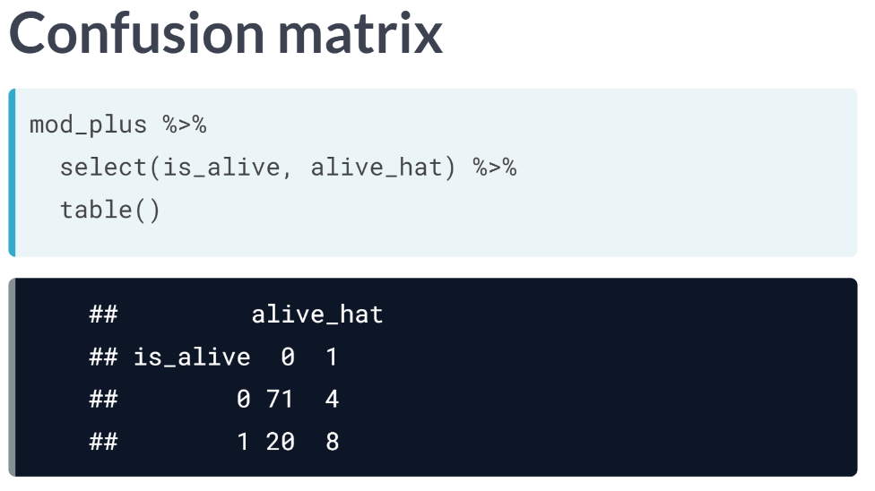  
One common way of assessing performance of models for a categorical response is via a confusion matrix. The simply cross-tabulates the reality with what our model predicted. In this case, our model predicted that 91 patients would die, and only 12 would live. Of those 91, 71 actually did die, while of the 12, 8 actually lived.

Thus, our overall accuracy was 79 out of 103, or about 77%. Note that our model predicted only 12 patients would live, but more than twice as many patients actually survived. Our model's underprediction is probably a consequence of the low survival rate overall, coupled with our clumsy rounding scheme. One way to improve the accuracy of our binary predictions would be to experiment with looser rounding threshold.

# Making probabilistic predictions

Just as we did with linear regression, we can use our logistic regression model to make predictions about new observations. In this exercise, we will use the newdata argument to the augment() function from the broom package to make predictions about students who were not in our original data set. These predictions are sometimes called out-of-sample.

Following our previous discussion about scales, with logistic regression it is important that we specify on which scale we want the predicted values. Although the default is terms -- which uses the log-odds scale -- we want our predictions on the probability scale, which is the scale of the response variable. The type.predict argument to augment() controls this behavior.

A logistic regression model object, mod, has been defined for you.



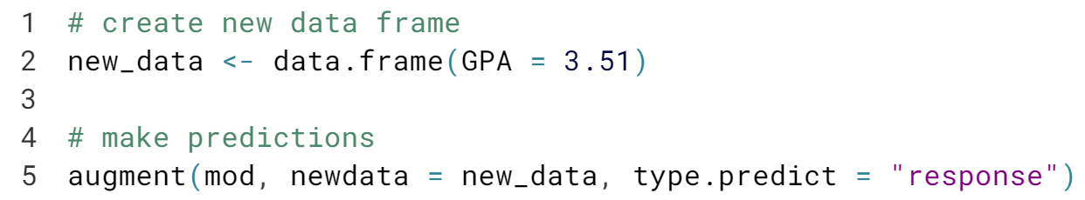

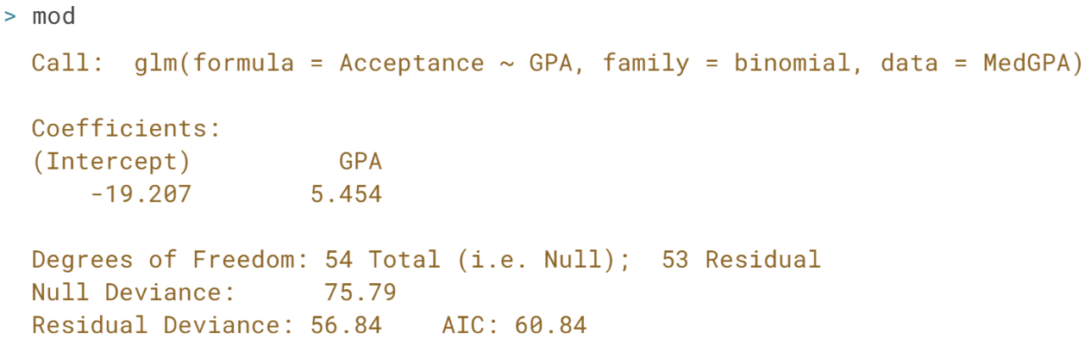

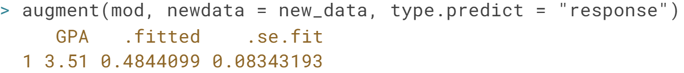  
Perfect predicting! By framing your prediction as a probability you can show how likely it is that this student will get admitted to medical school.

# Making binary predictions

Naturally, we want to know how well our model works. Did it predict acceptance for the students who were actually accepted to medical school? Did it predict rejections for the student who were not admitted?

These types of predictions are called in-sample. One common way to evaluate models with a binary response is with a [**confusion matrix**](https://en.wikipedia.org/wiki/Confusion_matrix). [Yes, that is actually what it is called!]

However, note that while our response variable is binary, our fitted values are probabilities. Thus, we have to round them somehow into binary predictions. While the probabilities convey more information, we might ultimately have to make a decision, and so this rounding is common in practice.

There are many different ways to round, but for simplicity we will predict admission if the fitted probability is greater than 0.5, and rejection otherwise.

First, we'll use augment() to make the predictions, and then mutate() and round() to convert these probabilities into binary decisions. Then we will form the confusion matrix using the table() function. table() will compute a 2-way table when given a data frame with two categorical variables, so we will first use select() to grab only those variables.

You will find that this model made only 15 mistakes on these 55 observations, so it is nearly 73% accurate.

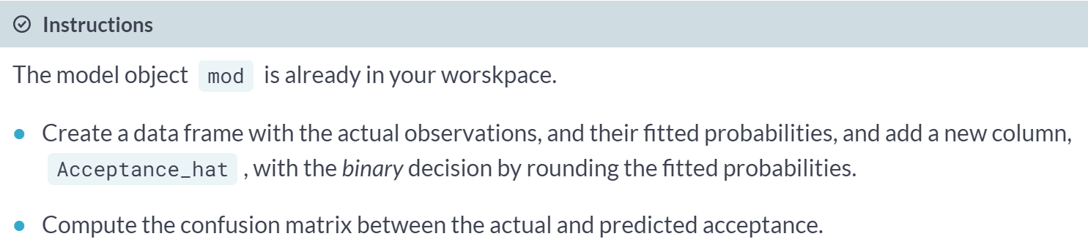

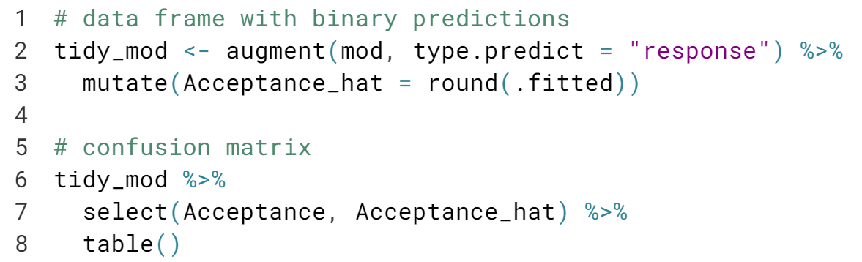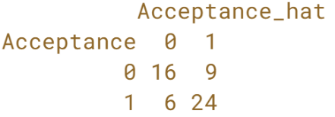

**Case Study: Italian restaurants in NYC**Explore the relationship between price and the quality of food, service, and decor for Italian restaurants in NYC.



No matter where you are, or where you've been, we've all been to a restaurant before. If you're in Europe or North America, there's an excellent chance that you've been to an Italian restaurant.



The Italian restaurant in New York City are legendary, and it's time to put our understanding of newly developed regression modeling skills into practice to understand how it operates. What are factors that contribute to a price of a meal at Italian restaurant in NYC? We'll address this question with a series of multiple regression models.



The Zagat guide is an influential review of restaurants. They are made famously by their use of selective quotes from actual diners to build a pithy description of each restaurant. But we won't be working with the text.

Rather, we'll be working with the numeric reviews we see posted here. Each restaurant is rated on a scale 0 to 30 for the quality of its food, decor, and service. The average price of a meal - which includes one drink and a tip - will be our response variable. How do these factors influence the average price of a meal?  
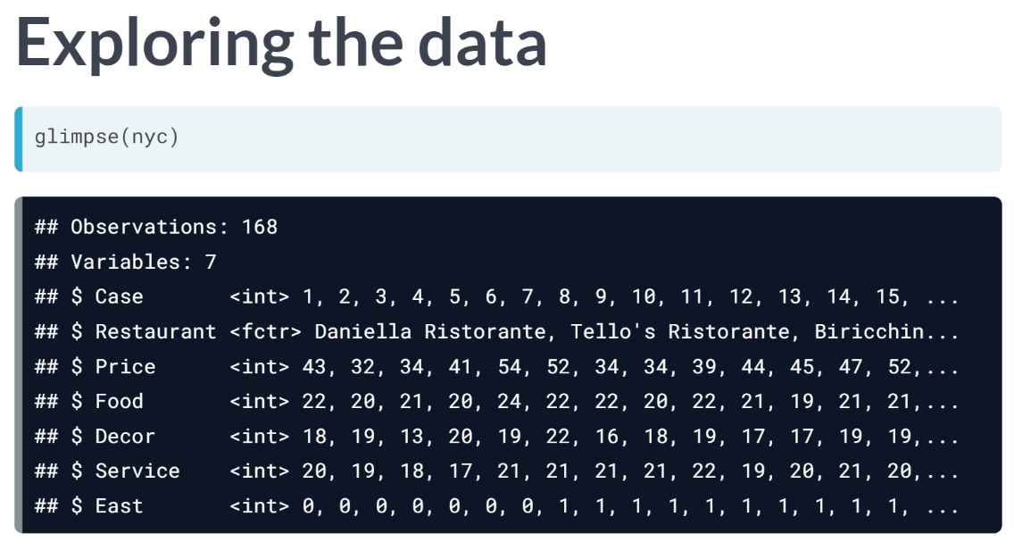  
Our data come in the form of Zagat reviews from 168 Italian restaurants in NYC from 2001. The ***glimpse()*** function can help us get a sense of how the variables are encoded and what values they typically take on. The East variable records whether the restaurant is located east or west of Fifth Avenue, which historically divides the island of Manhattan.

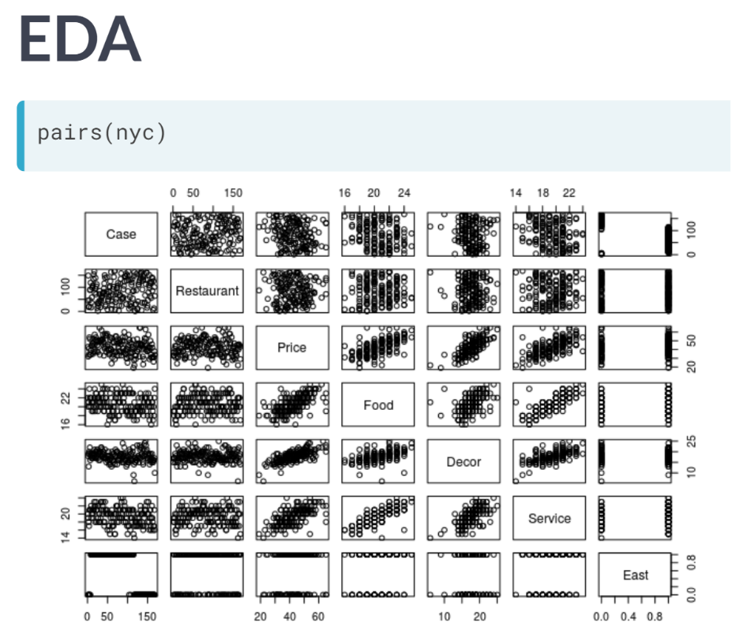  
Before we can sensibly build models, we should spend some time exploring the data. How are the variables distributed? How are they relate to one another? What patterns are present? The ***pairs()*** function can help us explore these relationships visually.

It shows a grid of scatterplots for each pair of variables in the *nyc* data frame. It's easy to see that, for example, Price and Decor are strongly correlated, while Case and Food are uncorrelated.

# Exploratory data analysis

Multiple regression can be an effective technique for understanding how a response variable changes as a result of changes to more than one explanatory variable. But it is not magic -- understanding the relationships among the explanatory variables is also necessary and will help us build a better model. This process is often called [**exploratory data analysis**](https://en.wikipedia.org/wiki/Exploratory_data_analysis) (EDA) and is covered in another DataCamp course.

One quick technique for jump-starting EDA is to examine all of the pairwise scatterplots in your data. This can be achieved using the pairs() function. Look for variables in the nyc data set that are strongly correlated, as those relationships will help us check for [**multicollinearity**](https://en.wikipedia.org/wiki/Multicollinearity) later on.

Which pairs of variables appear to be strongly correlated?

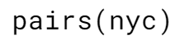  
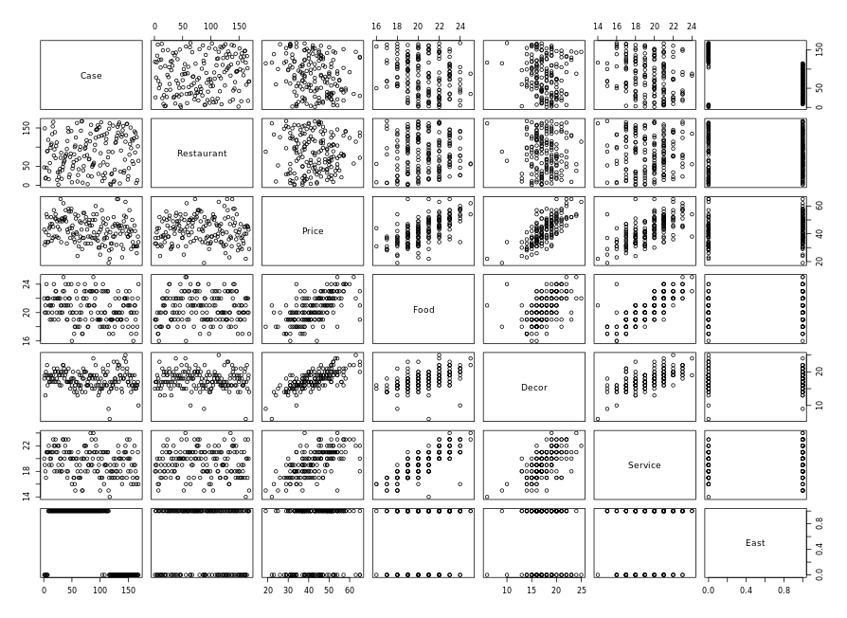  


# SLR models

Based on your knowledge of the restaurant industry, do you think that the quality of the food in a restaurant is an important determinant of the price of a meal at that restaurant? It would be hard to imagine that it wasn't. We'll start our modeling process by plotting and fitting a model for Price as a function of Food.

On your own, interpret these coefficients and examine the fit of the model. What does the coefficient of Food mean in plain English? "Each additional rating point of food quality is associated with a..."



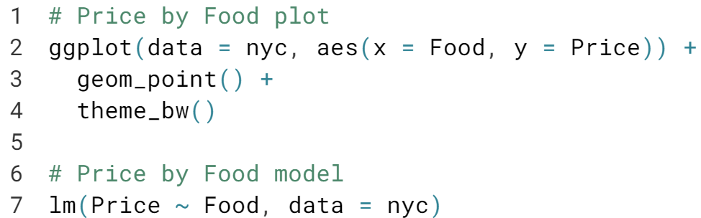

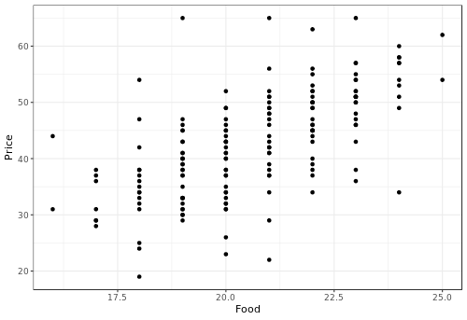  
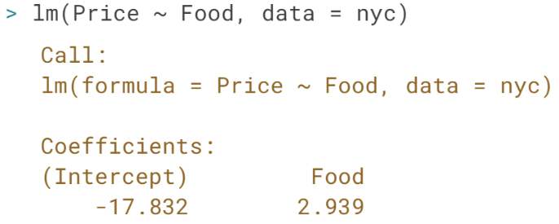



Fifth Avenue is one of the most well-known streets in the world, renowned for its flagship stores for shopping, landmark hotels, and internationally recognized sites.



A walk down 5th Avenue from Central Park to Washington Square Park would take you past the Plaza Hotel, Trump Tower, Saks Fifth Avenue, the New York Public Library, the Empire State Building, and the Flatiron building. It would also take you past the Graduate Center of the City University of New York, where I studied for my doctoral degree.

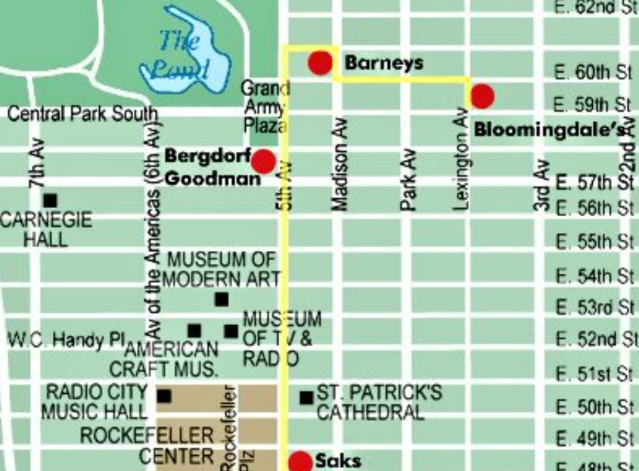

5th Avenue divides the island of Manhattan vertically. The city's east side has historically been home to expensive residences and opulent attractions. Maybe even food is more expensive on the east side. Do Italian restaurants located on the east side of 5th Avenue tend to charge more? How much more?

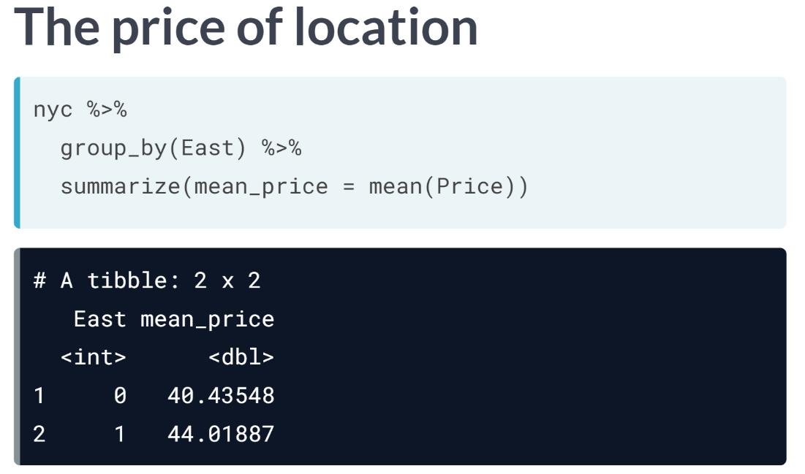  
It's certainly true that the average price of a meal for restaurants located on the east side of Manhattan was higher than it was for restaurants on the west side. The table above shows that they charged about $3.58 more, on average. But does this figure really represent the premium for being on the east side? Could it be the case that the restaurants on the east side also bad better food, and that is what was driving the increase in price?

  
Another important consideration in dining out is the quality of the service. Are people willing to pay more for higher quality service, even if the food doesn't taste any better? How much more? How does the average price of meal vary with respect to the quality of the food and the service? These next exercises will allow us to delve into these questions.

# Parallel lines with location

In real estate, a common mantra is that the three most important factors in determining the price of a property are "location, location, and location." If location drives up property values and rents, then we might imagine that location would increase a restaurant's costs, which would result in them having higher prices. In many parts of New York, the east side (east of 5th Avenue) is more developed and perhaps more expensive. [This is increasingly less true, but was more true at the time these data were collected.]

Let's expand our model into a parallel slopes model by including the East variable in addition to Food.

Use lm() to fit a parallel slopes model for Price as a function of Food and East. Interpret the coefficients and the fit of the model. Can you explain the meaning of the coefficient on East in simple terms? Did the coefficient on Food change from the previous model? If so, why? Did it change by a lot or just a little?

Identify the statement that is FALSE:

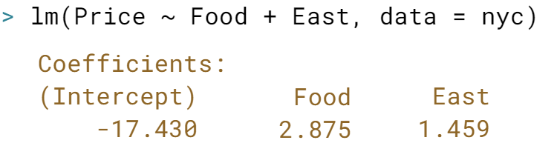



# A plane in 3D

One reason that many people go to a restaurant—apart from the food—is that they don't have to cook or clean up. Many people appreciate the experience of being waited upon, and we can all agree that the quality of the service at restaurants varies widely. Are people willing to pay more for better restaurant Service? More interestingly, are they willing to pay more for better service, after controlling for the quality of the food?

Multiple regression gives us a way to reason about these questions. Fit the model with Food and Service and interpret the coefficients and fit. Did the coefficient on Food change from the previous model? What do the coefficients on Food and Service tell you about how these restaurants set prices?

Next, let's visually assess our model using plotly. The x and y vectors, as well as the plane matrix, have been created for you.

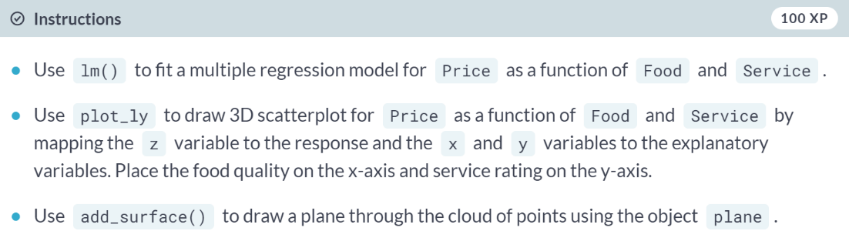

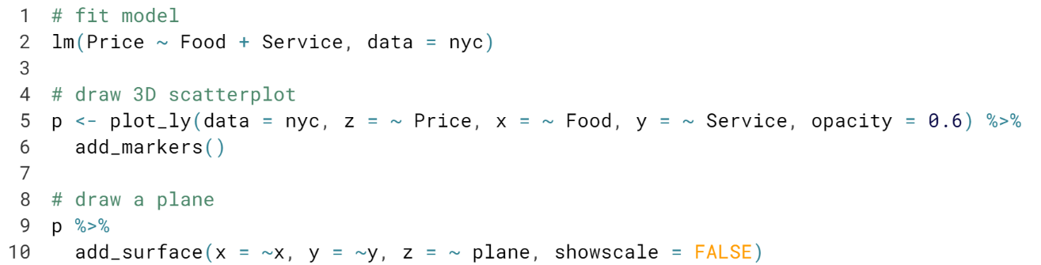

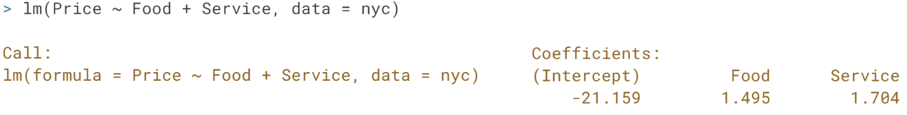  
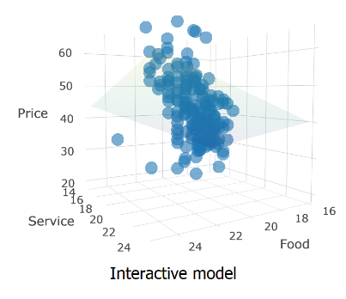



The last criteria for the Zagat review are decor.



This refers to the visual presentation of the restaurant: the furniture, the wall adornments, and the overall ambience. Clearly, restaurants vary widely in the quality of their decor. But how does the perceived quality of decor vary with the price of a meal? And how is the effect moderated by the quality of food and service? In what follows, we will build more complex models for the price of a meal at an Italian restaurant in NYC using Zagat ratings.

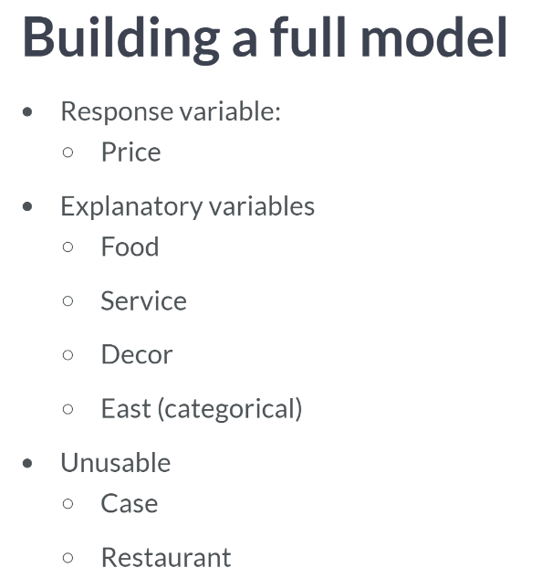

The possible explanatory variables include food, service, decor, and east. Other variables recorded in the data set that should not be considered explanatory variables are case (which records an ID number for each restaurant), and restaurant (which records the name of the restaurant). Consider for a moment what a full model that included all of these explanatory variables would look like.

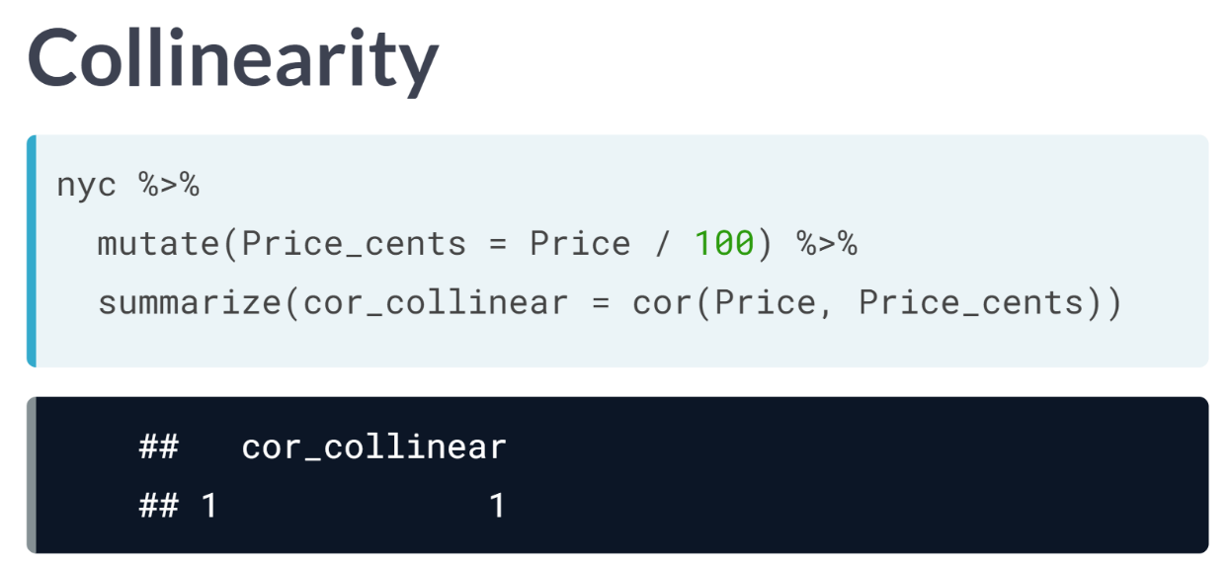

If one variable is a constant multiple of another variable, then they are said to be colinear.

If two colinear variables are explanatory variables in a model, the second one won't tell you anything, because it is providing redundant information.

A solution would be to simply drop one of the variables from the model.

Which one you drop doesn't matter, since they are providing the same information.

Here, we demonstrate collinearity between price measured in dollars and price measured in cents. The variables of the two variables aren't the same, but they are perfectly correlated.

If you already know the price in dollars, you don't get any additional information from knowing the price in cents. Real data hardly ever lines up perfectly, so we'll rarely have perfect collinearity.

However, variables that are highly correlated will be approximately colinear. Furthermore, the collinearity does not have to be one-to-one.

It might be the case that one variable is colinear with a linear combination of several other variables.

This can make it much harder to figure out which variable might be appropriate to drop.

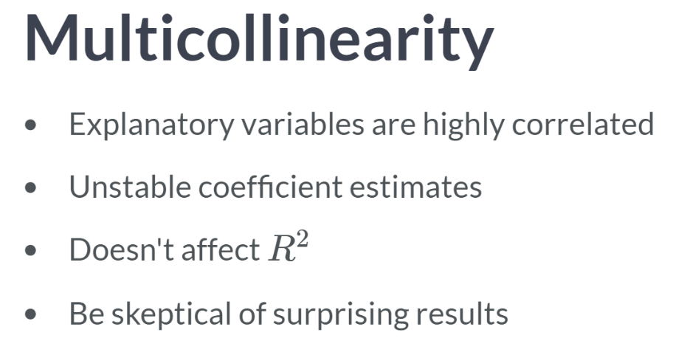

As we add more explanatory variables to our model, it becomes more likely that we will encounter multicollinearity. A full discussion of multicollinearity and how you can work around it is beyond the scope of this course, but you should be family with the basic problem.

The main problem with multicollinearity is that it makes the coefficient estimates unstable. This means that small changes to the values in one variable (say, changing the food rating of a few restaurants) can result in dramatic changes to the best-fit coefficients. This instability makes the results less robust.

However, multicollinearity doesn't compromise the explanatory power of the model as a whole. The R squared values are still valid.

While there are a number of approaches to diagnosing and correcting for multicollinearity, at this stage we should exercise great caution when interpreting coefficients in a model where we have highly correlated explanatory variables.

If we see results that seem strange, counterintuitive, or surprising, it might be that multicollinearity is to blame.

# Parallel planes with location

We have explored models that included the quality of both food and service, as well as location, but we haven't put these variables all into the same model. Let's now build a parallel planes model that incorporates all three variables.

Examine the coefficients closely. Do they make sense based on what you understand about these data so far? How did the coefficients change from the previous models that you fit?

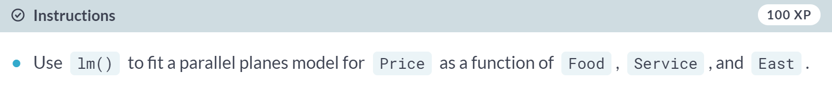



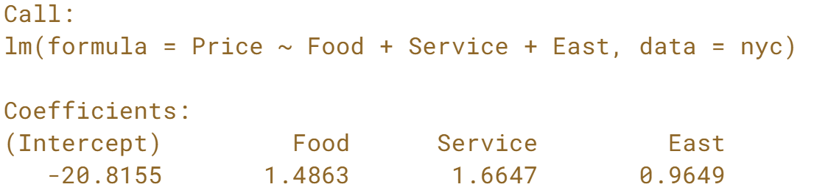

# Interpretation of location coefficient

The fitted coefficients from the parallel planes model are listed below.

(Intercept) Food Service East

-20.8154761 1.4862725 1.6646884 0.9648814

Which of the following statements is **FALSE**?

Reason about the magnitude of the East coefficient.



# Impact of location

The impact of location brings us to a modeling question: should we keep this variable in our model? In a later course, you will learn how we can conduct formal hypothesis tests to help us answer that question. In this course, we will focus on the size of the effect. Is the impact of location big or small?

One way to think about this would be in terms of the practical significance. Is the value of the coefficient large enough to make a difference to your average person? The units are in dollars so in this case this question is not hard to grasp.

Another way is to examine the impact of location in the context of the variability of the other variables. We can do this by building our parallel planes in 3D and seeing how far apart they are. Are the planes close together or far apart? Does the East variable clearly separate the data into two distinct groups? Or are the points all mixed up together?

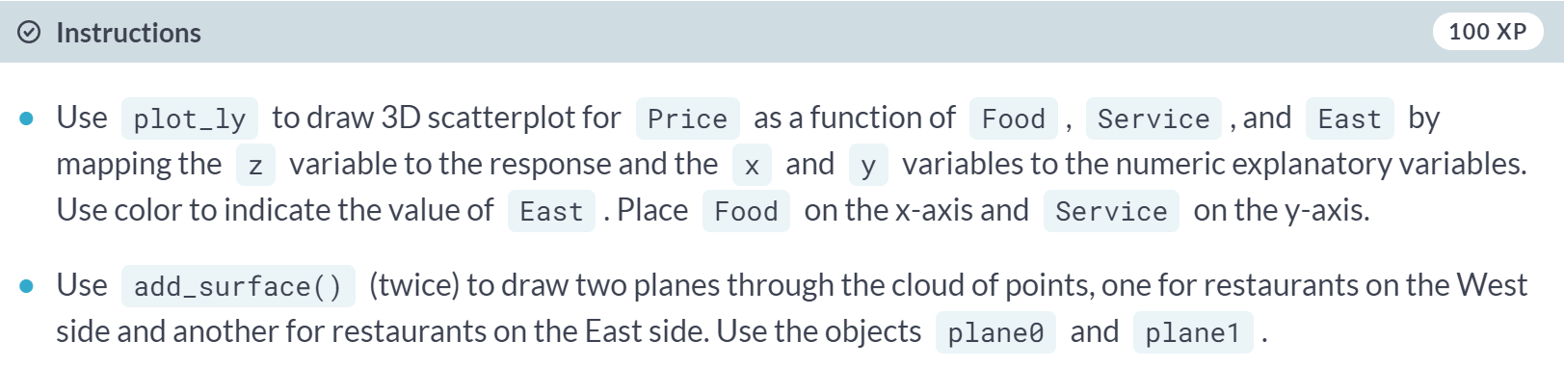

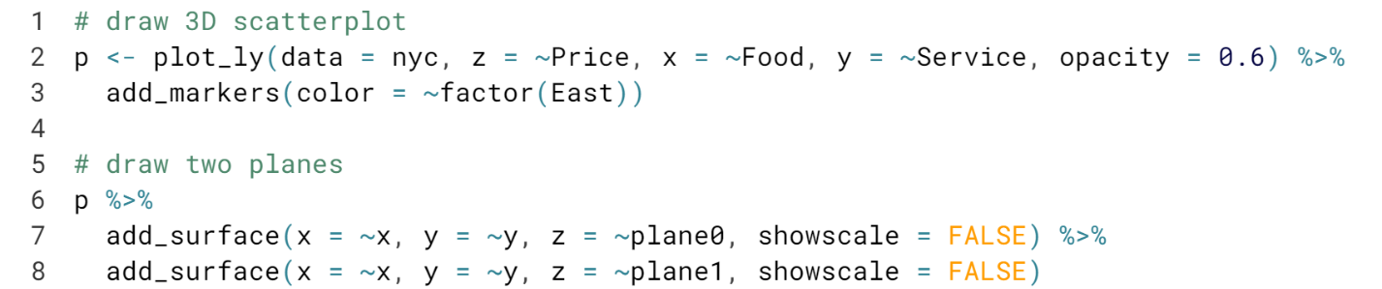

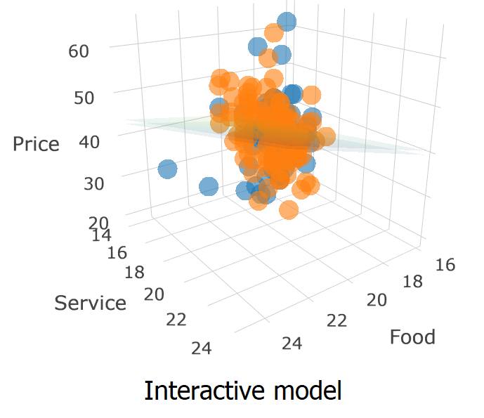

# Full model

One variable we haven't considered is Decor. Do people, on average, pay more for a meal in a restaurant with nicer decor? If so, does it still matter after controlling for the quality of food, service, and location?

By adding a third numeric explanatory variable to our model, we lose the ability to visualize the model in even three dimensions. Our model is now a [**hyperplane**](https://en.wikipedia.org/wiki/Hyperplane) -- or rather, parallel hyperplanes -- and while we won't go any further with the geometry, know that we can continue to add as many variables to our model as we want.

As humans, our spatial visualization ability taps out after three numeric variables (maybe you could argue for four, but certainly no further), but neither the mathematical equation for the regression model, nor the formula specification for the model in R, is bothered by the higher dimensionality.

Use lm() to fit a parallel planes model for Price as a function of Food, Service, Decor, and East.

Notice the dramatic change in the value of the Service coefficient.

Which of the following interpretations is invalid?

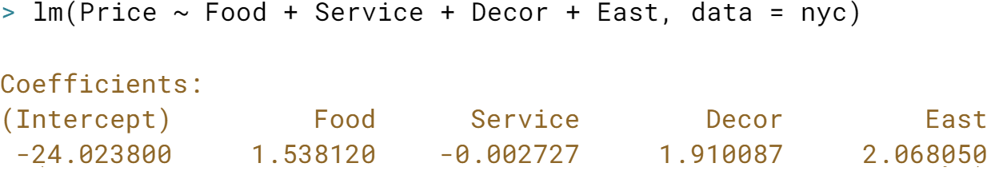





In this course, we learned about a variety of multiple regression models by focusing on the interplay between the mathematical, geometric, and syntactical representations of these models. We extended many of those same ideas to logistic regression, which covers the case in which we have a binary response variable. We discussed this material as a branch of descriptive statistics.

That is, we focused on how the models work, how we should interpret them, and how they can be used, but we didn't talk at all about inference. Statistics have developed many techniques for performing inference on the parameters of these regression models. Those techniques help us answer questions about whether the effects we observe are within the realm of statistical noise, or not.

Without inference, we can only state how big the effect we observed was - we can't make any claims about whether that effect was likely the result of chance alone, or whether it represents a meaningful characterization of the underlying phenomenon. To complete the understanding of this concept, it's recommended to take inferential statistics for regression in upcoming course.